**KEY FACTS SHEET - Brief summary of the STIM MS study**

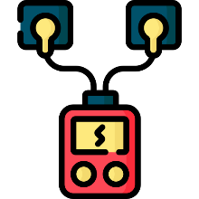

**A randomised controlled feasibility study investigating surface neuromuscular STIMulation as an exercise therapy versus usual care in people with multiple sclerosis (MS) to help improve lower limb strength, walking and fatigue (STIM-MS)**

**What is the purpose of the research?**

To gather information to plan a large study to see if muscle stimulation for people with MS strengthens muscles, improves walking, helps with tiredness, and reduces muscle spasms.

**What is muscle stimulation?**

Muscle stimulation could be a way of helping people with MS to exercise more. It can be used at home and makes muscles contract, like when someone exercises with weights. It involves applying painless electrical signals using sticky pads on the skin and some braces for your joints.

**Who is this study suitable for?**

People who:

* are 18 years or older
* have any form of multiple sclerosis
* have problems with walking **but** can walk at least 20 meters without resting (using your walking aids if needed)

**What would taking part in the research involve?**

* **Three** visits to the hospital, over a **total of 6 months** to measure your walking, leg strength and movement.
* We will reimburse your travel costs.
* Agreeing to be randomly put into either one of two groups.
  + **Half of the people** will be put into the **muscle stimulation** group and the **other half** into the **usual care group**.
* Filling in some questionnaires

**Interested in finding out more?**

* If you are interested in finding out more, please read the more detailed information sheets provided.