Physical Geology
A mineral is a naturally occurring combination of specific elements that are arranged in a particular repeating three-dimensional structure or lattice

Rocks can form in a variety of ways. Igneous rocks form from magma (molten rock) that has either cooled slowly underground (e.g., to produce granite) or cooled quickly at the surface after a volcanic eruption (e.g., basalt).

Relative ages of units may be established by applying fundamental and simple geologic principles:
- Law of Initial Horizontality
- Law of Superposition
- Cross-cutting relationships
- Lateral Continuity
- Faunal and floral succession
- Law of Inclusions
- Metamorphic relationships

Top of Bed identification traits:

- Graded beds -finer grained at the top
- Truncated cross-bedding -slightly concave up
- Ripple marks -concave up
- Sole marks -concave up (flute casts form on the bottom of siltstone or sandstone bed)
- Basal conglomerate -at base of formation
- Rip-up clasts -shale clasts ripped up from deposits below and transported by currents
- Scouring or channeling -concave up
- Mud cracks -V points down
- Solution surfaces -irregular surface at top of soluble rock
- Pebble dents -matrix immediately below imbcddcd pebble is dented
11. Brachiopod shells -convex up, barnacles may form on top surface
12. Coral -narrow end down, branches upward
13. Pclecypod shells -disjointed shells arc generally convex upward
14. Worm trails -grooves on top of bed
15. Burrows -go down from the surface and open upward, may be filled in with a different material
16. Baked zone -under lava flow
17. Lava flows -vesicular portion of lava at top
18. Pillow lavas -convex up, bottoms of pillows have cusps pointing down

Geologic time scale

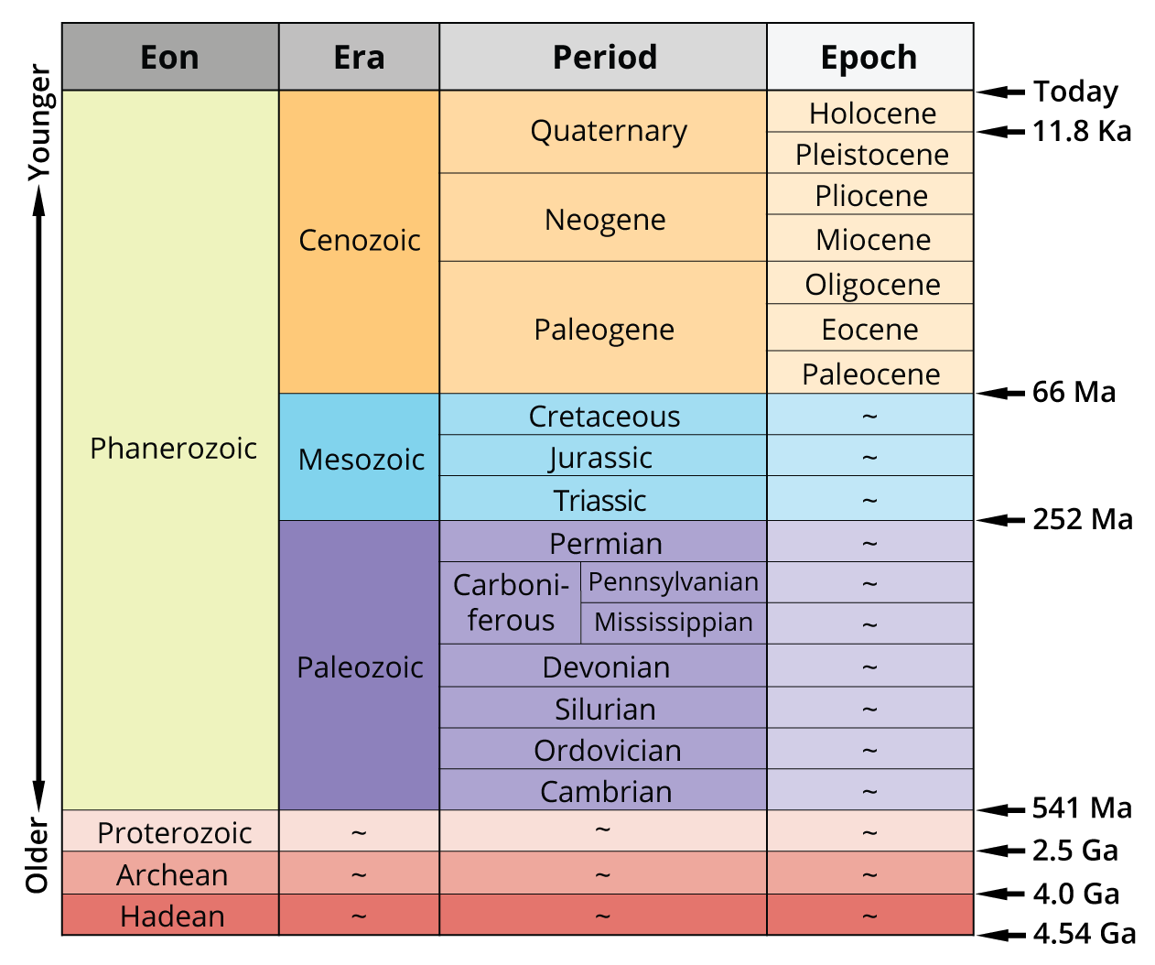

Camels Often Sit Down Carefully; Perhaps Their Joints Creak?
Persistent Early Oiling Might Prevent Permanent Rheumatism.

To memorize the Eras:
Ø Precambrian, Paleozoic, Mesozoic, Cenozoic:
* Please pay my children!

CENOZOIC ERAS
- Holograms are very recent (the Holocene is the most recent epoch)
- Glaciers are plastic or My glaciers are made of plasticine (the Pleistocene was the time of the “Great Ice Age”)
- The pliant Americas joined together or Pliable hominids arose (Hominidae began in the Pliocene, and North and South America joined up)
- Mild weather saw Africa collide with Asia (the Miocene was warmer than the preceding epoch; during this time Africa finally connected to Eurasia)
- Elephants become oligarchs! (during the Oligocene mammals became the dominant vertebrates)
- Continents obscenely separate (Laurasia, the northern supercontinent, began to break up at the beginning of the Eocene; Gondwanaland, the southern supercontinent, continued its breakup)
- Pale from the disaster, we pull ourselves together (the Paleocene marks the beginning of a new era, after the K-T boundary event (thought by many to be an asteroid impact) in which the dinosaurs and so much other life died)

