BAL Spring Regional Fine Art Competition, 2023

The Burlington Artists League, in conjunction with the BAL Fine Art Gallery, is hosting the Spring Regional Fine Arts Competition in April. The competition is open to the public. The opening reception will be on Saturday, April 1, 2023, from 2:00 to 4:00 PM. Cash Awards will be as follows: 1st Place in Painting - $150.00; 1st Place in Photography - $150.00; 1st Place in 3-Dimensional - $150.00; 2nd Place in Categories - $100.00; and 3rd Place in Categories - $75.00. For a category to qualify for awards there must be a minimum of 4 artists entering art into the category. Honorable Mention ribbons are awarded as the judge selects. All awards will be announced at the reception. Artists must be eighteen years of age to participate.

Entry Requirements:

Enter Artwork Monday, March 27 or Tuesday, March 28, 2023, from 1:00 to 6:00 pm at the Burlington Artists League Fine Art Gallery. Entry forms must be completed, and fees paid at the time art is received.

Only original composition works by the artist, completed in the past two years, in drawing, painting, graphic art, collage, photography, sculpture, jewelry, and mixed media, will be accepted and judged. No workshop or art class instructed art will be accepted. No entry may have been previously entered in any BAL competition.

The entry fee is $40.00 for non-members and $30.00 for members of the Burlington Artists League that have joined at least 30 days prior to the competition entry date. This fee enables the artist to present up to three pieces for the competition.

The Burlington Artists League welcomes new members for an annual membership fee of $35.00. The forms are available at the Gallery or online at: www.burlingtonartistsleague.com

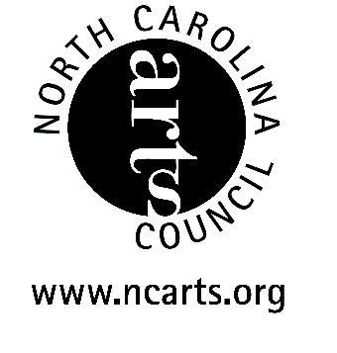
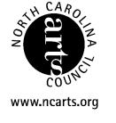
This project is supported by the NC Arts Council, a division of the Dept. of Cultural Resources through the Alamance County Arts Council

Burlington Artists League
P.O. Box 2016
Burlington, NC 27216

Postage

Stamp

Burlington Artists League
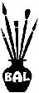

Invitation to the

Spring 2023 Regional
Fine Art Competition
April 2023

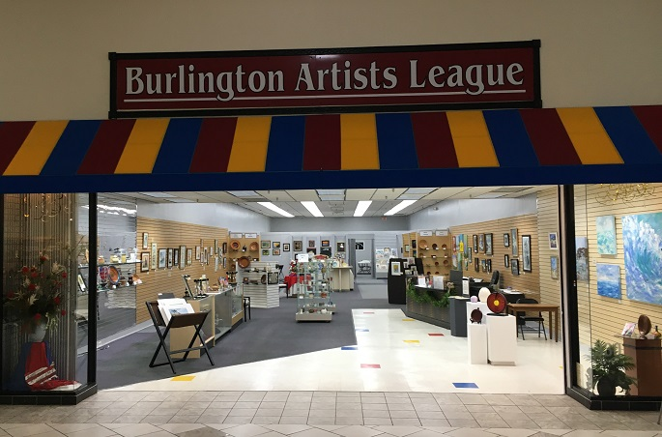

The competition is held at the BAL Fine Arts Gallery located in Holly Hill Mall and Business Center.

309 Huffman Mill Rd.
Burlington, NC. 27215
Phone: 336-584-3005

Preparation of
Submitted Art

All two-dimensional art must be wired for hanging and may not exceed 72 united inches excluding the frame. United inches are calculated by adding the width and the length of two adjacent sides of the work.
Providing appropriate and safe display of 3-D art is the responsibility of the artist and is subject to approval by the gallery.

Picture Hanging Wire Placement

All framed or gallery wrapped artwork submitted for display in the gallery must have hanging wires attached. Attach eyelets to the sides approximately 1/3 down from the top of the frame. Attach wire securely to the eyelets, to a length so that when you pull up at the mid-point of the wire, the highest point is 2.5 inches below the top of the frame.

Liability

The Burlington Artists League Fine Arts Gallery, Holly Hill Mall and Business Center, and their agents may not be held liable for any damages to or loss of art competition entries for the duration of the competition and exhibit.

Entry Agreement

When you deliver your artwork to the BAL Fine Arts Gallery, we will ask you to sign an Entry Form and Agreement for the competition. You will receive an entry receipt for your artwork entered by your request at the time of entry.

MARKING YOUR ARTWORK

Please fill in the entry tags below and attach to the back upper right corner of artwork that you enter. This is needed to check you in. Please print or you may fill in the tags using your computer

Entry # 1
Annual Regional BAL Fine Arts competition

Title: _________________________________________

Artist: ________________________________________

Medium: _________________________________

Price: $______________, or NFS Value: $____________

Phone: _(_____)________--______________________

Entry # 2
Annual Regional BAL Fine Arts competition

Title: _________________________________________

Artist: ________________________________________

Medium: _________________________________

Price: $______________, or NFS Value: $____________

Phone: _(_____)________--______________________

Entry # 3
Annual Regional BAL Fine Arts competition

Title: _________________________________________

Artist: ________________________________________

Medium: _________________________________

Price: $______________, or NFS Value: $____________

Phone: _(_____)________--______________________

Duration of Exhibit
Oct. 1 through Oct. 30, 2010

April 1- April 28, 2023

Submitted art must remain on exhibit for the duration of the show. Artwork pick-up is Saturday, April 29, 2023 from 1:00 pm to 6:00 pm.

Location of Gallery

The BAL Fine Arts Gallery is located in Suite 330 in the Holly Hill Mall and Business Center at the corner of South Church Street and Huffman Mill Road in Burlington, NC. If traveling Interstate 40/85 and coming from the East take Exit 141 and at the end of the ramp turn right onto Huffman Mill Road; if coming from the West take Exit 141 and at the end of the ramp turn left onto Huffman Mill Road. The Mall will be approximately 1.5 miles on your left.

Gallery hours are 12 noon to 6:00 pm Tuesday through Saturday.

Entry / Competition Agreement is separate.

Gallery phone: 336-584-3005

Website: www.burlingtonartistsleague.com

E-mail: balartgallery@gmail.com

