**WELCOME TO THE GROOM’S EXPO**

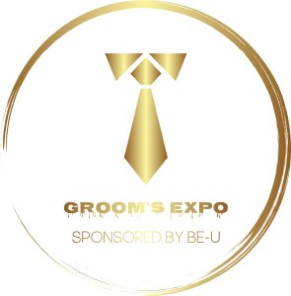

**The Forgotten Male, “Always Thought About & Also Always Ignored”**

**Theme: It’s All about Me!!**

Let’s not be a Groom Zilla Let’s be a Groom Winner! Show your Lady that you can help plan the Wedding of her Dreams and yours if need be. In this Expo we want you to have all the tools needed to plan or help in planning the Wedding you desire. Often times the Wedding is all about the Bride and the Groom just needs to show up, but I want to prepare you to have a little if not a lot of input so you don’t feel left out in the cold. Women need Hairstylist to help them look beautiful on their big day. Okay, Men need a Barber. Women need to be pampered with a massage and a manicure/pedicure to relax them. I’m sure some of you men need to de-stress too and get your hands pampered so they will look nice in those Wedding photos next to hers. Women want to pick out their Bridal Gown and Bridesmaids Dresses. Men also want to have an Opinion of what Tuxedo style or Suit they want for themselves and for their Groomsmen. They may also want to plan the destination for the Honeymoon. The list can go on and on from the style of Shoes, to the type DJ, Transportation, Bachelor Party and choosing the Ring. Well, this Groom’s Expo will have it all. This Event will be Open to the Public. We will have Vendors for the Ladies too, but it’s going to be Catered towards what Men Like! So, Grab a Friend. Ladies grab your Man. Come on down and Enjoy this Experience. You can also benefit from seeing what Men like too!

Let’s Talk About It and Also Come See About It!

Presented by:

Crown Connections & BE-U

Tonya Harris

Beusbi2023@gmail.com

901-308-7446

