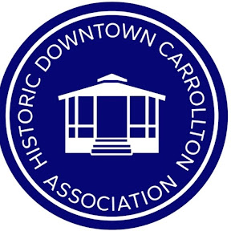 HDCA Mission Statement:
The HDCA exists to preserve, promote, and encourage the civic, social, tourist,
commercial, and economic welfare of the Historic Downtown area of the City of Carrollton.

HDCA GENERAL MEETING 01/29/2026 Chris Lynn Secretary
Paula, Bill, Eddie, Carolyn, John O. Chris, Janet, John R, Alexandra, Chris @ 3 Nations
5:55 p.m. Paula started meeting
5:56 p.m. open with prayer by The Blessing Church Pastor Yoon
Paula opening statement thanking Jerry Tx Lumberjaxe, Pour Choices and Joe’s Pizza for putting Calvin up during inclement weather as well as thanking 3 Nations for hosting and Joe’s Pizza for catering.
5:57 p.m. all 2025 board members asked to stand for recognition, called all 2026 Board members up to be sworn in as Board Members and handed reins to John, John presenting card and flowers to Paula as past president
6:03 p.m. Mayor Steve Babick spoke about Master plan and long-term investments
6:10 p.m. John introduces Emma Bailey- Emma spoke about 2026 City events and Next event is TEXFest. Introduction to Heather management of Parks and recreation.
6:14 p.m. John announced working with city to get The Ticket out for event, John talked about change coming to the square announcing Jimmy Hush as next speaker
6:16 p.m. Jimmy Hush introduction to his team, Janna Wilson and Corey Clark Jimmy started with changes of The Oilfield Building 18 suites of salons upstairs and coffee shop and restaurant downstairs; end of February construction starts and completion date goal by end of June first of July- the salons will have constant foot traffic; Corey Clark talked about Jammy’s Jerk Chicken restaurant- opening date goal June 2026; designs were shown of the inside the building, Jimmy wants to ensure the stain glass has another home that is in the currently in the building and possibilities for the stair case. Janna spoke about bring music to the square, has about 65K Followers; on Instagram lovemicdallas. Mayor thanked Jimmy for presentation.
6:42 John R. spoke about past and future of HDCA and the goals, creating value, other operations Idioms, ownership and accountability.
Asked all Members at assembly :What do you want to see from HDCA?
- Collaboration with city
- Traffic – more people in the suare
- Market to city and other locations
- Building community – making it a place to spend the day.
- Fresh ideas fresh energy
- Social media
- Word of mouth
- Thank owners of business and compliment business
- Get property owners involved
- Sidewalk repairs – Mayor advised to download Carrollton app and take photos
- QR codes for business and the history of the building

