The Senior Center
6 Golf Club Lane – Garden City, NY 11530

November 2025 516-385-8006

Monday | Tuesday | Wednesday | Thursday | Friday
3
. | * Denotes an established group.  + Denotes reservations required.  ++Denotes a “pay to go” class/event. |  |  | Don’t forget the Neil Diamond Experience at the Argyle Theatre tomorrow, Saturday, November 1st. Bus leaves at 11:15.++
3 | 4 | 5 | 6 | 7
10:00 Exercise with Felicia  Noon – 4:00 Retired Men’s Group*  Ask about the Mpnday evening Duplicate Bridge Group | Election Day-  Senior Center is Closed | 10:00 Exercise with Felicia  11:15 Senior Dance/Performance Group++  12:30 – 3:00 Lunch Group (all are welcome, bring your lunch!)* | 11:00 Cardio/Resistance Exercise with Cathy++  Noon – 4:00 Retired Men’s Group*  1:00-3:30 Pool Chat Group (all are welcome, bring your lunch!) | Trip to the Nassau County Museum of Art and lunch at Mim’s.  Bus leaves at 11:45++
10 | 11 | 12 | 13 | 14
10:00 Exercise with Felicia  Noon – 4:00 Retired Men’s Group*  Ask about the Mpnday evening Duplicate Bridge Group | Veteran’s Day Observed-  Senior Center is Closed | 10:00 Exercise with Felici1a  11:15 Senior Dance /Performance Group++  12:15 BINGO with Erin Fleischman+  12:30 – 3:00 Lunch Group (all are welcome, bring your lunch!)* | 11:00 Cardio/Resistance Exercise with Cathy++ (Last Class)  Noon – 4:00 Retired Men’s Group*  2:00 Reverse Mortgage Workshop+  1:00-3:30 Pool Chat Group (all are welcome, bring your lunch!)  1:00 Chi Kung with Andrea++ | 12:00- 2:00 Thanksgiving Luncheon++
17 | 18 | 19 | 20 | 21
10:00 Exercise with Felicia  Noon – 4:00 Retired Men’s Group*  Ask about Mpnday evening Duplicate Bridge Group | 10:30 Zumba Gold with Andrea  11:30 NYU Information Session: Hands Only CPR/Choking+  12:00-2:00 Open Mah Jongg, bring your lunch and a set.  1:00-3:00 Open Ping Pong | 10:00 Exercise with Felicia  11:15 Senior Dance/Performance Group++  12:30 – 3:00 Lunch Group (all are welcome, bring your lunch!)* | Noon – 4:00 Retired Men’s Group*  1:00-3:30 Pool Chat Group (all are welcome, bring your lunch!) | 10:00 Exercise with Felicia  11:00 Resistance Bands with Felicia
24 | 25 | 26 | 27 | 28
10:00 Exercise with Felicia  Noon – 4:00 Retired Men’s Group*  Ask about Mpnday evening Duplicate Bridge Group | 10:30 Zumba Gold with Andrea  12:00-2:00 Open Mah Jongg, bring your lunch and a set.  1:00-3:00 Open Ping Pong | 10:00 Exercise with Felicia  11:15 Senior Dance/Performance Group++  12:30 – 3:00 Lunch Group (all are welcome, bring your lunch!)* | Happy Thanksgiving!  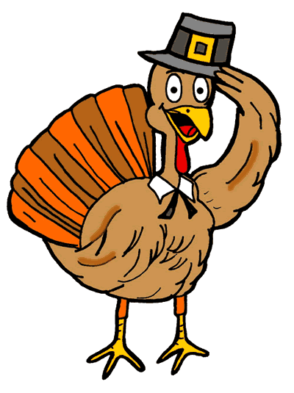 | 10:00 Exercise with Felicia  11:00 Resistance Bands with Felicia

