Registration is open!
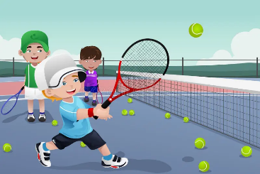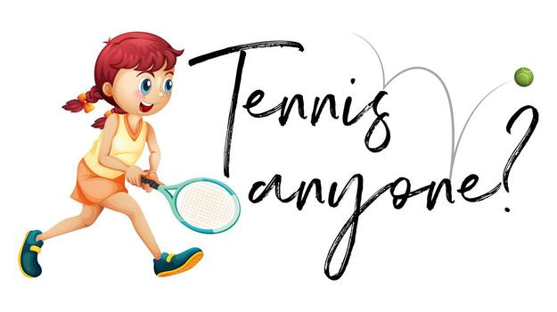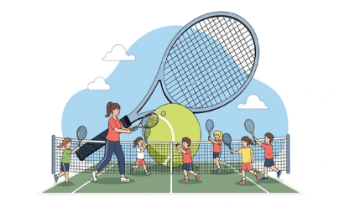
Youth Tennis Camps at Community Park – FULL WEEK 5 sessions
Morning Session 10am to 12 noon / Afternoon Session 1pm to 3pm
Session 1 - Monday, June 29 – Friday, July 3
Session 6 - Monday, August 3 – Friday, August 7
Novice - (geared for 5 to 7 years old)
Junior – (geared to 8 to 11 years old)
Senior – (geared to 12 –15-year-olds)
FEE: $295 per person per 5 day session
Youth Tennis Clinics in July – at Community Park Afternoon sessions 1:30 to 4pm (geared for 8 to 15 years old)
Fee: $150. per each 2-day clinic (You can sign up for any or all the clinics)
- Clinic 2A – Monday, July 6th & Tuesday, July 7th
- Clinic 2B - Thursday, July 9th & Friday, July 10th

- Clinic 3A – Monday, July13th & Tuesday, July 14th
- Clinic 3B - Thursday, July 16th & Friday, July 17th

- Clinic 4A – Monday, July 20th & Tuesday, July 21st
- Clinic 4B - Thursday, July 23rd & Friday, July 24th

- Clinic 5A – Monday, July 27th & Tuesday, July 28th
- Clinic 5B - Thursday, July 30th & Friday, July 31st
The camps/clinics include - Tennis instruction, developmental games and activities, but most of all having fun while learning the game of tennis!
Sign up with your Community Pass Account - Program is located under Tennis Lessons!

