Garden City Recreation and Parks / POOL  Special Events JUNE / JULY 2026 |  |  |  |  | 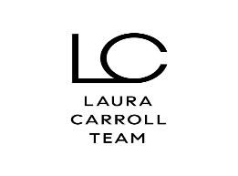 | 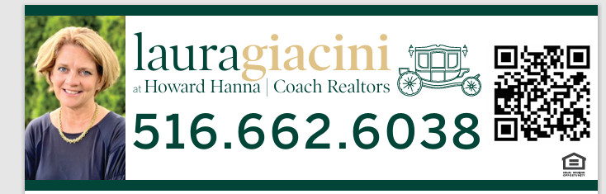
SUNDAY | MONDAY | TUESDAY | WEDNESDAY | THURSDAY | FRIDAY | SATURDAY
JUNE 21 –FATHERS DAY “STEEL MARGARITA” Steel Drum Band 2PM | JUNE 22 | GAZEBO CONCERTS ON THE VILLAGE GREEN  BEGIN AT 7:15PM | PARK EVENTS | POOL EVENTS | Thank you to or Sponsors | 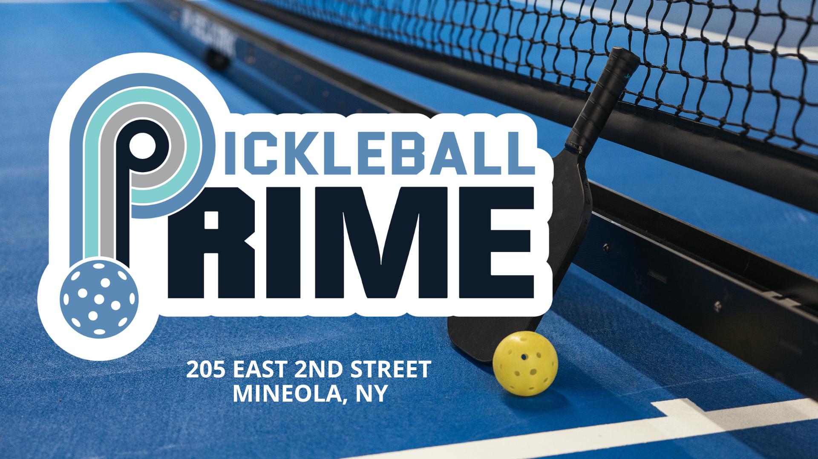
JUNE 28  Live Poolside Music by Michael Colarossi 2pm | JUNE 29 | JUNE 30  MOVIE NIGHT  “ZOOTOPIA 2”  8:30PM | JULY 1  ARTS & CRAFTS 10:30AM IN THE SNACK BAR AREA | 2  BINGO AT 2PM IN PICNIC AREA | 3 | 4TH OF JULY 1 – 4pm  FAMILY FUN DAY  MUSIC, GAMES AND PRIZES Music by: The Hambones Sponsored by Hofstra University
5  BINGO FOR PRIZES IN THE PICNIC AREA 2PM | 6  SENIOR CITIZEN DAY with Johnny Whimple from 11am to 1pm | 7  MOVIE NIGHT  “HOW TO TRAIN YOUR DRAGON” (2025)  8:30PM | 8  ARTS & CRAFTS  10:30AM IN THE SNACK BAR AREA | 9 Gazebo Concert  “SOUND CHASER”  Sponsored By Hofstra University  BINGO- 2PM IN PICNIC AREA | 10 Movie Night: Superman (2025) Rated PG-13 8:30pm Top your own Sundae at the Snack Bar  Sponsored By Hofstra University | 11  Carnival Day 1 – 4pm  Fun and Games  Sponsored by Pickleball Prime
12  SUNRISE THEATER COMPANY PERFORMANCE OF “THE LIGHTNING THIEF” 2PM | 13 | 14  MOVIE NIGHT  “GOAT”  8:30PM | 15  ARTS & CRAFTS  10:30AM IN SNACK BAR AREA  Playgrounds Field Trip to Adventureland | 16 Gazebo Concert  “VINNY MEDUGNO with the Chiclettes”  BINGO AT 2PM IN PICNIC AREA | 17 | 18 now on July 25th  PARTY UNDER THE STARS 5:30 – 9PM  POOLSIDE BAR & BBQ  Music By: County Line  Sponsored by: Hofstra University
19  BINGO FOR PRIZES IN THE PICNIC AREA 2PM | 20 | 21  MOVIE NIGHT - POOL  “LILO AND STITCH” (2025)  8:30PM  Magic of Amore Edgemere Pk 6pm | 22  Tie Dye Day 1pm  With DJ Bob  ARTS & CRAFTS  10:30AM IN THE SNACK BAR AREA | 23 Gazebo Concert  “DR. K’S REFLECTION OF MOTOWN”  BINGO AT 2PM IN PICNIC AREA | 24  Rubber Duck Races down the slides 4 – 6pm fun and prizes Sponsored by Laura Giacini -Coach Realtors | 25  $1 DAY at Mini Golf all rounds only $1 Sponsored by Laura Giacini – Coach Realtors
26  Magic of Amore 1pm sponsored by Laura Carroll Team | 27 | 28 MOVIE NIGHT  29 Arts & Crafts 10:30am in Snack Bar area  “HOPPERS”  8:30pm |  | 30 Gazebo Concert  “THE FIREFLIES”  BINGO AT 2PM IN PICNIC AREA | 31 | AUGUST 1  Wacky Inflatables in the Main Pool 4 – 7pm

