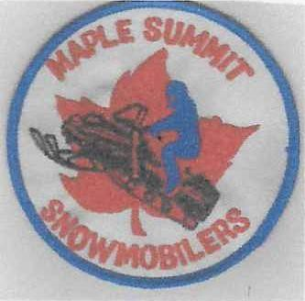

**MAPLE SUMMIT SNOWMOBILERS**

APPLICATION FOR CLUB MEMBERSHIP

# Membership period November 01 to October 31

Club membership dues are $20.00 per year per adult (18 years or older). Any child under the age of 18 is automatically a member as long as one parent is a paying member. **Your dues and donations are appreciated and needed to keep the trails groomed, insured, and ridable.**

Our club's purpose is to promote friendship and good snowmobiling among all riders. Members are encouraged to attend monthly meetings normally held on the first Saturday of every month (September — April), time and location to be posted monthly on the club’s website and on Facebook. Children are welcome to attend.

Remember that many of our trails are on private property and volunteer help is always needed to keep them in proper order so that all trail rides may be better enjoyed.

If you would like to receive a sticker and/or membership card please enclose a self- addressed envelope.

FOR IMFORMATION CALL (412) 480-7068

Please detach here

**New Member Renewal**

# Qty Memberships: ______ x $20.00ea = $______________

# Qty Trail Maps: ______ x $10.00ea = $______________

# Additional Donation: = $______________

# **Total: $_______________**

Name (s):

Address:

Email:

Phone Number:

How did you hear about the club?____________________________________________________

Please mail completed application and payment to: **Maple Summit Snowmobilers, Inc**.

2533 Harrison City Road, Export, Pa., 15632

**THANK YOU** MapleSummitSnowmobileClub.org Facebook