A Western Wabanaki Activity Calendar

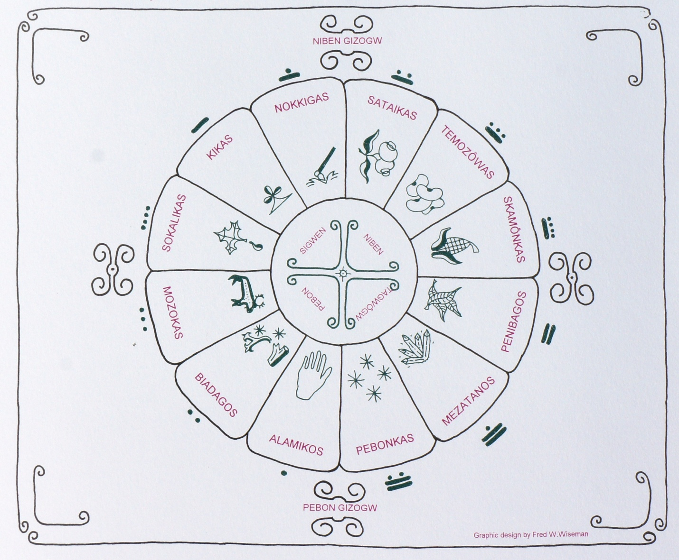
A first calendrical approximation, 1993

Note: This calendar does not include national observances such as the October and November Native American Days, or the November Native American Month.

Biligizos Alamikosowôgan (Forgiveness Day)
This Late December-January celebration occurs at the first New Moon after winter solstice. One recorded Abenaki tradition at this time is to forgive all the previous year's hurts, move on, and begin the next year with a clean emotional slate. This is an old Odanak custom, that is also known at Indian Island in Maine. At Koas in the Connecticut River Valley, there is another old, perhaps allied tradition, where all of the scrap wood is set aside over the year (including the discarded Christmas tree) and then set alight as the sun set. After that, people dance, cheer and eat outside as the bonfire burns down to embers. Biligizos Alamikosowôgan is very important since it sets the whole agricultural and social calendar!

Alamikos (Greetings Moon)
Depending on the astronomical correlation between the winter solstice of the solar calendar and the lunar new moon, this celebratory month occurs in late December through late January. A tradition that has been recorded in oral histories at Odanak, Indian Island and Indian Township is that this moon is the appropriate time to reach out to people you have lost touch with over the year. Nicole Obomsawin of Odanak indicated that this is the time to have social dances such as the Round Dance, Snake Dance and Friendship Dance. Non agricultural dances such as the Eagle, Mosquito, etc. are probably also appropriate at this time.

Sokalikas (Maple Sugar time)
Depending on the onset of spring, this event occurs at different times, usually in early March. In the past, Wabanakis have teamed up with sugar houses or maple sugar celebration event planners to promote the fact that Native Americans originated the idea that led to a multibillion maple products industry in New England and the Upper Midwest. Sokalikas, an Odanak Quebec named moon, is a time to gather at Abenaki-owned sugar houses for collecting maple sugar, visiting, and doing traditional style demonstrations for the public.

Kikas (Field making and planting moon)
Depending on the weather, Kikas occurs in May through early June. Vermont, New Hampshire and Quebec Abenaki communities open up and plant their fields, at this time. The labor has been frequently accompanied by brief ceremonies blessing the field, often with the "Hi-go" calling in song and the "Gaya-wane-he" four directions chant, followed by a picnic-style meal beside the fields. Probably the most important ceremonial planting happened on May 31, 2007 where a "lost" variety of corn was returned to the Koas Abenakis and was planted for the first time under Native American control, with Elnu Chief Roger Longtoe performing the ritual songs. Also, the Sun Ceremony and Rain Ceremony could certainly be practiced any time during or after Kikas, since the crops will be germinating and growing -- and would need the Sky Beings' aid.

Abenaki Heritage Week
Governor Howard Dean declared the first week in May as "Abenaki Heritage Week" in 1993. For over 15 years, it was observed in Highgate, then Swanton, VT; the only significant Abenaki celebration in the Western Wabanaki area. At the beginning, the weekend gathering was followed by a week-long series of presentations and performances by Abenaki culture bearers throughout the state. The celebration was moved to late May in 1998 because of weather problems for regional early May outdoor celebrations. Except for one revival attempt by the Vermont Commission on Native American Affairs, Abenaki Heritage Week has languished since 2010. Possible future versions of May celebrations could perhaps Incorporate "Recognition Days" for Nulhegan and Elnu (2011) and Koasek and Missisquoi (2012).

Nokkigas (Cultivation Moon)
Nokkigas, the "Cultivating Moon," is in June throughout Abenaki territory. Indigenous communities gather at this time to cultivate and tend the fields, a great time to visit while working and afterwards. Today the back-breaking labor may be accompanied by a bit of drumming and singing, and maybe even a social dance especially for the kids. Community meals, often served beside the fields, follow the hard work of weeding the crops and worrying about rain. There are no known formal ceremonies specifically associated with Nokkigas. However, other Eastern Woodland tribes have prescribed celebrations during the cultivation period, many times involving sun and rain ceremonies, and so we can speculate that at least some Abenaki communities probably did as well. The Odanak Abenaki Rain Dance and the Sun Dance are almost certainly fragments of lapsed Abenaki crop nurture ceremony. The Old Farmer's Almanac tells us that the "Strawberry Moon" (June) name "was universal to every Algonquin tribe" and so perhaps a strawberry celebration was done here as well in the past. These cultural elements comprise socially and historically appropriate Nokkigas festivities.

Skwedabaskhôzig (Shooting the Fire Ceremony)
Although some Abenaki families celebrate it casually, the formal June 21 Summer Solstice ceremony was but an entry in Gordon Day's Abenaki Dictionary, without any memory other than Odanak oral histories of guns being shot off, thought to be a reference to the July 14 Québécois Bastille Day celebration. But in 2015, an ongoing Seven Nations variant of the ceremony was held for the first time within memory on Abenaki territory -- at the Freleighsburg, QC Strawberry Moon Celebration; thanks to Kahnawake Tradition Keeper Steve McComber. Abenakis, Kahnawakes, Akwesasnes, Wendats, Innus and Québécois gathered, and a Sacred Fire was lit. Red-cloth tobacco ties were assembled, while the makers put their good thoughts and wishes for a excellent year into the tobacco. The tobacco ties were then reverently placed in the Sacred Fire which quickly consumed them. An arrow with a fat/oil soaked head was lit from the communal fire and quickly shot toward the noonday sun, to carry the community's wishes to the sky. A celebratory meal followed.

Abenaki Heritage Days
Each mid/late June is the now-traditional time for the Lake Champlain Maritime Museum's "Abenaki Heritage Days Celebration," originally created in 2006-2007 as an Indigenous commemoration of the then-upcoming (2009) Lake Champlain Quadricentennial. It quickly took on a life of its own, and by 2011, it was the key intertribal Abenaki celebration, featuring singing, drumming, dancing, arts exhibits, lectures, reenactor encampments and many other activities. Recently it has become the premier venue for Abenaki artists to display and sell their wares. Although open to the public, Abenaki Heritage Days now functions as the main occasion when Abenakis from all over can gather to catch up on the year, show off the newest regalia or craft arts, trade ideas, hopes and dreams, and eat together at the inter tribal feast after the museum closes on Saturday evening.

"Bean Hole Supper" time
June through September is the traditional time for the "Bean Hole Supper," sponsored by various inland Wabanaki area churches; June-August suppers using the previous year's bean harvest. The Bean Hole cooking technique makes a pot of beans, maple syrup and salt pork then lowers it into an pre-heated pit in the soil and left to cook for over eight hours. The bean hole is accepted as an indigenous invention, and the New York Times once said that it was of Abenaki origin! Although the Abenakis do not seem to retain bean ceremonies such as are done elsewhere in Native America, the Bean Hole Supper remains; and is a wonderful local tradition-based way to honor one of the Three Sisters. If it were to coincide with the early fall dry bean harvest, September/October would be an appropriate time for it. We now have over 16 regional bean varieties to celebrate!

Sataikas (Blueberry Moon)
This month, more or less coinciding with our July, is a linguistic monument to the Wabanaki-area blueberry harvest and may be an echo of an ancient Abenaki commemoration of our first significant wild fruit of the year. Sataikas is believed to have been important, at least a time to collect this wonderful source of nutrition, flavor and antioxidants that would be eaten fresh or made into pemmicans and other foods that could be stored for winter. It is logical to assume that some kind of commemoration of this crop was done in the past. Blueberry festivals, featuring entertainment, sale of blueberry-based products and a dinner with blueberry desserts are still common in Maine, and other Northeastern tribes have strawberry festivals in June. The Odanak Abenaki word Sataikas (which means "blueberry maker") hints at its importance, so an Indigenous blueberry commemoration is culturally and historically appropriate.

Kawakwenigas (Harvest Moon)/Temozôwas (Cutting [Hay] moon)
The first name for the ± August moon name relates gathering plums and cherries; it is also the harvest time of the first dry beans as well as early corn varieties such as Koas and Gaspé. The second name refers to colonial and early modern history of cutting wheat for bread and hay for livestock. There are no remembered celebrations of the wheat harvest. Other Abenaki month names are Mijowôgankas (the meal maker) and Micinigizos (the eating moon) indicating that this time period heralds the Western Wabanaki agricultural harvest.

The Green Corn Ceremony usually occurs late in Kawakwenigas or early in the next moon (late August-late September), but the ceremonial date is set specifically by the corn becoming ripe. It is traditional that no one should eat the corn before the ceremony, so the ripening date is critical. However, setting the green corn or "corn-on-the-cob" period (that lasts but 2-3 weeks for the Gaspé corn variety) is a distinctly regional variable. The main focus of the Day's activities ritually recounts the history and ecology of Indian corn. This is because when the corn is at the "Green Corn" stage, the waiting and uncertainty lies behind, and a successful harvest is almost assured, barring catastrophe such as Tropical Storm Irene (2011). In recent New Hampshire Green Corn Ceremonies; greetings, welcome and calling-in songs opened the day's festivities, followed by speeches by local and foreign dignitaries. Then the attendees witnessed an emotional Abenaki Knife Dance. The main event was the Skamonibmegawôgan or Green Corn Dance, composed of three songs, "Ya-n'gwes," "Ho'-wa-ta gay," and "Ya-ne-hoo," that ritually represented the spiritual origin, maturation and harvest of Abenaki corn. The Ceremonies were followed by singing, drumming, the Friendship Dance, and a celebratory meal of green corn, early dry beans, and summer (white scallop) squash.

Skamônkas (Corn maker moon)
The September moon is named for the main corn harvest, the period when the corn is dry and ready to be shucked and prepared or stored for making into hominy, corn meal or other foodstuffs. This is also the time of the main dry bean harvest, and some of the winter squashes and earlier pumpkins are ready to collect. Unlike the August moon, which celebrates the fact that a successful harvest has begun by eating fresh produce, Skamônkas is focused on collecting and storing dried crops and for serving through the winter and spring. There are no recorded celebrations during this very busy harvest period, but there must have been a collective feeling of thanksgiving in the Abenaki communities at this time.

Missisquoi Massacre Day
Although the actual commemoration day has fluctuated a bit since the 1980's, October 14 (more or less)
Missisquoi Massacre Day was an official Missisquoi tribal holiday for many years. It memorialized the British attack on Missisquoi Village toward the end of the French and Indian War. This horrific event is still recalled in family oral histories in most Vermont Abenaki bands; mentioning fleeing the attack, hiding, women and children being killed, and the Missisquoi River being "red with blood." Therefore it is an important inter-tribal Western Wabanaki historical commemoration.

Harvest Dinner
The Harvest Dinner, a community fixture at Missisquoi since at least the 1950's, occurred in mid-late October. It is therefore our oldest continuous modern celebration, antedating the May Heritage Days celebration by three decades. It seems to have been timed to follow the killing frosts in the Missisquoi area that ended the dry corn (for cornmeal and hominy), late pole bean, the big winter squash and the pumpkin harvests. So as the Green Corn Ceremony kicks off the Western Wabanaki harvest season, the Harvest Dinner closes it in style! Festivities traditionally began in the early evening with dignitaries giving speeches, then a cafeteria-style serving line. Each major Indigenous family was expected to contribute their specialty foods. The dinner usually ended with social time -- singing, dancing, gift giving, presentations etc.

Ôétsi ôasôet gizos ("The sun turns back" = Winter Solstice)
Vermont and New Hampshire have hundreds of prehistoric stone platforms, some of which scholars have shown to have astronomical alignments with distant landmarks on the December 21 winter solstice. They are an enduring legacy of ancient observances of the day. Historically, the winter solstice was traditionally observed in order to set the Forgiveness Day, and the whole year's calendar. More recently, the Elnu Tribe has instituted a commemoration of the Winter Solstice with singing, drumming, feasting, and a bonfire to end out the year.

This calendar is a mere outline of this ceremonial lore; the result of a rough-and tumble, thirty-year intertribal, international and intercultural effort, to understand and reclaim the Western Wabanaki year -- with contributions (in alphabetical order) by Brian Altavater, Rebecca Bailey, Teprine Baldo, Eloise Biel, Melody Brook, Art Cohn, Patrick Coté, Nancy Coté, Gordon Day, Brian Deer, Peggy Fullerton, Rob Hunt, The Intervale Center, Elie Joubert, Takara Matthews, Steve McComber, Nancy Millette, Wayne Newell, Joseph "Cozy" Nicholas, Danny Nolette, Denny Obomsawin, Nicole Obomsawin, Cheryl O'Neil, Sagakwa Farm, Roger Longtoe Sheehan, Vera Longtoe Sheehan, Shelburne Farms, Homer St. Francis, Don Stevens, Donald Soctomah, Cecile Wawanolet, Luke Willard, Fred W. Wiseman and many others.
Frederick M. Wiseman. October, 2016

Corrections and Additions are Welcome!

