**Fused Glass Picture Frame $50**

**April 8th @ 6-9pm**

Make one fused glass picture frame in this fun fusing class. No experience necessary.

**Stained Glass Sun Catcher $30**

**April 10th @ 6-9pm**

Select from a great selection of stained glass patterns to make a beautiful stained glass sun catcher for your window or wall. At the end of class, you will get to take home your sun catcher!

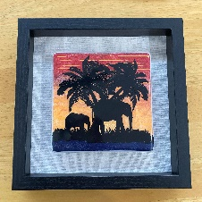

**Silk Screen Fused Glass Art Panel $120**

**3 Sessions:**

**April 13th, 20th, & 27th @ 6pm – 9pm.**

In this class you will learn how to make a 6x6in fused silk screen glass panel using the Glass Line Paint and EZ Fire enamels. The creative process will be divided into 3 sessions. Find the agenda for each session on our website.

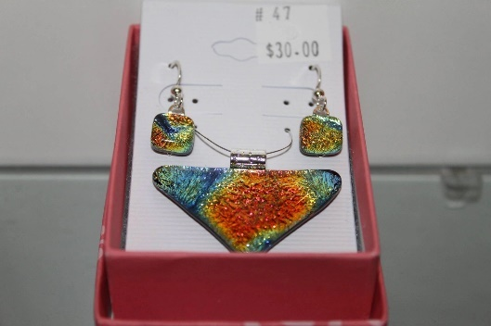 **Fused Glass Jewelry $40**

**April 15th @ 6-8pm**

Make dazzling Dichroic fused glass gems for a pendant, earrings or more. Learn the basics of glass fusing. No experience is necessary. Pick up your piece after one week. *Decals and multiple firings extra.

**Stained Glass Copper Method**

**$120 + Glass**

**April 17th @ 9am – 6pm**

Take this stained glass class in just one day from 9am - 6pm. You will create on project and take it home after learning how to design the piece, cut and grind the glass then solder the pieces together. Must be 18 Years old.

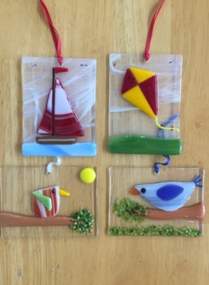**Fus****ed Glass Sun Catcher $18**

**April 22nd @**

Make one fused glass sun catcher to hang in your window or wall in this fun fusing class. All ages welcome and no experience is necessary. These are approximately 3x4” & 3X3” pieces.

**Stained Glass Flower Panel $60**

**April 24th @ 10am – 1pm**

Select from a beautiful selection of stained glass to make a beautiful stained glass flower panel for your window or wall. At the end of class, you will get to take home your creation.

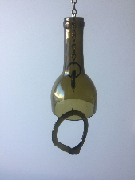

**Wine Bottle Wind Chime $30**

**April 29th @ 6-9pm**

Make a beautiful wind chine from a wine bottle. Learn how to cut the bottle with the tools we sell in the store. If you love this craft, you will be able to do it right at home.

.

**You must sign up at least 24 hours in advance of classes. Cancelation of classes must be 48 hours before class.**

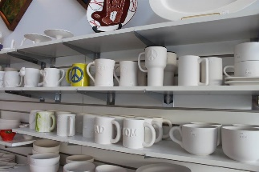**Book a Private Party:**

Reserve our party room for your special occasion to paint ceramics or participate in our many glass or painting classes. For a small fee of $25, you can bring cake, punch, snacks, and alcoholic beverages to enjoy during your party. You may also order food from one of the local restaurants on the square. The best part, we do all the clean-up for you!