**Fused Glass Jewelry $40**

**Sept. 2 @ 6 – 8pm**

Make a dazzling Dichroic fused glass gems for a pendant and earrings. Learn the basics of glass fusing. No experience is necessary. Pick up your piece after one week. *Decals and multiple firings extra.

**Fused Glass Spoon Rest $40**

**Sept. 9th @ 6 - 8 pm**

Learn how to cut curves in glass and assemble a fused glass spoon rest. All materials are included. *Decals and multiple firings extra.

**Stained Glass Lead Came Method**

**$120 + Cost of glass**

**Sept 11th @ 9am – 6pm**

Take this Stained Glass Class in just one day, from just 9 am to 6pm. You will create one projects and take it home after learning the basics of stained glass including designing a piece, cutting glass, grinding the glass and then assembling the piece with lead came. Must be at least 16 years old. Please Bring small box for your glass scraps. Come in to pick out your glass and pattern before the day of the class.

. 

**Fused Glass Picture Frame $60**

**Sept. 16th @ 6-9pm**

Make one fused glass picture frame in this fun fusing class. No experience necessary.

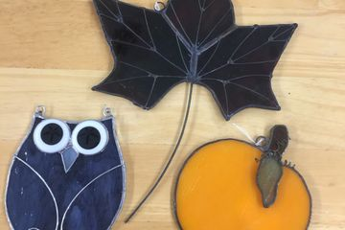**Stained Glass Fall Sun Catcher $35 Sept. 21st @ 6-9pm**

In this 3-hour class students will be taught basic stained-glass construction including cutting, foiling and soldering. Create a stunning fall shaped sun catcher. Great for beginners!

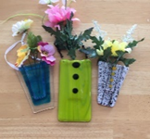**Fused Flower Pocket $45**

**Sept. 23rd @ 6-9pm**

Learn the inside and out of how to successfully make a fused glass pocket vase. The decorative options when combining texture and function are truly endless. This class will provide all you need to know to create a one of a kind decorative pocket vase

Don’t forget your tickets for Wine Witches & Brew

October 29th

**You must sign up at least 24 hours in advance of classes. Cancelation of classes must be 48 hours before class.**

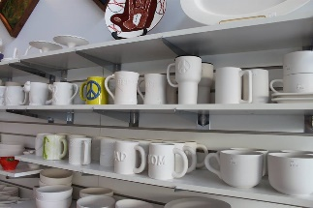**Book a Private Party:**

Reserve our party room for your special occasion to paint ceramics or participate in our many glass or painting classes. For a small fee of $25, you can bring cake, punch, snacks, and alcoholic beverages to enjoy during your party. You may also order food from one of the local restaurants on the square. The best part, we do all the clean-up for you!