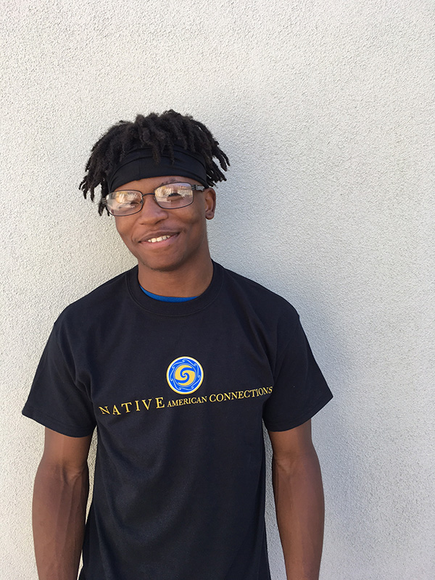

Rashiem

Rashiem was experiencing homelessness a year and a half ago. He reached out to his high school counselor who referred him to HomeBase, Native American Connections’ (NAC) homeless shelter for youth where he received life skills. The staff helped Rashiem transition into Saguaro Ki, a transitional housing program for youth, located next to HomeBase.

“HomeBase provided me with goals and gave me resources to find a job, do better in school, and gave me clothes and food,” said Rashiem. “I saved money to transition into Saguaro Ki, and they motivated me to become successful. The staff here has had a huge impact on me and made me want to become a better person.”

A lot of homeless youth don’t know what to expect of HomeBase when they begin living in a shelter. “I would tell anyone coming to HomeBase to stay focused,” said Rashiem. Don’t get involved with bad things. Listen to the staff and follow the rules since it’s very easy to slip up.”

Through case management and life skills in job and education, Rashiem is continuing to improve his life in getting an apartment, car, and attending college.