The Do’s and Don’ts of Warehouse Safety

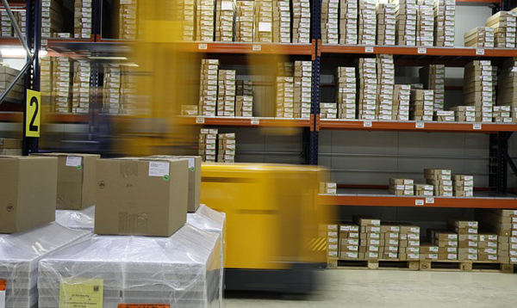

A man’s eyes infected by sawdust, employee operates the forklift incorrectly, one saws his own finger off accidentally – what do they all have in common? All of these are dangerous hazards that can occur in a warehouse. Without proper warehouse safety training, many employees can suffer from multiple injuries and even death. In 2017 there were a total of 28 fatal injuries in just the state of Arizona according to the Bureau of Labor Statistics https://www.bls.gov/iif/oshwc/cfoi/tgs/2017/iiffw04.htm. Although every warehouse is different, here are some general safety tips employees should follow while working in this environment.

Operating the Forklift
No one wants to get run over by a forklift! According to OSHA, an average of 100 employees are killed and 95,000 injured every year while operating the forklift. Employees need to be trained and certified in order to be allowed to operate the forklift safely. Part of the training includes the following:
- Examining the condition of the forklift including tires.
- Inspecting aisles and surroundings for crowdedness.
- Ensuring ventilation of warehouse to keep concentration of gases from engine exhaust below acceptable limits and much more!
Employees should be aware of their surroundings when driving to avoid any injuries to their coworkers.
Docks
No one wants to get struck by falling equipment or get pinned by a forklift operator. Ouch! Forklift operators need to learn to drive slowly on the dock plates and make sure that the docks are secure. They also need to know if the plate can support the load. Dock ladders and stairs need to meet OSHA specifications as well. Visual warnings should be easily seen near the dock edges to prevent people from getting near the docks.
Conveyors
When conveyors are mishandled, employees can suffer from musculoskeletal disorders and even get hurt from getting caught in pinch points and hit by falling objects. Follow the Lock Out Tag Out (LOTO) procedures that require employees to disengage and lock out during maintenance or cleaning. Another tip people should be aware of is to be aware of what they are wearing so that they don’t get entangled in conveyor equipment.
Manual Lifting and Handling
Many bodily injuries can occur when lifting equipment and boxes that are too heavy for the employee to handle. If no one is around to help you lift a heavy object, you can use powered equipment to avoid injury as long as you can operate it safely. Never try to lift an object that you can’t handle. Always test it out by lifting the load slowly and get the feel of handling it properly. When lifting and loading, make sure the floors are clean and avoid twisting while carrying a load as it can lead to possible musculoskeletal disorders. Ergonomics and physical work training should be implemented when working in the warehouse.
Hazard Communication and Handling Dangerous Chemicals
Imagine getting your skin burnt from a chemical spill? It is highly recommended to follow and maintain a Material Safety Data Sheet when you’re handling each chemical in the facility. Proper training in storing them, disposing, cleaning spills and handling them is needed to avoid any accidents that may occur.
Charging Stations
Without proper guidelines, fires and explosions can occur in charging stations. It goes without saying that charging stations should be away from any open flames. Fire extinguishers that are fully charged should be available in any case of fire. When using these stations, Personal Protective Equipment (PPE) should be worn to protect employees from getting exposed to acids. A good ventilation system needs to be installed when these stations get used since lots of fumes get dispersed from gassing batteries.
Materials Storage
Another fatal accident that can occur is when materials are not stored properly on the shelves. Workers needs to stack loads evenly to avoid any objects dropping on their heads. When a worker needs something, they should remove one object at a time from the shelves. It is best to make sure your surroundings (aisles and passageways) are clear so that you don’t trip and risk an injury when storing and removing materials from shelves.
Energized Equipment
To ensure the safety of your workers around electrical equipment, a Lockout/Tagout (LOTO) program must be put into effect. This program consists of procedures that teach employees how to properly shut off electrical equipment and prevent them from releasing hazardous energy during maintenance and servicing activities. The last thing a company wants to deal with is not only damaged industrial equipment but the loss of an employee as well due to electrocution.
Warehouses may be dangerous to work at but with provided training and proper safety techniques, employees will feel safer working in a healthy environment. Imagine a warehouse with no training on handling equipment and maintaining cleanliness? More people would climb on loose ladders, workers slipping on debris and other freak accidents would occur! All of these tips contribute to higher profits and less injuries which is why OSHA requires these procedures to be part of their regulations. Of course there are more guidelines OSHA would want businesses to follow, such as avoiding loose clothing and making sure emergency exits are marked, but these tips are a good start. Let’s continue making the warehouse a safe environment to work!

Top 5 Reasons to Own an Energy Efficient Car Wash Dryer

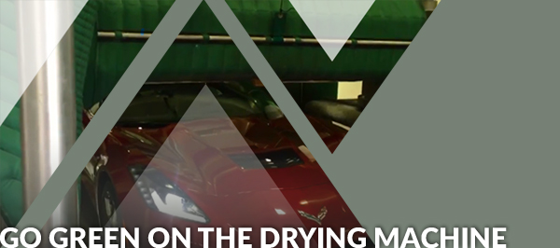

I’m sure some of you aren’t invested in the “go green” movement but more and more people are choosing to save energy now. To some people, the thought of saving energy is broad and does not apply to them. I have heard people saying that they just want a car wash dryer that works and do not care much for energy efficiency. Electricity can easily be taken for granted and the next thing you know, you receive an electric bill for $500,000 – okay maybe not that much but you understand what we’re saying. Here are our top reasons on why you should own a dryer that uses low horsepower for your car wash.
LOWER ELECTRICAL BILLS
It’s a no-brainer: Using less energy saves you money in the long run. It has been repeated many times in all of the energy consumption articles you have read but it is a pretty important reason that cannot be ignored. Who wouldn’t want to save money for their business? There are more reasons to save energy that extend beyond the obvious in cutting back on your bills.
SAVE CONSUMPTION OF THE EARTH’S LIMITED RESOURCES
Electricity is generated using methods that hurt the environment so if we can reduce the demand of it, the emission of harmful pollutants will lower as well. Consuming less energy will have a better impact on the Earth and even wildlife. Operators do have options available to make their new or existing systems more energy efficient. The manner in which the system is started, the frequency of start-ups and energy expenditure between vehicles are all areas that an operator should focus on to effectively control the use of energy. Some products that aid in energy savings are AirGates® and VFD systems.

INCREASES PRODUCTIVITY
You can use motors with low horsepower without sacrificing drying quality and performance. For example, Proto-Vest uses motors equipped with impellers that exert more volume, pressure and control the airflow better. A good dryer with energy efficient add-ons enable us to do more while using less energy.
LESS WEAR ON YOUR EQUIPMENT AND BANK ACCOUNT
Just like with a Proto-Vest dryer, equipment lasts longer when you add products to lower the ramp up time of a motor. Without any control devices or equipment that can control the use of your motor, you would not only be spending more on electrical costs but you would be replacing the motor quicker than usual. It takes a lot of patience and diligence to maintain a car wash dryer but who wants to constantly stress about replacing the motor and spending a lot of money in a short amount of time?

YOUR HEALTH IS A TOP PRIORITY
This is an issue we often forget! Climate change is a concern. Having less pollutants circulating in the air means that you and your coworkers are breathing better air. Don’t forget to take care of yourself in your car wash environment.
Want to avoid these possible issues for your car wash? If you haven’t already, start going more green today! Energy conservation is very beneficial for car wash businesses and other industries. You can save money, increase your productivity, protect your health and the environment all through energy-saving measures. Enjoy all of the perks of being energy efficient by becoming more energy-conscious of your car wash business!

