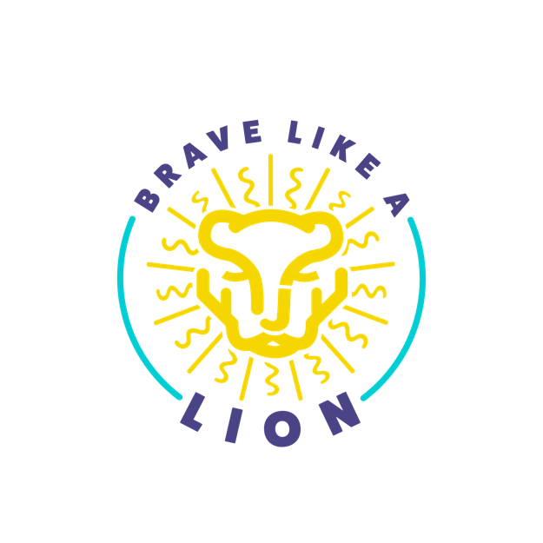
Thank you for applying for our Intensive Scholarship Program. Please answer these questions to the best of your abilities. Each question helps us determine eligibility for the scholarship. In addition to this questionnaire, please attach an additional write up telling us about your child, your family, your history with intensive therapy, and any additional info you would like to be considered in the scholarship evaluation process.

The Brave Like A Lion Scholarship is intended to assist families in attending intensive therapy programs using licensed clinicians performing Physical Therapy,Occupational Therapy, Speech Therapy or a combination of these services.

Childs Name:

Child’s Date of Birth:

Parent/Guardian/Contact Person’s Name:

Contact Phone Number:

Contact Address:

Contact Email Address:

Please List All Active Therapy Diagnoses (Examples; Cerebral Palsy, Prader Willi Syndrome, etc)

Have you been scheduled for an Intensive in 2026?
If yes, where and when will this service take place?

Who will be attending the Intensive with the child?
What services will be used in this intensive and for what frequency (PT,OT, ST, etc-how many

hours per day, how many days per week, how many weeks)?

What is the expected financial cost for this intensive as charged by the provider?

What is the total expected expense of intensive to family including travel expense, lodging, therapeutic services mentioned in the previous question, etc?

How much funding have you raised to date for this experience?
How many intensives has this child participated in in the last year? Please list those

opportunities, dates and location.

Does this child receive weekly therapy sessions routinely? If yes, please list those services and frequencies.

Is your weekly therapist in collaboration with the intensive program?
Would your weekly therapist/s be willing to write a recommendation for this intensive

scholarship?

Would you pediatrician be willing to write a letter of recommendation for this intensive

scholarship?

Family Demographics

How many individuals are living in home with this child? Please Describe the family dynamic.

What is the combined Adjusted Gross Income for the home as reported to the IRS for the last

tax season?

Developmental Motor Skills

Can the child stand unassisted (no device or caregiver support)?
Can the child walk unassisted (no device or caregiver support)?

Can the child walk using a Device? If so, what kind of assistive device?
Can the child sit unattended?
Can the child roll each direction?
Can the child crawl?

Can the child roll?

Can the child lift their head if in quadruped (on all 4’s)?

Has the child been identified as a “Problem Feeder” by physician?

Does your child eat at least 30 different total foods?

Does your child independently use a spoon/fork?

Does the child have a G, J or NG tube?
How many words does the child currently use verbally?
Does the child have an augmentative and alternative communication device (AAC)? If so

please describe.

Do you have a current swallow study?

Does your child have any sensory processing differences? If yes, please describe?

Does your child independently complete any daily activities such as brushing teeth, bathing, morning routine, etc? If no, describe independence level.

What are your hopeful outcomes of attending the Intensive described previously?

Please attach any additional information about the child, family, intensive history, functional abilities or any other info you would like to have considered in determination of this scholarship. We love seeing your pictures!

The Brave Like a Lion Scholarship is a product of the Resilient Arrow Project (501C-3). It was established in 2023 to assist families as they attend Intensive Programs in memorial to James Ryan Henson, Jr. All donations to this foundation are tax deductible. All proceeds are contributed to the therapy community.

