**Level Up**

Day 1

Blessed Love, Blessed ones!

**To level up in spirit, we must prepare our heart and transform our thoughts through love.**

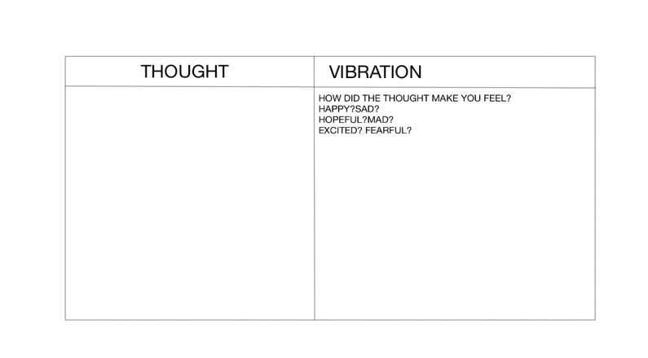Every thought has a frequency. This means that every thought has a vibration, an energy that vibrates through you and goes out into the universe.

What “random” things do you think about?

Are they random?

What mood does your thought put you in?

What perspective is your thought coming from?

To the Right is a chart of two lists. You can recreate this list on paper, on a free notes or doodle app on your phone.

Throughout the day you are going to track your thoughts. If possible set five alarms for you to stop and write down what you were thinking right before the alarm went off. This does not have to be full sentences, the most important thing is to capture the *feelings or desires or visions* in that moment.

Next to each thought you will write, positive (+), negative (- ) or neutral (*)

At the end of the day before you go to bed, review this chart. Take a mental note of how many + and – you see.

How do they reflect your current mood at the end of your day?

**Challenge** yourself to change the neutral (*) thoughts to positive or negative. To help yourself decide which it should become, take a moment to think about the universal impact of the thought..

*Every thought you have> holds a vibration> and makes an impact, even if it* *is never verbalized or acted upon.*

Impact

Vibration

***Repeat this exercise for 5 days, paying close attention to your +, -, and \*****.*

**At the end of the week**, **review your chart**: Which symbol shows up the most?

Thought

How do you think that mirrors or matches the energy you deal with on a daily basis in your life?

It is normal to have thoughts that are all over the place or constant. It is important to understand what these thoughts do to you, your surroundings and those who surround you.

**A transformation**: Go through your chart for the week. For every negative thought, think of a way to flip it to positive. Say the positive version aloud.

Time travel is done in the mind. We are able to create positive vibrations by changing our thoughts.

No matter the situation, it is important to think positively, and Vibe High!

-From, Your Spirit Guide