Level Up
Worksheet 1
Day 1-5
Blessed Love, Blessed ones!
To level up in spirit, we must prepare our heart and transform our thoughts through love.
Every thought has a frequency. This means that every thought has a vibration, an energy that vibrates through you and goes out into the universe.
What random things do we think about? Are they random? What state of mind do your thoughts put you in? Take notes on your thoughts throughout the next five days and complete the chart:
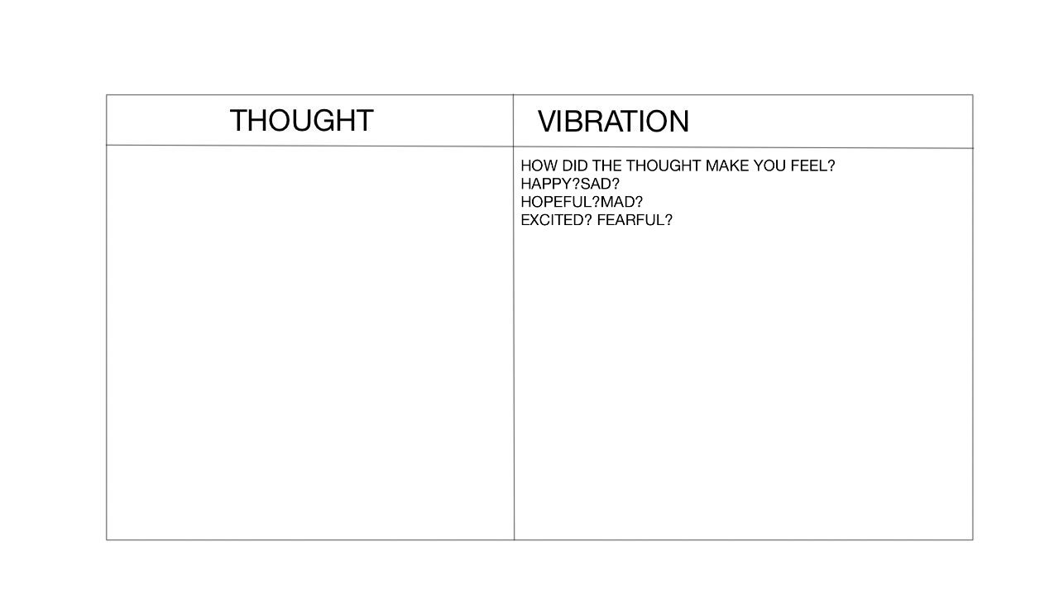
Now let us explore the impact of our thoughts. Below, write a positive thought you can think about every day under “thought”. Under “Vibration”, write what vibration would this thought send out. Under “Universal Reaction”, write what could be the universal reaction.
