Level Up
Worksheet 2
Day 6-10
Blessed Love, Blessed Ones!
It is said that 10% of our minds are conscious and the other 90% is subconscious. The 90% holds life situations, environmental factors and trauma that have caused us to establish a finite identity of who we are.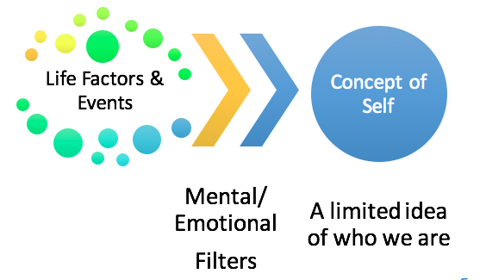

Energy is infinite therefore so are we.
Think of events in your life that have caused you to limit your idea of yourself.
Use this space and time to recall a positive or negative event that impacts your life.

What benefits do you hold from this event?

What benefits can you gain by releasing emotional attachment from this event?

Even positive characteristics can limit us. Categorizing ourselves through strict labels, titles or specific life roles can constrict our abilities to learn and grow. What limitation can you break through? Choose one “box” to step out of throughout the next few days. If choosing to commit to a spiritual program is already a step out of your box, continue in that walk.

