Level Up
Worksheet 5
Day 21-25
Blessed Love, Blessed Ones!
Now that we have begun to take note of what we create around us, let’s tune into the most important place: inside of us. Below is an empty diagram of a person and 7 of their chakras-or energy wheels. If you are able to print out the page, you may color in the energy wheels their respective colors.
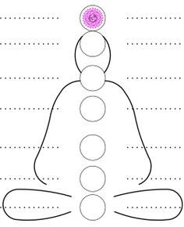
Starting from the lowest row of dots and circle, begin numbering the rows 1-7. Write the number in front of the line to the left. Numbering 1 through 7 beginning at the bottom row. Our number 7 should land at the dotted top line, in front of the purple top chakra.
Now we can know which chakra we are speaking about by number. As we name the chakra, write the name on the line to the left and the phrase given on the line to the right.
Let’s use the first Chakra as an example:
Chakra 1, is the Root Chakra, it is Red. “I am”.
You have written 1 in front of the bottom left dotted line, write “Root “on this left dotted line and “I am” on the dotted line to the right. Color the circle-or wheel-red.
1.Root
I am .

Do this for every chakra as you go up.
Our 2nd Chakra is our Sacral Chakra. It is Orange. “I feel”.
Our 3rd Chakra is our Solar Plexus Chakra. It is yellow. “I do”.
Our 4th Chakra is our Heart Chakra. It is Green. “I love”.
Our 5th Chakra is our Throat Chakra. It is Blue. “I speak”.
Our 6th Chakra is our Third Eye Chakra. It is Indigo. “I see”.
Our 7th Chakra is our Crown Chakra. It is Purple. “I understand”.

For the next few days think about how you would complete these phrases. I am, I feel etc. We will revisit this rainbow, our energies, in our next worksheet!

