“Modern Pentecostal Women” Dr. Kristen Welch, Director of Archives & Research, IPHC
- April 9, 1906, Beginning of the Azusa Street Revivals *120 years ago this year!*
Women’s History
Latter Part of the 19th Century: The Cult of True Woman ideal holds sway (i.e. woman is the moral guide in the home). This ideal fueled reform efforts, such as in temperance, abolition, and suffrage, and gave wealthier white women a leadership role in society, particularly after the Civil War. They were “deeply engaged in very public affairs, writing for newspapers, giving speeches, raising money, founding charitable institutions, and lobbying political bodies.” Putting women in the pulpit was not just a matter of obtaining the right to follow God’s call, but it was a political tool.
We have women like Frances Willard (Methodist), head of the Women’s Christian Temperance Union, published Woman in the Pulpit in 1888 as part of her “do everything” approach: preaching, education, and lobbying (pulpit, position, politics) to help women work towards social equality. Preceding her was Catherine Booth (Salvation Army) with Female Ministry: Woman’s Right to Preach the Gospel, published in 1859 and Phoebe Palmer (Methodist and Founding Mother of the Holiness Movement), Tongues of Fire on the Daughters of the Lord, published in 1869, and Julia A. J. Foote (Pioneer of the African Methodist Episcopal Zion Church) with “Women in the Gospel” (Chapter 20 of her autobiography, A Brand Plucked from the Fire, published in 1881. These texts are examples of the multiple purposes motivating the arguments for women to preach in the 19th century.
Poor white women and most Black women faced hard labor and sometimes abuse. For example, mill work was brutal. Many women found themselves in cotton mills. They experienced terrible working and living conditions, long hours, little food, no education (children worked in the mills too), and no hope. The Lowell Offering, published in the 1840s, exposed the realities of this work as did Rebecca Harding Davis’ Life in the Iron Mills, published in 1861, but it’s not until 1938 that the Fair Labor Standards Act passed Congress and limited the workday, set minimum wage, and effectively ended child labor as well.
White women made progress as the last of the Coverture laws were overturned in the 1880s. These laws took away a woman’s right to own property, to serve on a jury (it’s 1975 before women obtain equal representation because they can’t automatically opt out of service), to testify in court (her testimony did not count until she gained the right to serve on federal juries in 1957), to divorce and retain custody of her children, to keep the wages she earned, and to be protected from spousal abuse. However, women still could not practice law, obtain an equal education, and were effectively banned from many professions.
Black women may have experienced slavery and were likely to have parents who experienced it. The Civil War ended only 41 years before the Azusa Street revivals. The intersection of race, lack of access to education, economic distress, fear of violence (lynching continued until 1968 and involved almost 5,000 people –although many were not reported), and a lack of political power.
It took the Ku Klux Klan Act of 1871 to suppress some of the violence towards African-Americans. Jim Crow Laws were still in effect, and African-Americans were portrayed as lesser beings as the norm in American culture. It was illegal for a white person to marry a Black, Asian, or Native American person. Virginia passed the first anti-miscegenation law in 1861. 38 states had laws against interracial marriage at one point, but this was finally overturned in a Supreme Court case, Loving vs. Virginia, in 1967. Ida B. Wells-Barnett gives her speech “Lynch Law in All Its Phases” and publishes it as a pamphlet in 1892 and 1893, once giving her speech at the invitation of Frederick Douglass at the Metropolitan African Methodist Episcopal Church in Washington, D.C.
Jobs for Women
Domestic, Seamstress, Teacher, Mill Worker, Laundress, Boarding House Keepers, Weavers, “Sweated Industries/Sweatshops”—make clothing, nails, chains, etc., Agricultural, Clerical (typists, stenographers, bookkeepers). Very few worked as journalists, writers, nurses, doctors, or artists. It was uncommon for them to hold positions of authority in the workplace.
Why are these contexts important?
It is vitally important to understand that Azusa Street did not actually create a place of equality for men and women and for people of all races. The impetus for Blacks to form their own denominations is evidence of the fact that while practices differed temporarily, they did not change everyone’s perspectives on race, intellectual ability (for women in general as well as for African-Americans), and ability; instead these revivals planted the seeds that grew into true opportunities for equality and watered the seeds others who came before them had already planted. Contemporary scholars usually acknowledge the romanticization of Azusa Street, and it’s important to understand the levels of cultural defiance occurring here as well as the continued battles for equality that came after, which gained ground in stages in the decades to follow and that are still being fought today.
- 1908, William B. Fuller leaves the PHC to form the Fire Baptized Holiness Church of God of the Americas
- 1913, the “Colored Convention” had been formed to accommodate racial divisions. This became Gethsemane Pentecostal Holiness Church.
- 1914, the Assemblies of God forms and ordains white ministers, breaking away from the Church of God in Christ, founded by two Black men, Charles Mason and J. P. Jones in 1897. It became Pentecostal after Mason went to Azusa Street in 1907. They originally ordained both Black and white ministers.
Suggested reading:
Sherry Sherrod DuPree, Biographical Dictionary of African-American, Holiness-Pentecostals, 1880-1990, published in 1989.
Estrelda Alexander has published several books on African-Americans and Pentecostalism.
There are many books on the history of Azusa Street. Vinson Synan, Dan Woods, and Doug Beacham are IPHC historians worth reading if you want to learn about the IPHC’s early history and leaders. Joseph Campbell also was an IPHC historian. Searching The Advocate and the General Conference minutes, as well as regional conference minutes, is also helpful. The Advocate and General Conference minutes are on the Pentecostal Consortium: https://pentecostalarchives.org/
Want to go further back?
Excavating Women: The Archaeology of Leaders in Early Christianity by Carina Oliveira Prestes (2025)
The Female Mystic: Great Women Thinkers of the Middle Ages by Andrea Janelle Dickens (2009)
Brekus, Catherine A. Strangers and Pilgrims: Female Preaching in America, 1740-1845. Chapel Hill: U of North Carolina P, 1998.
Campbell, Joseph. The Pentecostal Holiness Church, 1898-1948. The Publishing House of the Pentecostal Holiness Church: Franklin Springs, GA, 1951.
Cott, Nancy. The Grounding of Modern Feminism. New Haven and London: Yale UP, 1987.
Cox, Harvey. Fire From Heaven: The Rise of Pentecostal Spirituality and the Reshaping of Religion in the Twenty-first Century. Cambridge, MA: Da Capo P, 1995.
Hyatt, Susan. “Spirit-Filled Women.” The Century of the Holy Spirit: 100 Years of Pentecostal and Charismatic Renewal 1901-2001. Ed. Vinson Synan. Nashville: Thomas Nelson, 2001. 233-64. Important precedents to PHC women leaders:
- Phoebe Palmer (1807-74), Methodist,
- Catherine Mumford Booth (1829-90), Salvation Army,
- Hannah Whittall Smith (1832-1911), Quaker,
- Amanda Berry-Smith (1837-1915) (African-American), preacher/evangelist.
Scanzoni, Letha Dawson, and Susan Setta. “Women in Evangelical, Holiness, and Pentecostal Traditions.” Women and Religion in America: 1900-1968. Ed. Rosemary Radford Ruether and Rosemary Skinner Keller. San Francisco: Harper and Row, 1986. 223-65.
Stanley, Susie C. Holy Boldness: Women Preachers’ Autobiographies and the Sanctified Self. Knoxville, TN: U of Tennessee P, 2002.
Schneider, Carl J., and Dorothy Schneider. “The Holiness and Pentecostal Churches: 1900-1960.” In Their Own Right: The History of American Clergywomen. New York: Crossroad P, 1997. 150-75.
Lindley, Susan Hill. “You Have Stept Out of Your Place”: A History of Women and Religion In America. Kentucky: John Knox, 1996.
Her Story by Barbara McHaffie

Prophetic Pentecostalism
The Fire Starters: Preachers, prophets, evangelists, missionaries, itinerant preachers, “Mothers in Israel” (Judges 5:7)
The emphasis on Joel’s prophecy was not invented on Azusa Street. It fueled the Second Great Awakening in the 19th century, when they believed that the turn of the century would bring Christ’s return and that women should speak because it was the lasty days, predicted by Joel (Schneider and Schneider 37-38). In 1827, Charles G. Finney (1792-1875) insists women must speak before “promiscuous assemblies” for this reason (Schneider and Schneider 38). Finney’s second wife, Elizabeth Ford Atkinson, was famed for her ministry to women at ladies’ meetings. Finney’s Oberlin (a college established in 1833 and the first to admit students of color in 1835 and the first to admit women in 1837) has students Antoinette Brown, Lucy Stone, and Salley Holley, whose 1851 graduation speech advocated for a woman’s right to speak and to preach (SS 38). The revivals of the Second Great Awakening are noted for allowing women to speak, as well as for Blacks and whites to mingle, as well as for being open to the poor (SS 38-39). Antebellum revivals were like the “rock concerts” of the day – complete with concession stands and all sorts of people –good and bad—in the crowds, but they gave itinerant women evangelists a chance to preach (SS 40). However, it’s Holiness women who claim the right to preach is based on the inspiration of the Holy Spirit (SS 42). Credentials were “spiritual” not “educational” in both Black and white holiness groups (43).
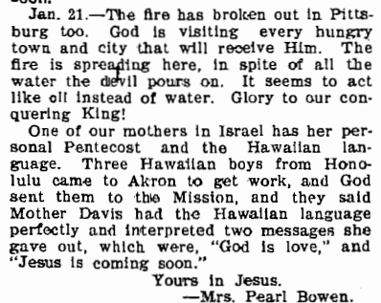
January 1907, The Apostolic Faith

Key themes of Azusa Street:
- Divine healing. The Apostolic Faith newsletters record numerous healings. It becomes the center of many women’s ministries in the first half of the 20th century.
- The desire to evangelize the world is paramount. Numerous accounts of people being miraculously able to speak in other languages fill The Apostolic Faith newsletters. People set off for other countries with nothing in their bank accounts but faith. The rhetorical effect of naming place after place after place where “Pentecost” has come is to give the impression that something immediate and world-changing was happening that required a Christian’s immediate attention. Hurry! Hurry! Hurry! Jesus is coming!!!
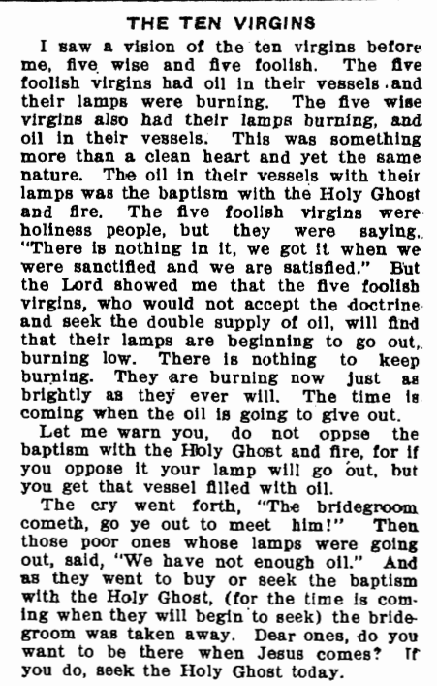
From November 1906, The Apostolic Faith
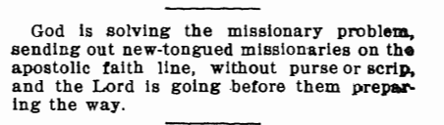
From November 1906, The Apostolic Faith
- 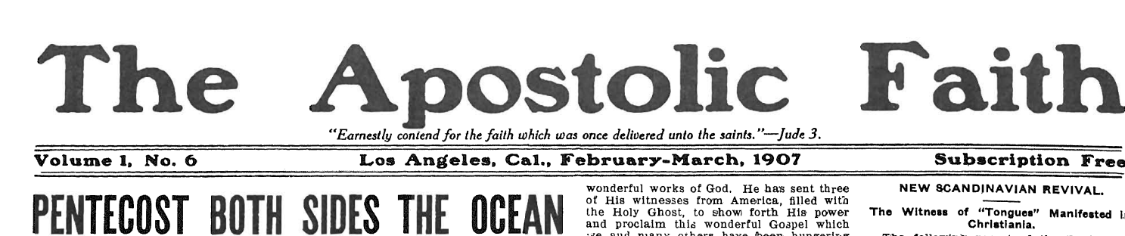
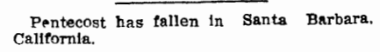
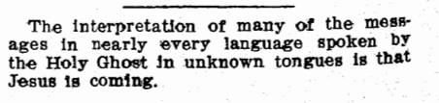
Both from May 1907, The Apostolic Faith

- April 1907: Pentecost has come to Monrovia, Liberia; Brixton, London; Beli Vernon, PA; Durham, NC; Springboro, PA; Calcutta, India; Mobile, AL; Alvin, SC:
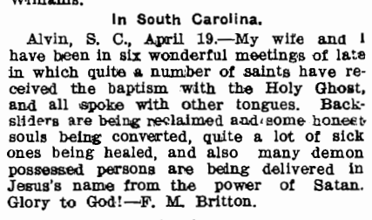
F. M. Britton is one of our early leaders.
Lincoln, PA; San Diego, CA; Dayton, OH: San Antonio, TX; Skovde, Sweden; Honolulu; Homestead, PA; Fort Worth, TX; Toronto, Canada.

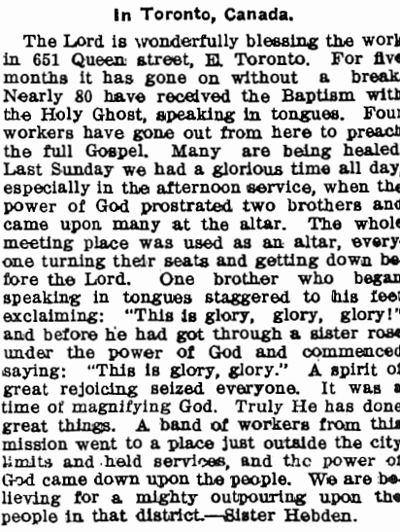
From the April 1907 edition of The Apostolic Faith:
The first Canadian to speak in tongues was Ellen Hebden. She spoke in tongues on November 17, 1906, and then launched the East End Mission (Sloos 181). Hebden’s experience led to three and a half years of revivals, attracting thousands of seekers (181-182). It is notable that “influential Pentecostal leaders attended the Hebden services; they included Frank Bartleman, Aimee Semple McPherson, and William Durham, as well as future Pentecostal Assemblies of Canada leaders such as George Chambers, R. E. McAlister, Arthur Atter, and A. H. Argue” (182). Canada’s first Pentecostal missionary family, Charles and Emma Chawner, were launched from there (182).

In this same edition, there’s a piece by B. H. Irwin, founder of the Fire-Baptized, who merged with the PHC in 1911.
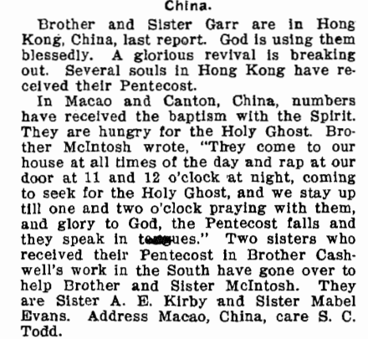
In the October 1907 edition (mislabeled January 1908 by The Apostolic Faith publishers), they list: Denmark, Germany, Wales, Honolulu, London, China, Sweden.

Brother Garr helps found the Assemblies of God. In the text, two women who received the baptism in a revival with the IPHC’s Cashwell are mentioned.

- In the May 1908 edition, they list these countries as having received the message of the baptism of the Holy Spirit: Ireland, England, China, West Africa, Australia, Scotland, Jerusalem, Sweden, India. In the January 1908 edition, U.S. cities that have received the news are listed: Indianapolis, IN, Norwood, OH, Atlanta, GA, Hill River, MN, Utica, NY, Linn, MA, Dallas, OR (Yes, Oregon, not TX), Portland, OR, Stockton, CA, Shenandoah, IA, Concord Junction, MA, Strole, VA, Portsmouth, VA, Richmond, VA, Philadelphia, PA, Swanton, OH, Minneapolis, MN, St. Paul, MN, Baltimore, OH (Yes, Ohio not Maryland), Denver, CO. G.B. Cashwell and F. M. Britton are having revivals: 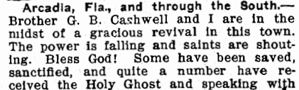
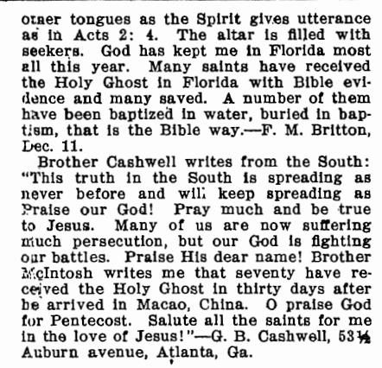
- The Mukti (salvation), India revivals are reported in June 1907 and September 1907 editions of The Apostolic Faith. Pandita (Pantida is the word for teacher; it’s not a name) Ramabai and the Methodist Miss Abrams are leading these. In Pune, India (Bombay), Pandita Ramahai’s (1858-1922) Mukti Mission in Poona experienced a woman-led revival (no missionaries) whose followers included young women “baptized by the Spirit” who had “seen visions, fallen into trances, and spoken in tongues” between 1905 and 1907 (Anderson 36; 172). Pandita Ramahai was an early feminist who advocated for women’s education (Suarsana 41). She went to the U.S. and returned to India, working closely with Minnie Abrams, a white Methodist woman. The revivals at the Mukti Mission, a home and training center for widowed women, were inspired by the Welsh revivals and the Azusa Street revivals (54).
- The belief that they were about to witness Christ’s return and enter into 1,000 years of peace dominated early Pentecostal theology. This is also evident from Azusa Street, as we read in The Apostolic Faith newsletters.
- Tongues were a way to communicate in languages unknown. Here is an excerpt from the December 1906 The Apostolic Faith that shows both:
- 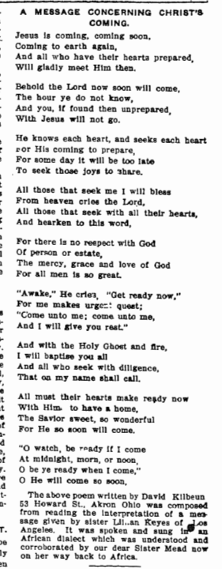

- Outsiders ridicule what’s happening. This leads to a sense of shared persecution; drawing upon Paul—this makes it seem to be more likely to be of God.
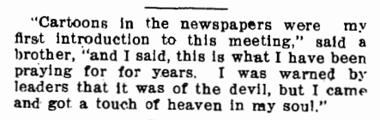
This draws some people in:

From November 1906, The Apostolic Faith
- Children getting saved and baptized is another key theme.
- Visions! There are numerous visions:
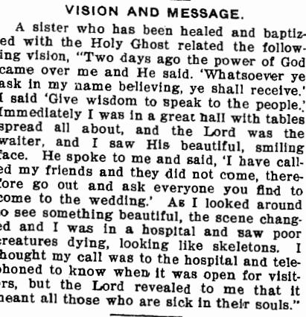
From November 1906, The Apostolic Faith
From The Apostolic Faith, 9/1906. Sister Anna Hall:
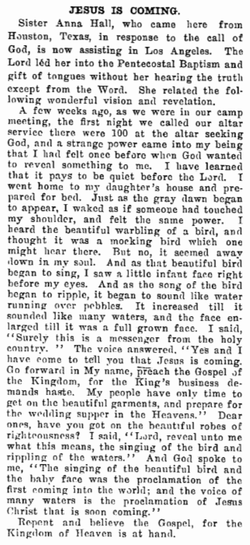
- There are “Mothers in Israel”: 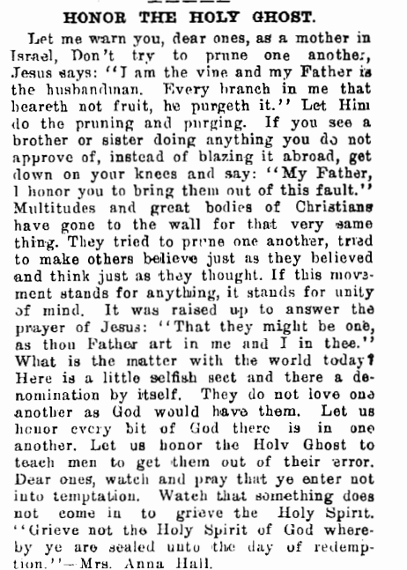

Pentecostal Women’s History: Before Azusa Street
- One of the most famous woman preachers in the International Pentecostal Holiness Church denomination was Agnes N. Ozman LaBerge. Born in 1870 in Wisconsin, Agnes begins her autobiography by describing herself as “evangelist” and “missionary.”¹² As such, she became a wanderer, much like the Yorks, traveling from place to place to preach and convert. It is possible that part of the authority used by early Pentecostal preachers was derived from the fact that they were often strangers among the people they hoped to convert. At Bethel College in Topeka, Kansas, she prayed for about three weeks for the baptism of the Holy Spirit and received it on New Year’s Day, 1901.¹³ She soon traveled to Houston, Texas, and heard the soon-to-be-famous William Seymour preaching. As a preacher ordained by the IPHC in Oklahoma, the very first person of the twentieth century to experience both baptism and tongues at the same time, and as an indirect influence on William Seymour, Agnes N. O. LaBerge was an exemplar (Welch, “Rhetoric, Religion, and Authority”).
- LaBerge picks up on a popular phrase: What God Hath Wrought, as the name of her autobiography, published in 1920/1921. Here is a reference to this phrase from the May 1908 newsletter, The Apostolic Faith, which reported the events on Azusa Street:
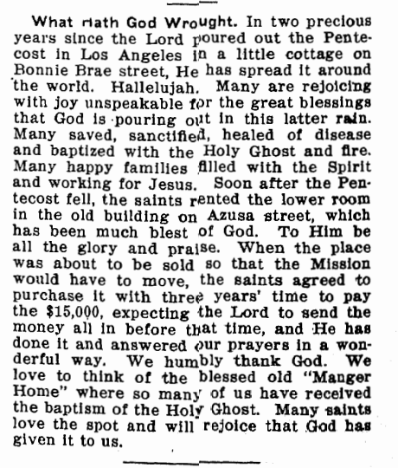

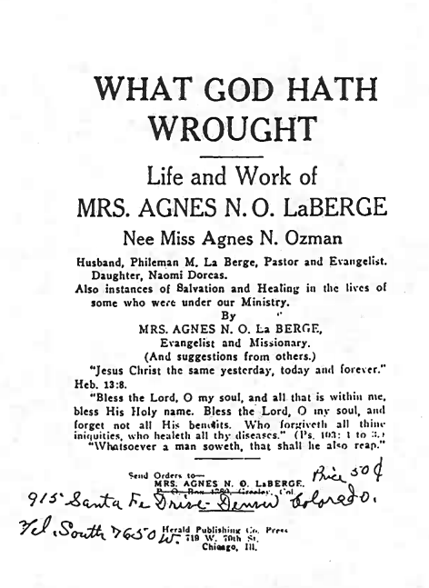
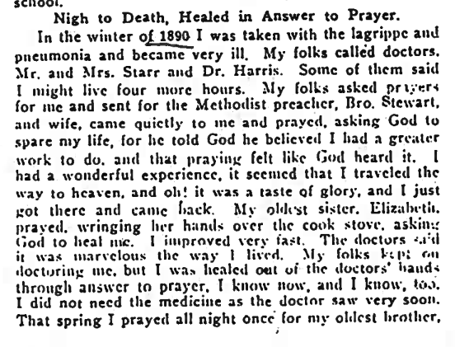
She dies and comes back to life or she has a vision.

Sections of her autobiography:
Birth and Childhood
Words to Children (she explains how Christ loves children in a scripture filled exposition)
School Life
Death of Mother
Subject of Baptism
Second Coming of Jesus
Divine Healing
Bible School
Kansas City, Kansas and Missouri
Notice the interplay of life story and teaching doctrine. In one chapter, she recounts her history. In the next, she preaches to the reader.
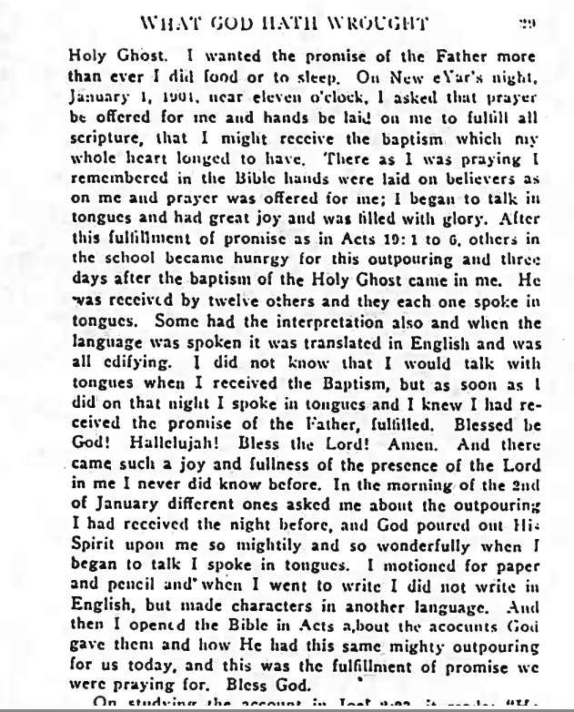

Pentecostal Women’s History: On Azusa Street
- Julia Hutchins both helps and undermines Seymour’s ministry. She’s the one who invites him to California from Houston but then decides his message of tongues as the evidence of baptism is incorrect (Alexander 22). She was a Black preacher who once pastored a Baptist Church in L.A. before she joins the Holiness believers and leased a space at Ninth and Sante Fe Street to preach. (24). The invitation actually came through someone else though. Her congregation was unhappy with her, so she reached out to Neely Terry. She calls on Seymour, and Seymour receives money from Charles Parham, the one who taught him the doctrine of tongues as evidence of the baptism. But after Seymour arrives, he preaches on Joel 2:28 and finds himself locked out of Hutchins’ church and without shelter (25-26). One of the families from the church, Ruth and Richard Asberry, who are willing to take him in happens to own the Bonnie Brae Street home where the Azusa revivals begin (27). However, later Hutchins goes to Azusa Street, believes she received the “gift of the Uganda language” and leaves for Africa in September of 1906 (27). The Apostolic Faith papers offer several writings by her. In 1918, she opens a facility for delinquent girls but it lasted only a year (34). She eventually returns to Atlanta (35).
- Lucy Farrow (Frederick Douglass’ niece) is sent by Parham (Seymour’s teacher in Houston) to Bonnie Brae Street from Houston because no one had received tongues despite Seymour preaching the message (Alexander 43). It is Farrow who ministers to the first person, Edward Lee, to receive the baptism on Bonnie Brae Street (44). She leaves by August 1906 to evangelize elsewhere (45). Later, Farrow is the one who is preaching and convinces Howard Goss, one of the founders of the Assemblies of God, of the tongues as evidence doctrine (45-46). Her work is reported in The Apostolic Faith papers, and it conveys a successful ministry as she evangelizes after leaving Azusa Street (47).
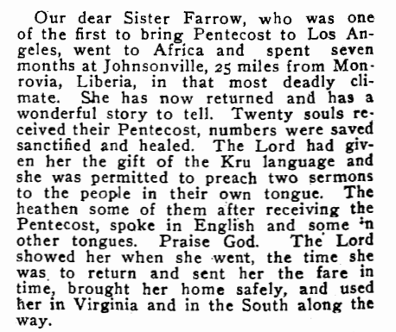
- From the October 1907, The Apostolic Faith
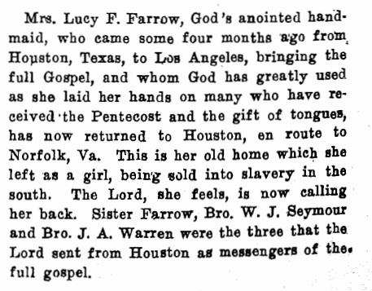
From The Apostolic Faith, LA, September 1906

- Jennie Moore (later Seymour’s wife) hears Seymour preach on Acts 2:4, falls on the ground, speaks in tongues in six different languages, each followed by an interpretation in English, and then plays the piano, although she was never trained to play (Martin 88). she spoke in tongues (195). She was the first Black woman to speak in tongues in the 20th century. This happened on Bonnie Brae Street, before the revivals had moved to Azusa Street. After Seymour dies, she assumes leadership on Azusa Street. She was a member of Hutchins’ congregation when she got saved (Alexander 194). Seymour died in 1922 and another preacher, a white man named R. C. Griffith, tried to take over (203). The court battle basically bankrupted the church and ended the ministry (203). The mission was lost to foreclosure (203).
- Clara Lum arrives on Azusa Street in May of 1906 and receives the baptism (Alexander 54-55). She writes The Apostolic Faith newsletter. 13 issues are available on the Pentecostal Consortium. There are about 50,000 on her mailing list, but when Seymour breaks her heart and marries Jennie—possibly because she is white and Mason, one of the founders of the COGIC advises Seymour to avoid the trouble that will come due to the anti-miscegenation laws -- she leaves for Portland and takes the mailing list with her (61). Later, the Seymours traveled to Portland to try to retrieve the mailing list, but to no avail (62). This essentially cuts them off from communicating with like-minded Christians, but also their financial support. Being cut off from both prayer and financial support, Lum effectively destroyed Seymour’s Azusa Street ministry. Most sources say Seymour’s ministry was done by 1915.
- Clara had a gift for writing, preaching, and she had a healing ministry for a while. Estrelda Alexander says she spent most of her life preaching, and she worked for Florence Crawford (Florence Crawford received her baptism on Azusa Street and started The Apostolic Faith evangelical organization in Portland, Oregon). Lum was a servant in Parham’s home before arriving at Azusa Street (Alexander 53).
- Rachel Sizelove, She received her baptism on Azusa Street and was licensed to preach by the Azusa Street Mission in 1906 or 1907. She went to Springfield, Missouri, where she had a vision of a bubbling fountain which would send the gospel out to the world. She also led others in the baptism experience there. Her sister, Lilian, began a church in 1913 that would later become the mother church of the Assemblies of God. In 1922, the AOG’s first ministerial school was started in the basement of that church.
- Florence Crawford:
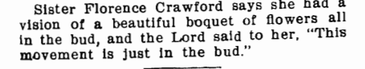
From November 1906, The Apostolic Faith
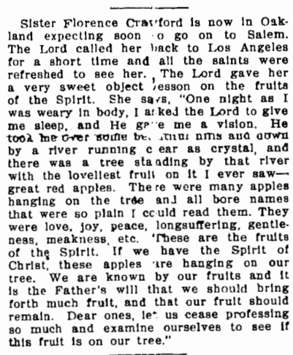
From the December 1906 The Apostolic Faith.
According to Estrelda Alexander, Crawford was on the original board at Azusa Street, but she left to evangelize the Pacific Northwest (34). She is one of the earliest denominational founders out of Azusa Street, creating the Apostolic Faith Church (34). Before Azusa Street, she honed her leadership skills when she became the leader of the Los Angelos Women’s Christian Temperance Union, and by 1902 she lead the National Congress of Mothers, later known as the PTA or Parent-Teacher Association (35-6). She had to set aside her own racial prejudice to attend the Azusa Street services, and she hid it from her family (38). However, while there, she got the baptism and claimed she was the first white woman at Azusa Street to do so (38). She claimed to speak in Chinese, and a Chinese-speaking man confirmed it. She also claimed divine healing from several ailments (39). While Seymour writes the most articles for The Apostolic Faith, she comes in second (40). She claimed she was called to preach, and she often shared visions God had given her (40-41).

From October 1906, The Apostolic Faith
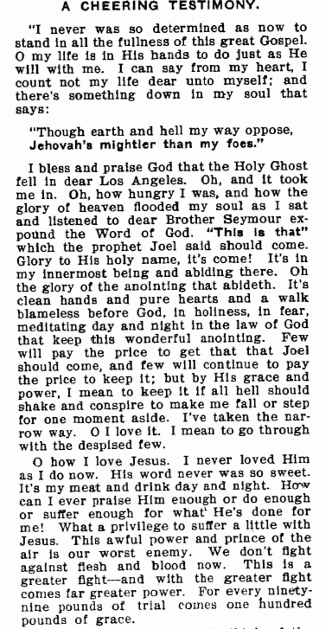

- Yes, women can preach on Azusa Street. Why? January 1908, The Apostolic Faith:

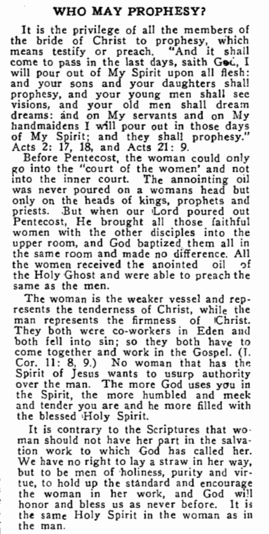
From May 1907, The Apostolic Faith: 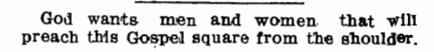



Scan the QR code to read issues of The Apostolic Faith. Many women are recorded in these newsletters.

Pentecostal Women’s History: After Azusa Street
- Mary Magdalena Lewis Tate (1871-1930) She was an African-American preacher who was saved and called to preach at 19 years of age, around 1890 (Alexander 75). She traveled throughout the Ohio Valley and the South evangelizing and founded an independent congregation, the Latter Day Saints of the Foundation of True Holiness and Sanctification, in 1903 (75-6). She did not join in the services on Azusa Street, but in 1908, she spoke in tongues with the baptism (77). She created a new church and denomination in 1908, the Church of the Living God the Pillar and Ground of the Truth (78). She would later become the first woman to become Bishop (First Church Overseer) of a Protestant denomination (78). Her denomination grew, but it split off into other churches over time.
- Maria Woodworth-Etter (1844-1924) Known as “signs and wonders Etters,” she focused on healing. Held massive tent revivals. A Diary of Signs and Wonders, 1916
- Ida Bell Robinson (1891-1946) A woman preacher who was the founder of the largest African-American denomination established by a woman and which continuously allowed women to serve in leadership positions (Alexander 141). It was the Mount Sinai Holy Church of America, founded in 1924. She was ordained and preached in the United Holy Church before they started to restrict women’s leadership (145-146). “If Mary the mother of Jesus could carry the word of God in her womb, why can’t women carry the word of God in their mouths?” (146).
- Mattie Perry (1868- ) Answered Prayer, date unknown.
- Hannah Whittall Smith (1832-1911), The Christian’s Secret to a Happy Life, 1868. She was “a lay speaker and author in the Holiness movement in the United States and the Higher Life movement in the United Kingdom.”
- Stanley Frodsham, Jesus is Victor: A Story of Grace, Gladness, and Glory in the Life of Alice Mary Frodsham, 1930, Pentecostal, Canadian
- Annie Douglas (1854- ) A Mother in Israel: the story of Mrs. Annie Douglas, 1920s?
IPHC Women Preachers
- Annie Verde, Laid Up Treasures: Life of Mrs. M. E. Verdes, 1938, IPHC
- Berta (Roberta Royal) Maxwell; Organized the Mizpah Prayer Band in Falcon, NC; first primary teacher at Falcon Holiness School, 1902 / 1920 (Posey) *Earliest documented woman preacher in the IPHC, according to Posey.
- Mary B. McKeehan; Worked with the holiness press Live Coals; printing, editing, and ministry work 1902–1904; Associated with the Fire-Baptized (Posey)
- Mary E. Ford; Sermon included in Let My Handmaid Speak; ordained IPHC minister, Oklahoma Conference; Sermon date not given; active by 1939 (Posey)
Pentecostal Educators and Founders of Bible Schools
- The Duncan Sisters. Elizabeth Duncan Baker and her four sisters begin a “missions-oriented faith ministry in Rochester, New York. This included Elim Faith Home (est. 1895), Elim Publishing House, Elim Tabernacle Church, and Rochester Bible Training School (1906-24)” (Hyatt 247). The Tabernacle had an “outpouring” and their school became the “first permanent Bible school of the 20th century Pentecostal revival” (248). Elizabeth visited Pandita Ramabai work in India, which was a mission to help temple prostitutes (248).
- “Mother Moss” (1875-1919) Educator and pastor. Established the Beulah Heights Assembly and then the Beulah Heights Bible and Missionary Training School in 1912 (248).
- Minnie Tingley Draft (1858-1921), had a healing evangelist ministry; founded Bethel Pentecostal Assembly in New Jersey in 1907, and presided over the earliest Pentecostal missionary agency in the U.S., the South and Central African Pentecostal Mission (248). She published the South and Central African Herald and established Bethel Bible Training School in 1916 (248).
- Aimee Semple McPherson (1890-1944), established the L.I.F.E. Bible College, 1923 (249). She is the first to receive a license for a Christian radio station by the FCC. This happens in 1924 (Hyatt 259).
- Christine Amelia Eckman (1879-1955), opened the “School of the Prophets” in 1924 in New York. Later known as the Zion Bible Institute (252). She was also a preacher.
- Nora Chambers (1883-1953), teacher in the Church of God. The first teacher at Lee College (now Lee University) (252).
Suggested Readings:
- Barfoot, Charles H., and Gerald T. Sheppard. “Prophetic vs. Priestly Religion: The Changing Role of Women Clergy in Classical Pentecostal Churches.” Review of Religious Research 22.1 (September 1980): 2-17.
- Holmes, Patricia. “The ‘Place’ of Women in Pentecostal/Charismatic Ministry Since the Azusa Street Revival.” The Azusa Street Revival and Its Legacy. Harold D. Hunter and Cecil M. Robeck, Jr., Eds. Cleveland: Pathway P, 2006. 297-316.
- I wrote two books on IPHC women preachers (Kristen Welch). The first one focuses on IPHC women from Oklahoma and the second one from South Carolina.
- Geraldine Posey’s book, Let My Handmaid Speak, is the most comprehensive book we have on IPHC women preachers.
Women’s History
Early 20th Century: The 1890s-1920s saw the New Woman. Known as the “Gibson Girl” as portrayed by artist Charles Dana Gibson. The Library of Congress describes her as follows:
Writers in the 1890s and early 1900s described the “New Woman” as an independent and often well-educated, young woman poised to enjoy a more visible and active role in the public arena than women of preceding generations. They agreed that the Gibson Girl represented the visual ideal of this new phenomenon. During her lengthy popularity, the Gibson Girl appeared in varied guises that highlighted her talents and interests as well as her beauty and social skills. As her star faded, the Gibson Girl’s active, vital persona paved the way for future icons, such as the flapper of the 1920s.
The shift: Woman in the public sphere as a reformer to woman in the public sphere as someone free to enjoy exercise, to become educated, and to be active politically, such as with fighting for women’s suffrage.
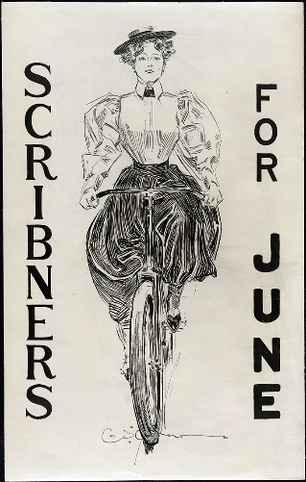 From the Library of Congress

Priestly Pentecostalism
The Shift from Azusa Street to “Modern” Pentecostalism: As Pentecostals became more mainstream and organized, the function of working within denominational boundaries includes the requirement for education to accompany a preaching license. So the move is from just the audience’s perception of an anointing to credentials backed by education, even if that education is only having read the Bible through more than once.
- The modern era of Pentecostal women preachers begins in the 20th century around the 1920s and 30s, according to Schneider and Schneider, authors of In Their Own Right: The History of American Clergywomen (1997). They describe this as the shift from prophetic to priestly, from God-called to a requirement to be educated and licensed or ordained in addition to being called (169). Barfoot and Shepphard call 1901-1920 “Prophetic Pentecostalism” and 1920s to the 1970s “Priestly Pentecostalism” (2).
- The shift to the “modern era” is after women have gained the right to vote (1920) and there’s been a cultural shift that moves away from the “True Woman” ideology and towards the “Flapper” era. WWI pushes many women into the workforce. Gains in the right to an equal education had been won and women were increasingly going to college, but they were still denied a spot in many professions. For Blacks, Jim Crows laws and the revival of the KKK in 1915 were just two of the forces working against them, so progress was unevenly distributed.
- “Call stories” were dominated by the “call-refusal motif.” In 1995 Harvey Cox published Fire From Heaven on Pentecostalism and included a description of a rural woman preacher from an extremely conservative town in south of Charleston, West Virginia. Betty Lou’s sermon is transcribed, along with her every breath and motion, to illustrate her dramatic and barely believable call story that fits into a “call-refusal motif” Cox finds in biblical accounts such as when Moses first refused to lead his people out of Egypt and when Jonah first refused to go preach to Ninevah (130-32). The “call-refusal” pattern, echoed in women’s call stories for decades after, is a woman preacher’s way of justifying herself in a culture that does not typically support women preachers.
- The stereotype is formed: Cox’s Pentecostal woman preacher is the epitome of the stereotypical woman preacher. She is poor, uneducated, unsophisticated, and seems to take a somewhat fundamentalist approach to her faith except that she feels that the authority of scripture may be superseded by divine revelation. David Roebuck describes how early Pentecostals in the Church of God were also poor and uses it as a starting place for describing how, as the church members became wealthier, they brought their beliefs and practices more in line with the rest of society. This included limiting the role of women as preachers (53-5).
- A Starting Place for Education in the IPHC
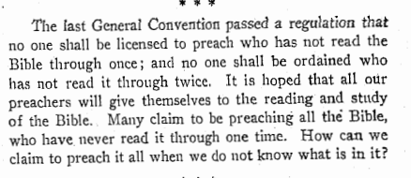
The Advocate, October 25, 1917: G. F. Taylor writes:

Pentecostal Women’s History: The CEO’s: Denomination Builders, Pastors, Evangelists, Preachers, Healers, Exhorters
- Alma Bridwell White (1862-1946) She is the founder and first Bishop of the Pillar of Fire Church, which was the Methodist Pentecostal Union.
- Carrie Judd Montgomery (1858-1946) Had the “Little Palace of Healing,” affiliated with the Assemblies of God.
- Aimee Semple McPherson (1890-1944) She begins in the IPHC when she marries Canadian Robert Semple. They married in 1908. They were both ordained in 1909. By the time she founds the Foursquare Church in 1923, she has been married and divorced. She holds services multiple times a day, seven days a week, has a weekly healing service, and presents her sermons as theatrical performances.
- Kathryn Kuhlman (1907-1976) Famous healing evangelist, had radio broadcasts. Popular in the 1950-60s.
- Dr. BeBe Patten (1913-2004) is educated at McPherson’s L.I.F.E. Bible College and founds her own thriving ministry, running a crusade in 1944 which drew in crowds of 5,000 a night for 19 weeks. She founds the Oakland Bible Institute (Patten University) in Oakland, California that same year. She opened the doors to both Black and white students and organized an interracial girl’s choir called the FGC (Flying Girls Choir). In the 1920s and 1930s, two of her revivals were burned to the ground for being interracial.
- 1949, T. L. and Daisy (1924-1995) start Osborn Ministries in Tulsa, Oklahoma, a prolific missionary outreach. Dr. Daisy authors three books: Women Without Limits, The Woman Believer, and 5 Choices for Women Who Win (Hyatt 254).
- Olive Kellner (1899-1967), part of a husband and wife healing ministry team, listed in the Voice of Healing magazine as featured evangelists, was ordained by the AOG.
- Myrtle D. Beall (1896-1979), one of the pastors in the Bethesda Missionary Temple in Detroit, which in 1948 became the center of the Latter Rain Revival that broke out in 1947 in the Sharon Bible School in Canada (Hyatt 253).

IPHC Women Preachers
- Dan and Dollie York, ministers in Oklahoma while still Indian Territory, The Life Events of Dan and Dollie York.
- Instead of A Visit, by Mr. and Mrs. W. R. Norton, of India, 1923 (Pandita Ramabai mentioned in this book)
- A Girl Led by the Hand of God, Henrietta Lawson, 1946.
- Mary Washington Williams, Memories of Childhood, 1948.
- The IPHC organizes the Woman’s Auxiliary in 1945. See Blanche King’s articles on women in The Advocate.
- Mildred Wicks (1913-1998) She is licensed by the IPHC and preaches a revival in 1931 where nearly 200 people come to Christ (Isgrigg). She grew up with Oral Roberts, who was ordained by the IPHC, and took his father’s spot as pastor in Westville, Oklahoma in 1938. In 1947, she and Oral Roberts run healing crusades together in at a church in Newnan, Georgia where they had both pastored at one time, and had over 700 people come each night. She worked as an evangelist for many years and returned to Oklahoma to start an independent Pentecostal Church in 1971. I Knocked, the Door Opened Unto Me, 1940’s or 50s.
- Fifty Years on the Battlefield for God, Florence Goff, 1940s, early 1950s
- “God’s Calling—His Enabling,” Blanche King, published in The Pentecostal Message, 1950. Edited Sunday-school literature; assistant editor of The Advocate; wrote the foreword/material concerning Joseph King in Yet Speaketh
- Margaret Muse Oden, Steps to the Sun, 1955
- “Scriptures on Sanctification,” Ruth Moore, published in The Pentecostal Message, 1950.
- “Women’s Auxiliary Balanced Contribution to the Church,” Mrs. R. E. Johndrow, General Vice-President of the Women’s Auxiliary, 1950s, Courtesy of the Cornerstone Archives.
- Agnes Robinson; Editor of The Helping Hand for 28 years; editor of Reach for 8 years; editor of Teen Teacher for 6 years, c. 1958–1986 (Posey)
- Greta Campbell; Evangelistic preaching and recording ministry; Greta Campbell Trio recorded eight albums 1951–1970 (Posey)

1901–1929, From Geraldine Posey’s book, Let My Handmaid Speak
Year | Woman | Conference / affiliation | Status or ministry documented by Posey | Major work / contribution
1901 | Berta (Roberta Royal) Maxwell | North Carolina | Joined conference; ordained minister from 1901–1919 | First documented woman minister in Posey; later founded Mizpah Prayer Band
 |  |  | Teacher at Falcon Holiness School | First primary teacher when school opened
 |  |  | On conference roll as minister; Foreign Missions Board | One of the earliest documented IPHC women ministers
1907, 1911, 1912 | Annie Cotton | North Carolina | Lady preacher | Conference minutes
1911 | Berta Maxwell | North Carolina | Lady preacher | Conference minutes
1912 | Dovie Dunn | North Carolina | Lady preacher | Conference minutes
1912 | Beadie Noble | North Carolina | Lady preacher | Conference minutes
1919 | Dessie McCurley | — | Woman evangelist/writer | Articles in The Advocate, March 6 & 13, 1919
1920 | M. K. Shannon | Oklahoma | Pastor | Named among pastors in Wagoner District
1925 | Hattie Edge | Baltimore/Eastern Virginia | Evangelist | Norfolk District
1925 | J. W. Everheart | Baltimore/Eastern Virginia | Evangelist | Norfolk District
1925 | J. R. Jones | Upper South Carolina | Lady evangelist | Anderson District
1925 | Avie Dunn | Upper South Carolina | Lady evangelist | Anderson District
1925 | Lula Ferguson | Upper South Carolina | Lady evangelist | Anderson District
1925 | S. T. E. Dudley | Georgia | Local evangelist | Conference record
1925 | J. D. Parker | Georgia | Local evangelist | Conference record
1925 | Nolie Goolsby | Georgia | Local evangelist | Conference record
1927 | M. L. Canady | Lower South Carolina | Recommended for ordination | Conference credentials
1927 | Lessie Polston | Lower South Carolina | Received license | Conference credentials

Posey identifies Maxwell as the earliest lady minister of record, joining the North Carolina Conference in 1901 and appearing on its roll in 1907. She says Maxwell was ordained in 1901, remained a minister until asking that her name be removed from the roll in 1919, and continued her ministry afterward.

1932–1939
Year | Woman | Conference | Status / ministry | Publication or contribution
1932 | Lessie Polston | Lower SC | Minister | Conference record
1932, 1933 | Minnie Calder | Lower SC | Minister | Conference record; Wadesboro & Ellerby
1932 | J. T. Warren | Lower SC | Minister | Conference record
1933 | Lessie Polston | Lower SC | Pastor | Cheraw & Haystown
1933 | F. B. Graham | Lower SC | Pastor | Little Star
1933 | Pearl Fagen | Lower SC | Pastor | Gum Springs
1933 | Laura Graham | Lower SC | Evangelist | Conference record
1933 | Mary Sue Britton | Lower SC | Evangelist | Conference record
1933 | M. L. Canady | Lower SC | Evangelist | Conference record
1933 | Natalie Carnes | Lower SC | Evangelist | Conference record
1933 | Nita Alexander | Lower SC | Evangelist | Licensed to preach
1933 | S. J. Britton | Lower SC | Evangelist | Conference record
1933 | Ethel Moore | Lower SC | Evangelist | Conference record
1933 | Lila Medlin | Lower SC | Evangelist | Conference record
1933 | Alma Graham | Lower SC | Evangelist | Licensed to preach
1934 | Lucille Swails | Lower SC | Recommended for license | Conference examination
1934 | Irene Wilson | Panhandle | Ordained | Conference minister
1934 | H. O. Byerly | Panhandle | Ordained | Conference secretary-treasurer
1934 | Eska Galvin | Panhandle | Ordained | Conference minister
1934 | Opal Manning | Panhandle | Ordained | Conference minister
1934 | Clara Coffman | Panhandle | Licensed | Conference minister
1934 | Vessie King | Panhandle | Licensed | Conference minister
1934 | Lucile King | Panhandle | New minister | Received by conference
1934 | Wanda Keller | Panhandle | New minister | Received by conference
1934 | Evelyn Egger | Pennsylvania | Woman minister | Conference record
1934 | F. D. Haag | Pennsylvania | Woman minister | Conference record
1934 | Velma Smail | Pennsylvania | Woman minister | Conference record
1934 | Inez Wasmund | Pennsylvania | Woman minister | Conference record
1934 | B. D. Landon | Pennsylvania | Woman minister | Conference record
1939 | Mary Ford | Kansas → Oklahoma | Minister; transferred to Oklahoma | Later published “Obedience”
1939 | Stella Buchanan | East Oklahoma → Oklahoma | Minister | Transferred
1939 | Tinnie Shockley | East Oklahoma → Oklahoma | Minister | Transferred
1939 | Grace Andrews | Oklahoma | Minister | Dropped for failure to report
1939 | N. C. Brandstatter | Oklahoma | Minister | Withdrew
1939 | Ella Lou Wedel | Oklahoma | Minister | Withdrew
1939 | A. N. Goodwin | Missouri | Minister | Reported preaching 17 times

1940–1949
Year | Woman | Conference | Ministry
1940 | Dorothy Donithan | California | Became minister; later Woman’s Auxiliary missions leader
1941 | C. H. Linn | Maryland | Ordained general evangelist
1942 | Natalie Carnes | Lower SC | Committee on Evangelism
1942 | Lucile Barnes | Lower SC | Committee on Publication
1942 | Mary Sue Evans | Lower SC | Committee on Publication
1942 | Nita Alexander | Lower SC | Committee on Publication
1942 | Lila V. Medlin | Lower SC | Committee on Publication
1944 | B. B. Sellers | South Carolina | Assistant pastor
1944 | J. L. Wall | South Carolina | Assistant pastor
1944 | Mary Sue Evans | South Carolina | Pastor
1944 | H. C. Alexander | South Carolina | Pastor
1944 | Natalie Carnes | South Carolina | Pastor, Georgetown
1944 | J. L. Frazier | South Carolina | Assistant pastor
1944 | F. B. Graham | South Carolina | Pastor
1944 | Lila Medlin | South Carolina | Co-pastor
1944 | Ruth Kirby | South Carolina | Co-pastor
1944 | J. Paul Jones | South Carolina | Served with husband
1944 | Ethel Moore | South Carolina | Pastor, Rock Hill
1944 | Alma Graham | South Carolina | Evangelist
1944 | Lucile Barnes | South Carolina | Evangelist
1944 | Laura Graham | South Carolina | Evangelist
1944 | J. T. Warren | South Carolina | Evangelist
1944, 1945 | Lila Berry | North Carolina | Evangelist; organized Woman’s Auxiliary
 |  |  | First General President of Woman’s Auxiliary
1946 | Eleanor Cato | Alabama | Evangelist
1946 | Lavella Ezell | Alabama | Evangelist
1946 | Lou Eria Ealum | Alabama | Evangelist
1946 | Rachel McGraw | Alabama | Evangelist
1948 | Clara Louise Peel Williams | North Carolina | Licensed minister/co-pastor
1948, 1949 | Elsie Inman | California | Minister; later pastor

Posey specifically notes that in 1947 18 of South Carolina's 126 ministers were women, while in 1948 women constituted significant proportions of the ministerial rolls in Tri-State, Upper South Carolina, Texas-Mexican, and Virginia conferences.

1950–1959
Year | Woman | Conference | Ministry / publication
1950, 1953 | Blanche Leon King | Georgia | “God’s Calling—His Enabling,” The Pentecostal Message
1950 | Elsie Inman | California | Continued pastorate/building project
1950 | Ruth Heath | — | Published in The Advocate
1951 | Viola B. Jarvis | North Carolina | “Lowland and Hobucken Have Great Revivals”
1951, 1953 | Mary E. Ford | Kansas/Oklahoma | Ministry documented; “Obedience,” The Pentecostal Message No. 2
1952 | Beulah Taylor | — | Article in The Advocate
1954 | Mary Haag | — | “Truxali Auxiliary,” The Helping Hand
1954 | Ruth Moore | — | The Helping Hand article
1954 | Effie Roberson | Western NC | Revival reports in The Co-Worker
1958 | Betty Ethel Glover Bailey | Western NC | Licensed to preach
1958 | Dollie York | — | Historical subject in The Advocate
1959 | Lila Isaac | Woman’s Auxiliary | “From the Field,” The Helping Hand

1960–1969
Year | Woman | Conference | Ministry / contribution
1960 | Thelma Player | South Carolina | Founded By-Way Church
1961 | Lila Isaac | Woman’s Auxiliary | General WA leadership; worked on revised WA Manual/programs
1961 | Agnes Robinson | South Carolina | WA Board
1962 | Flossie Cooper | South Carolina | Began Gibson Church mission
1963 | Flossie Cooper | South Carolina | Gibson Church formally organized
1964 | Nina Alexander | South Carolina | Church-planting/pastoral ministry
1965 | Mary E. Ford | Oklahoma | Guest evangelist; remembered as preacher/minister
1967 | Sophia Fordyce | Pennsylvania | Pastor, Saltsburg Church
1968 | Valla Cleta Eland | East Oklahoma | Published encouragement to pastors/evangelists
1969 | Greta Campbell | Upper South Carolina | Lead Me Saviour, Greta Campbell Trio
1969 | Blanche Leon King | Georgia | Emmanuel College commencement address
1969 | I. M. Huggins | North Carolina | “Sermon of the Month”
1969 | Sarah Honeywell | Great Plains | Ordained
1969 | A. C. Kersey | Great Plains | Ordained
1969 | J. H. Miller | Great Plains | Ordained
1969 | B. A. King | Great Plains | Licensed
1969 | M. L. Lunsford | Great Plains | Licensed
1969 | E. M. Mathis | Great Plains | Licensed
1969 | Mabie Crouser | Great Lakes | Woman minister
1969 | Catherine Monhollen | Great Lakes | Woman minister
1969 | M. Thomas | British Columbia | Licensed
1969 | M. R. Webley | British Columbia | Licensed
1969 | I. Anstice | British Columbia | Licensed

Posey reports 473 women ministers out of 2,638 total IPHC ministers in 1966, or nearly 18 percent.

Pentecostal Women’s History: Donning the Power Suit: Professors and Performers, 1970s-2010s
- 1964-1973, Jim and Tammy Faye Bakker run a puppet show on CBN.
- 1966, The 700 Club airs. Tammy Faye Bakker is one of the founders.
- 1967, Women’s Aglow Fellowship International is created (Hyatt 256).
- 1973, Gwen Shaw (b. 1954) established End-Time Handmaidens and Servants. She was Canadian (Hyatt 257). Missionary to the Chinese (257).
- Freda Lindsay (b. 1914) In 1973, she became head of the Christ for the Nations ministry her husband started after he died (Hyatt 253). She oversaw “one of the largest Pentecostal missionary organizations in the world” (253).
- Pauline E. Parham (b. 1909) was one of the teachers at Christ for the Nations. She was the daughter-in-law of Charles Parham, William Seymour’s teacher (253).
- 1974, Dr. Fuschia Pickett (b. 1918) established Fountain Gate Bible College in Texas (Hyatt 259). Launched Spirit Led Women, a magazine, in the latter part of the 20th century (259).
- The Society of Pentecostal Studies is founded in 1970. Edith Blumhofer, who published on Aimee Semple McPherson, becomes the first woman president in 1987. Cheryl Bridges Johns (IPHC/COG) becomes president in 1993. Rebecca Skaggs, 1999; Sherry DuPree, 2001; Anthea Butler, 2005; Estrelda Alexander, 2010; Kim Alexander, 2011; Jacqueline Gray, 2017; Melissa Archer, 2022; Lois Olena, 2025; Marcia Clarke, 2026. African-Americans highlighted.
- In 1973, Paul and Jan Crouch (1938-2016), along with Jim and Tammy Faye Bakker (1942-2007), found TBN, the Trinity Broadcasting Network. Jan grew up Assemblies of God. It was the largest Christian broadcasting network, commercial free.
- 1974, PTL Club, hosted by Jim and Tammy Faye Bakker, is a televangelist show. Both of Tammy’s parents were Pentecostal preachers. 1978-1986, Heritage USA opens in Ft. Mill, SC by Jim and Tammy. It has a water park, theme park, and residential resort. 1966, Tammy is part of the group that founds the 700 Club.
- 1994, the Toronto Blessing revivals break out in Canada in the Vineyard congregation of John and Carol Arnott (Hyatt 263).
- Yongi Cho, pastor of the largest church in the world in the late 20th century changed his views on women after talking with God, and then he allowed women to lead the cell groups in his church in Seoul, South Korea. Soon, 90% were led by women and that’s where most of the church growth came from (Hyatt 255-256). His mother, Jashil Choi, created the Prayer Mountain, a prayer ministry (256).
- In the 1990s, Billie Brim operated Prayer Mountain out of Missouri and Cindy Jacobs cofounded General of Intercession in Colorado. She is the U.S. Coordinator of Wagner’s Spiritual Warfare Network (Hyatt 256).
- 2001-2007, The Holy Land Theme Park, Orlando, Florida opened. “It featured a replica of Herod's Temple, the Scriptorium museum (housing rare biblical manuscripts and artifacts), the 2,000-seat Church of All Nations, and live theatrical passion plays.” Founded by the Crouch’s.
- Elaine Lawless, God's Peculiar People: Women's Voices & Folk Tradition in a Pentecostal Church, 2005; Handmaidens of the Lord: Pentecostal Women Preachers and Traditional Religion, 1988; Dr. Lawless brings Pentecostals into the spotlight with her work. Unfortunately, she highlights the poorest and least educated Pentecostals. She is not Pentecostal.
- Marilyn Hickey (1931-2026): Famous televangelist. AOG. Marilyn Hickey Ministries – her t.v. show. Launched in 1973. She “founded Word to the World College in Denver in 1981” (Hyatt 259). Valerie Owen was the first and only woman to teach in the college and the only one to teach by satellite in America and Canada (Hyatt 260).
- Three women launch the website, God’s Word to Women, built on Dr. Bushnell’s book God’s Word to Women. These three women are in Texas: Babara Collins (b. 1935), former dean at Pickett’s Fountain Gate Bible College, Patricia Joyce (b. 1938) and Gay Anderson (b. 1933) (Hyatt 260).
IPHC Women Preachers
- Lila Isaac, The Glory Covered: The Story of Carl and Lila Isaac, 1970s; Developed Women's Auxiliary programs, manuals, study courses, newsletters, and translated WM materials, 1961 onward (Posey)
- Handwritten Testimony, Lucy Hargis, 1975, Courtesy of the IPHC Archives in OKC
- Grace Hope Curtis, Pioneer Woman for Christ, 1978
- Mary Sue Evans, Rhoda Tells of Her Walk with God, 1977
- Lois Tripp; “Women—Liberated to Minister,” The Helping Hand 1988
- Shirley Spengler Rohde; “Some Leaders Are Born Women”/women-in-ministry discussion, Woman’s Touch; reprinted in The Helping Hand 1987–1988 (Posey)
- Nelle Burnette Goodman; “Julie,” The Helping Hand 1986 (Posey)
- Deborah Whipple; “Taking Control of the Air Before Sending in the Ground Troops,” Evangelism USA, 1999 (Posey)
- “Worship,” a skit for the 1986 Women’s Ministries Founder’s Day Program, Author Unknown, Courtesy of the Cornerstone Archives.
- “Joy Through Intimacy With God,” a skit written by Jewelle Stewart, 1995 Women’s Ministry Founder’s Day Program, Courtesy of the Cornerstone Archives
- Deborah Whipple, “Don’t Treat Me Like I’m Dying,” IPHC Experience, 2006 (Posey)
- Kathy Sandlin; School of Intercession, Vols. I–III, by 2000; Altar Worker/Prayer Counselor Training Manual, by 2000; Prayer Diary of a Mother’s Heart, by 2000; Handmaiden for Harvest
- Janetta Adams; First solo recording after forming Mountain Harmony with her sisters, 1993 (Posey)
- Vickie McLaughlin Viars; Radio broadcasts: “Blessed Are the Broken” and “The Broken but Blessed”1998 (Posey)
IPHC Preachers & Sermons from Geraldine Posey’s book, Let My Handmaid Speak
- Kitty Mears “The Life and Times of David”
- Debra Whitside “Where Has the Power Gone?”
- Pauline Knowles “Quench Not the Spirit”
- Jennifer Oliver “Spiritual Holiness: The A List”
- Marie Haydock “Living Water”
- Becki Hudson “The Right Name and the Right Action to Go With It”
- Betty Walling “Five Meanings of Mercy”
- Karen Atkins “An Anointing from the Holy One”
- Jewelle Stewart “Watch the Clouds!”
- Sharon Hartman “You Might Be in the Middle of a Miracle”
- Jane Blass “What Kind of Pattern Are You?”
- Nelle Goodman “Mary—Martha World”

1970–1979
Year | Woman | Conference / setting | Ministry / publication
1970 | Natalie Carnes | — | Honored in The Challenge
1973 | W. R. McCutcheon | South Carolina | Pastor, Broad Swamp
1973 | Sally Stone | South Carolina | Pastor, Freemont Mission
1973 | Edna Yon | South Carolina | Pastor, Green Branch
1973 | Mary Sue Evans | South Carolina | Pastor, Orangeburg
1973 | Thelma Player | South Carolina | Pastor, By-Way
1973 | Lacy Drew | South Carolina | Pastor, Hickory Grove
1973 | Josephine Cox | South Carolina | Pastor, New Zion
1973 | Helon Phillips | South Carolina | Pastor, Pioneer
1973 | Kathleen Taylor | South Carolina | Approved for ordination
1973 | Linda R. Faber | Western NC | Evangelist
1973 | Shelby Jeffcoat | South Carolina | Evangelist
1974 | Opal Plowman | Southern California | Pastor; Pastor of the Year
1977 | Lila Isaac | Woman’s Auxiliary | General WA President profile
1977 | Agnes Robinson | IPHC | The Helping Hand article; WA leadership
1978 | Frances Tarkenton | Georgia | Pastor; King Memorial lecturer
- Posey's 1973 list is particularly useful because it shows women functioning as pastors, evangelists, and credentialed ministers simultaneously, rather than simply as auxiliary leaders.

1980–1989
Year | Woman | Conference / setting | Ministry / publication
1980 | Rita Wrenn | — | The Advocate article
1981 | Agnes Robinson | IPHC | International WA President
1981 | Violet Curlee | Southern California | Ordained
1981 | Minnie Davidson | Southern California | Ordained
1981 | Suda Faulkner | Southern California | Ordained
1981 | Murel Jones | Southern California | Ordained
1981 | Norva Moore | Southern California | Ordained
1981 | Rosie Shifflet | Southern California | Ordained
1981 | Inez Weed | Southern California | Ordained
1981 | Mary Velma Williams | Southern California | Ordained
1981 | Lillie Rae Moore | Southern California | Licensed
1981 | Essie Petty | Southern California | Licensed
1981 | Opal Rouse | Southern California | Licensed / World Missions
1985 | Ella Muncy | — | The Advocate, December 1985
1986 | Agnes Robinson | South Carolina | “Women Can Make a Difference in Their Worlds”
1986 | Nelle Goodman | — | “Julie,” The Helping Hand
1987 | Shirley G. Spencer | IPHC Publications | Executive editor; later first female executive editor
1989 | Hazeleen Graham | — | The Challenge article
1989 | Janetta Adams | North Carolina | Ministry/music

1990–1999
Year | Woman | Conference / setting | Ministry / publication
1990 | Renee Ross | — | “The Helping Hand,” Nov.–Dec. 1990
1991 | Deborah Williams | North Carolina | Ordained; revivalist
1992 | Deborah Williams | North Carolina | Profile in The Evangel
1994 | Violet Curlee | — | The Advocate article
1994 | Ruth Johnson | — | The Advocate article
1994 | Jeraldine Posey | — | The Advocate article
1995 | Ann McGraw | — | “The Hands of a Shepherdess”
1996 | Charlene West | Heartland | Intercultural ministry article
1996 | Christy Sorrow | — | Female military chaplain; The Advocate
1997 | Charlene West | Heartland | “Intercultural Ministries,” Evangelism USA
1998 | Charlene West | Heartland | Founded Centro de Celebracion
1999 | Deborah Whipple | Heartland | “Taking Control of the Air Before Sending in the Ground Troops,” Evangelism USA

2000–2011
Year | Woman | Conference / setting | Ministry / publication
2000 | Susan Wells | — | The Challenge article
2000 | Kathy Sandlin | Upper SC | School of Intercession I–III; training manuals/books
2002 | Sylvia Hill | Appalachian | Died 2002; 18 years pastor at Wolf Creek
2002 | Betty Ethel Glover Bailey | North Carolina | Died 2002; 31 years pastoral ministry
2002 | Theola Ammons | South Carolina | Died 2003; minister
2002 | Shelley Katri McDonald | North Carolina | Approved for ministerial license
2002 | Janice Marshburn | North Carolina | Deborah’s Daughters leadership
2002 | Patsy Vaughan | North Carolina | Women-ministers training/advisory council
2003 | Christy Sorrow | IPHC | Military chaplain; Issachar File
2004 | Charlene West | Heartland | “Meet Charlene West,” IPHC Experience
2004 | Deborah Riley | — | “A Hidden Heart,” IPHC Experience
2005 | Sarah Tarpley | Oklahoma / U.S. Air Force | Second female IPHC Air Force chaplain
2005 | Mandana Marsh | — | Devotional book documented in Hopewell News
2006 | Deborah Whipple | Evangelism USA | “Don’t Treat Me Like I’m Dying,” IPHC Experience
2006 | Jewell Stewart | — | Article on Lila Isaac
2007 | Janice Marshburn / Deborah’s Daughters | North Carolina | Official adoption of “Deborah’s Daughters”
2008 | Patsy Vaughan | North Carolina | “Out-of-the-Box Thinking for Women Ministers”
2008 | Kristen L. Sanders | — | Children’s ministry article
2009 | Lydia Figueroa | — | “Called to Abide,” IPHC Experience
2009 | Pauline Knowles | North Carolina | Retired ordained minister; 56 years ministry
2010 | Janice Marshburn | North Carolina | Deborah’s Daughters leadership
2010 | Patsy Vaughan | North Carolina | Deborah’s Daughters leadership
2010 | Cindy Midyette | North Carolina | Historian/Secretary, Deborah’s Daughters
2010 | Wilda Faircloth | North Carolina | Deborah’s Daughters council
2010 | Lydia Figueroa | North Carolina | Deborah’s Daughters council
2010 | Betty Rogers | North Carolina | Deborah’s Daughters council
2010 | Louise Thompson | North Carolina | Deborah’s Daughters council
2010 | Shirley G. Spencer | IPHC | Retired as Executive Editor, March 2010
Posey reports that Deborah’s Daughters began in 2002 with 91 women ministers, initially as “Women Ministers,” later “Lady Ministers/Lady Clergy,” and officially adopted the name Deborah’s Daughters in 2007.

Pentecostal Women’s History: Modern, as in Do You Mean Right Now? Yes, now: Return of the TradWives, Entrepreneurs, Professors, Pastors, Leaders, 2010s-now
Are scholars “preachers”? Yes! To be licensed, your pastor must hold a college degree. Who do you think taught your pastor? Whose class did he/she take? Whose books or scholarly journal articles are they reading to provide evidence and to build substance in their papers for college? Professors preach when they transform hearts and minds in the classroom. Institutions that are Pentecostal or welcome Pentecostals learners: Oral Roberts University, Emmanuel University, Southwestern University, Fuller Theological Seminary, Regent University, the Church of God Graduate School of Theology, Lee University. To learn about how Pentecostal women founded colleges and seminaries, read Dr. Abraham Ruelas’ book Women and the Landscape of American Higher Education: Wesleyan Holiness and Pentecostal Founders, 2010.
IPHC Preachers (Some of these will be included in an upcoming anthology)
- Sermon: The Turning Point of My Life, Wallapa Wisawasukmongchol, Ph.D.
- Sermon: So Send I You; God’s Purposes in Scripture, Roni Pruitt
- Sermon: Luke 2:22-24; 36-38, Anna, Summer Sneed
- Sermon: Keep Cool and Let God Do His Work, Rose Boyd
- Sermon: Feast and hospitality- Jesus Christ speaks up for his disciples, Rev. Joanne Wong Yuet-Ying
- Sermon: “Come to the Well” and “Becoming Cloud Watchers,” Jewelle Stewart
- Sermon: “On the Resurrection,” Ruth Powell
- Charlene West, Life is a Great Adventure, 2007
- Patricia Aman Coffee with Pat Internet Ministries; writing spiritual warfare book and The Turtle and the Giraffe by 2011; manuscripts undated (Posey)
- Shirley G. Spencer Executive editor of The Pentecostal Holiness Advocate, Issachar File, and IPHC Experience; edited numerous books, curriculum, booklets, and leaders' guides 1979–2010 (Posey)
- Marysue Huffman Freeman; Extensive preaching/ministry across the U.S. and more than 47 countries (Posey)
- Ruth W. Brookshire; Music/ministry writing and contributions (Posey)
- Identity Crisis, sermon by Cherie McDade

Texts from the OKC IPHC Archives
- Women Preachers, Or the Daughters of the Lord, Mrs. Palmer
- Us and Ours, Anna Sutton
- Sermon: Obedience, Rev. Mary Ford, in Pentecostal Messages, vol. 2
- From the Pentecostal Message: Sermon, Scripture on Sanctification by Ruth Moore
- Nora Brook, The Priceless Bloom and Other Poems
- The Cross Transformed into Glory, Mrs. Richard Edgerton
- The Country Parson, Marion Conway
- Sight Unseen, Rebecca Shirey
- Forgiveness, Ruth Webely-Miller
- Poems, Anna Sutton
- Living and Loving, Lillian Myers
- Lights and Shadows in the Life of Canaan, Mrs. Mary Mabette Anderson
- Live Coals of Fire, Mary Lenhert
- Letters to B. S. , Mary Lamoreaux Burnell
- Let’s Celebrate the Feasts, Charlene West
- Lest I Forget, Gladys Cooke
- Poems, Reflections, Jan Bridges
- His Will, His Way, Kathy E. Wofford
- Help, I’m a Teenager! Susan Smith
- Gleanings, For Private Devotions, Jeraldine E. Posey
- Faith and Fasting, Lottie Sutphin
- Echoes of Faith, J. E. Madewell
- Don’t Miss the Rapture, Charlene West
- Close Out of the Ages, Charlene West
- Born to be a Teacher, Stella Harris Walker
- Beholding God and Nature in Poetry, Mrs. Thelma Stroud
- Behold the Bride, Charlene West
- Behold the Kinsman Redeemer, Charlene West
- A Father to Us All, Susan Hyatt
- A Collection of IPHC Missionary Short Stories, Frank Tunstall
- An Orphan as a Missionary, Laura Mae Hylton
- I Saw the Highest Mountain and Stood by the Lowest Sea, Blanche King
- Let My Handmaid Speak, Jeraldine Posey,
- Embracing Our Place, Faye Leggett
- Her Door of Faith, Mildred Johnson
- Just an Ordinary Woman, missionary to China, Fannie Lowe
- Missions on the March, Rev and Mrs. DD Freeman
- You Gave Yet Africa Calls, Florine and Montgomery Duncan
- The Road to Health and Happiness, Lottie Sutphin
- The Hundredfold Pledge, Mary Lamoreaux Burnell
- Come Alive in the Word, A Detailed Study for Teenagers of the Major Tenets of the PHC, Susan Smith
- Men and Missions, Sara Lane Beacham
- The Christian’s Secret of a Happy Life, Hannah Whittall Smith
- E. May Law, Pentecostal Mission Work in South China
- An Orphan as a Missionary, Laura May Hylton
Interviews of IPHC Women Preachers:
- Betty Sue Walling
- Rita Wrenn
- Louise Mayhue
- Lois VanDyke
- Leona Coker
- Jewelle Stewart
- Ruth Powell
- Dorothy Cox
Interviews & Testimonies from Kristen Welch’s dissertation and book:
- LaDonna Scott
- Lennie Cordie Rex’s Testimony
- Peggy Eby (IPHC Preacher)
- Debbie Whipple (IPHC Preacher)
- Charlene West (IPHC Preacher)
- Wanda Baker (IPHC Preacher)
Black Pentecostal Scholars
- Yolanda Pierce, Became Dean of Vanderbilt Divinity School in 2023. COGIC heritage; In My Grandmother’s House: Black Women, Faith, and the Stories We Inherit
- Marla Frederick, Became Dean of Harvard Divinity School in 2023, Colored Television: American Religion Gone Global and Between Sundays: Black Women and Everyday Struggles of Faith discusses the faith of African American women in the South where she documented a number of experiences of Pentecostals.
- Keri Day, Elmer G. Homrighausen Chair and Professor of Constructive Theology and African American Religion at the Princeton Theological Seminary; First Black woman promoted to full professor at Princeton Theological Seminary in 2023. COGIC; Azusa Reimagined; constructive theology and African American religion
- Cheryl J. Sanders, Howard University School of Divinity, Saints in Exile; African American Holiness-Pentecostalism and ethos.
- Anthea Butler, University of Pennsylvania, Women in the Church of God in Christ: Making a Sanctified World; African American religion
- Judith Casselberry, Bowdoin College, The Labor of Faith; Gender and Power in Black Apostolic Pentecostalism
- Dara Colbey Delgado, Allegheny College, Studies African American women, Pentecostalism, and culture
- Estrelda Alexander, Started Seymour College and Seymour Press; African American Pentecostalism; Black Fire; Pan-African Dictionary of Pentecostalism, Philip's Daughters: Women in Pentecostal-Charismatic Leadership
Other Pentecostal Scholars
- Leah Payne, God Gave Rock and Roll to You: A History of Contemporary Christian Music
- Kim Alexander, Author of numerous books, including What Women Want: Pentecostal Women Ministers Speak for Themselves
- Adrian Hinkle (IPHC) becomes Dean of Oral Roberts’ School of Theology in 2023; Serves on IPHC Council of Bishops, Pedagogical Theory of the Hebrew Bible. Serves as the Executive Director of the Society of Pentecostal Studies, 2020-present.
- Linda Ambrose, Professor of history at Laurentian University. She is the author of For Home and Country: The Centennial History of the Women’s Institutes in Ontario, A Great Rural Sisterhood: Madge Robertson Watt and the ACWW, and, with Michael Wilkinson, After the Revival: Pentecostalism and the Making of a Canadian Church. She also co-edited Women in Agriculture: Professionalizing Rural Life in North America and Europe, 1880–1965 with Joan M. Jensen. Most recent book: Pentecostal Preacher Woman: The Faith and Feminism of Bernice Girard
- Cheryl-Bridges Johns (IPHC/COG), Re-Enchanting the Text: The Bible as Sacred, Dangerous, and Mysterious. She also has a book on menopause!
Entrepreneurs: Famous, Rich, and Influential Preachers
- Paula White-Cain (1966- ) Famous televangelist. Was Trump’s spiritual advisor and led the White House Faith Office. Authored numerous books.
- Dr. Juanita Bynum (1959- ) African-American Gospel singer, evangelist, author. She has numerous books, and her album Piece of My Passion reached #55 on the charts in 2006. Grew up Pentecostal and ministers in Pentecostal/charismatic churches, as well as elsewhere.
- Joyce Meyer (1943-) Charismatic author; leader of Joyce Meyer Ministries; preacher.
- Lisa Bevere (1960- ) Charismatic; Runs Messenger International with her husband, John. Has authored numerous books.
- Kathryn Krick ( ) –Lead pastor of 5F church in Los Angelos, Ignite Revival: Be Set on Fire to Change the World 2026, The Secret of the Anointing: The Power of God to Walk in Miracles 2023, Unlock Your Deliverance: Keys to Freedom from Demonic Oppression 2025, (books are in Spanish and German), podcast: Revival is Now.
Other Ladies Showing Up in Our Bible Studies
- Beth Moore, Lisa Harper, Lysa Terkhurst, Priscilla Shirer, Jen Wilkin, Courtney Joseph, Nancy Leigh DeMoss…
Fun Fact: Dolly Parton’s father was a Pentecostal preacher!
Central questions for today:
Should a woman be allowed to preach? This question persists.
What is a woman? When did identity trump biology? The scholar Judith Butler was one of the driving forces of fluid gender identity, and we need to answer this question for women using scripture and our testimonies. Academic theories change, and God’s truth undermines even those that seem to hold the most sway: 2 Corinthians 10:5: We demolish arguments and every pretension that sets itself up against the knowledge of God, and we take captive every thought to make it obedient to Christ.
How do we fuel our fight? We have things we wish to see open up or to progress. If Christ is the water, and the Holy Spirit is the oil, what feeds the flame, the mark of the Spirit’s indwelling? How does Christ fuel the fight? How role does the Spirit play? Taking up secular rhetorics (modes of argument based in sources other than scripture) might inspire us to use anger to feed the flame instead. When Jesus overturns the tables in the temple, what fuels his anger? Matt. 21:12-17.
Should women be allowed to serve in denominational leadership? We know to look to scripture, but do women need affirmative action to break into these ranks?
Sources:
Estrelda Alexander, Limited Liberty: The Legacy of Four Pentecostal Woman Pioneers

https://www.pbs.org/kenburns/not-for-ourselves-alone/cult-of-true-womanhood
https://naacp.org/find-resources/history-explained/history-lynching-america
https://www.npr.org/2021/06/12/1005848169/loving-day-interracial-marriage-legal-origin
http://www.pctii.org/iphc.html
Denzil Miller, The Women of Azusa Street.
https://www.loc.gov/exhibits/gibson-girls-america/the-gibson-girl-as-the-new-woman.html
https://localwiki.org/oakland/Bebe_Patten
https://www.healingandrevival.com/BioJOKellner.htm
https://www.reddit.com/r/Exvangelical/comments/18rqlp6/did_anyone_else_go_to_the_holy_land_experience_in/
https://religionunplugged.com/news/2026/4/27/marilyn-hickey-pioneering-pentecostal-televangelist-dies-at-94
https://danieldisgrigg.com/2023/11/01/black-female-pentecostal-scholars/
https://www.5fchurch.org/
https://www.christiancentury.org/features/dolly-parton-s-faith-was-hard-measure

