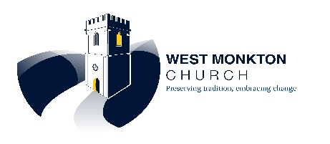
ST AUGUSTINE’S CHURCH, WEST MONKTON
SOMERSET ART WEEKS FESTIVAL 19 SEPTEMBER – 4 OCTOBER 2026
Calling all local artists, makers and creatives! The church is an Open Venue and offers you the unique opportunity to exhibit your work in the beautiful 13th Century Church of St Augustine’s in West Monkton.
You are warmly invited to enter your exhibits for display and sale.
The Somerset Art Weeks Festival theme is ‘Cultural Connections’; bringing partners, artists, and communities together to celebrate and explore the cultural ties that define us from Palaeolithic to Present, Human and Non-Human species.
The venue at West Monkton Church is a notable feature of our local landscape and has maintained its cultural connections with its surroundings since the 13th Century.
- We accept mixed media, ceramics, pottery, sculpture, and paintings, from amateur and professional artists. Adults and children’s sections (children under 16 years).
- We have access via ramp into the church building and the toilet. Some parts within the church are a bit short on space for wheelchair access.
- Visitors and exhibitors will be able to access refreshments (donation), free parking, toilet, prizes for best in show, daytime stewarding. Venue locked at night.
- Entry and payment done online. Entries cannot be accepted unless the entry fee has been paid.
- Entry per each adult exhibit £5
- Entry per each children’s exhibit £2
- Commission on all sales of 20%: in aid of St Augustine’s re-ordering project.

- We are equipped to accept Cash or Card payments for entries and for sale of goods.
- Please bring entries to the church: ready to hang, labelled as per information on entry form
9th – 12th September between 3.00pm and 7.00pm. Collect unsold items from 3.00pm 4th and 5th October.

- Exhibition will be curated on 14th September. We reserve the right to decline any entry appearing to be at odds with our venue which is an active Church in use for regular services and private prayer.
- ENQUIRIES: Tricia Cavill cavill663@yahoo.co.uk 07541 835069
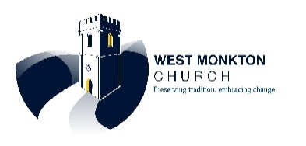
AT ST AUGUSTINE’S CHURCH WEST MONKTON
ENTRY FORM
This form is to submit your piece(s) for SAW at West Monkton Church 19 Sept – 4 Oct.
- Your piece must be ready to hang. Please label it on the reverse your name/name of piece/medium/price (red dot if not for sale). Drop off 9-12 Sept 3.00-7.00pm.
- It must not exceed 100cms on the longest edge.

Return this form by email to cavill663@yahoo.co.uk or bring it with your entry at drop off times below. Your entry is secured when funds are received at the bank.
SAW at St Augustine’s Church West Monkton
Name of exhibitor
Email address
Phone number
Name of entry | 1.  2.  3.  4.  5.
Medium  (oil, watercolour etc) | 1.  2.  3.  4.  5.
Price of exhibition piece for sale  Cards and Prints may also be brought to sell, bring your own browser | 1.  2.  3.  4.  5.
Pay entry now  Pay  £5 per entry adult  £2 per entry for under 16 | Use ‘SAW + your surname@ as bank reference. Eg Entry fee from Jane Smith has reference SAW JaneSmith  If you are submitting more than one piece add its number  e.g. SAW JaneSmith #1
Make payment to | Account name: PCC West Monkton  Sort code: 30-98-45  Account number: 03 28 39 27

