Name of the Institution

Mandatory Disclosures

Name of the Institution | : | INSTITUTE OF ENGINEERING AND MANAGEMENT
Address of the Institution | : | GOURAHARI VIHAR, RANIPUT
City & Pin code | : | JEYPORE - 764005
State/UT | : | Odisha
Phone number with STD code | : | 06854-299942
Email | : | iemadmn@gmail.com
Website | : | www.iemjeypore.co.in

Name and address of the Trust/ Society/ Company and the Trustees
Name of the organization running the Institution | : | INSTITUTE OF ENGINEERING AND MANAGEMENT
Address of the organization |  | Aurobindo Nagar, Jeypore - 764001
Phone number with STD code | : | 06854-251260
Email |  | iem.hsn@gmail.com
- Name and Address of the Principal
Name of Principal | : | Er. Nibedita Patra
Address |  | Jeypore
Mobile |  | 9438091365
Email | : | iemadmn@gmail.com

Name of the affiliating University
Name of the affiliating University | : | Biju Patnaik University of Technology
Address | : | Chhend Colony, Rourkela, Odisha 769004
Website | : | www.bput.ac.in
Latest affiliation period | : | 2024-25
- Governance
  - Members of the Board and their brief background

Sri Gupta Prasad Das | : | President
Smt. Karpura Nahak | : | Secretary & Director
Sri Dinabandhu Rauta | : | Vice President
Sri Biswanath Jena | : | Treasurer
Sri Simanchal Nayak | : | Executive Member
Sri Balaram Badatya | : | Executive Member

Members of Academic Advisory Body

Dr. Bhumika Panigrahi | : | Principal
Sri Himansu Sekhar Nahak | : | Administrative Officer
Er. M Srinivasan | : | Civil Engineering
Er. Nibedita Patra | : | Electronics & Communication Engineering
Er. Tapan Kumar Nayak | : | Mechanical Engineering
Er. Debasisha Praharaj | : | Electrical Engineering
Er. Amod Kumar Bagh | : | Computer Science & Engineering
Dr. P Ramakrishnan | : | Chemical Engineering
Dr. Susmita Mahapatra | : | Biotechnology

  - Frequently of the Board Meeting and Academic Advisory Body

Board of Governors | : | 2
Academic Council meeting | : | 4

Organizational chart and processes

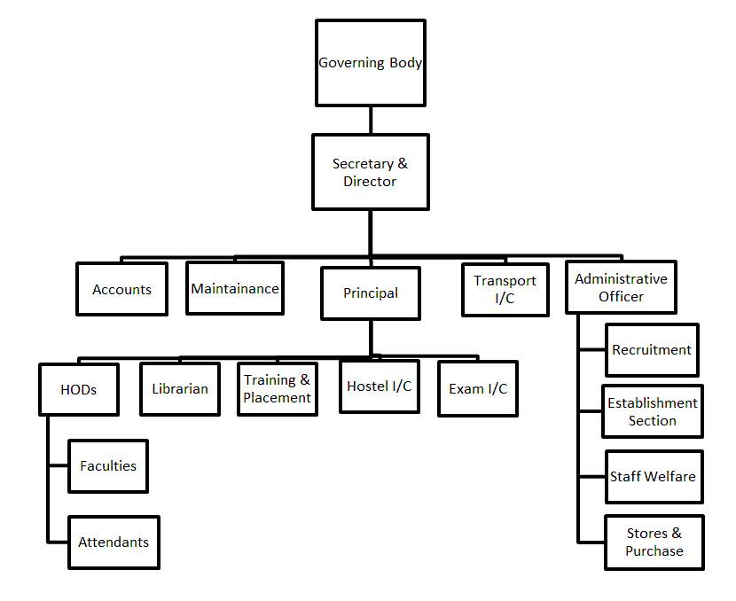

  - Nature and Extent of involvement of Faculty and students in academic affairs/improvements

    - The Philosophy behind Faculty Student Involvement: The Institute has been concentrating in Education, Training & Research on Engineering Technologies. These are globally recognized as emergent areas of rapid growth in the next two decades.
    - At GKCET, special emphasis has been placed on developing an environment highly conducive to building of a solid foundation of knowledge, personality development, confidence building, and pursuit of excellence, self-discipline and enhancement of creativity through motivation and drive. All Students are encouraged in multiple extracurricular areas.
    - Concept of Faculty Involvement: The faculty focuses on developing and strengthening systems thinking, problem solving, analysis, design, team work, communication skills and preparing students for lifelong learning. The faculty uses innovative techniques, interactive lectures, guided case studies, regular lab assignments, project work and critical and creative thinking.
    - Faculty Development Programme(s): GKCET believes in continuous training and development of its staff and teachers. The faculty is both multi-skilled and field specialized.
    - Interactive Sessions / Seminars / Lectures / Presentations are frequently organized; both in house and by inviting eminent external speakers to improve the quality of knowledge and skills.
    - Students are encouraged to explore the environment through participation in professional / curricular / co-curricular activities outside the Institute.
    - System of student mentoring has been put in place. Feedback is analysed at Departmental levels as also during meetings of various forums to imbibe and include new and valid suggestions.
    - Faculty is encouraged for undertaking R&D projects and do research to upgrade their knowledge.
    - Faculty is supported through to attend conferences / presentations / seminars and submit the reports, which are shared in the department for mutual benefit and enhancement of knowledge.
    - A system of student feedback on faculty and teaching is in place. The student feedback analysis is considered by the management and appropriate points implemented for further improvement.

Mechanism/ Norms and Procedure for democratic/ good Governance
    - The management recognizes the need for decentralization for the growth of the institute and accords autonomy commensurate with the level of management. Deans and heads are appointed who are given autonomy for efficient governance.
    - The roles and responsibilities of administrators / decision makers for various assigned jobs listed below clearly depict the delegation of authority, providing operational autonomy leading to a decentralized governance system.
- Principal
  - To implement and monitor the education system to cater to the institute’s vision and
mission.
- R & D
  - Monitors Research and Development activities in the institute
- Administrative Officer
  - Is responsible for supervision and management of all administrative and operational functions, to develop a strategic plan for the growth and image of the institute to initiate and monitor various student activities.
- Head of the Department
  - Is responsible for the academic and administrative functions of the department. In addition, Development Officer, Accounts Officer, Librarian, Workshop Superintendent take care of office related activities, finance related issues, library resources and workshop related activities. Other support functions are handled by the Admission-in-charge, College Examination Officer, Industry Institute Interaction Cell Coordinator, Academic & Research Coordinator, NSS coordinator.
- At the Department Level:
  - UG program has coordinators
  - Preparation of academic calendar based on time frame set by the University for planning and organizing of activities is done by Time Table co-ordinator.
  - Each course has a course co-ordinator who, in consultation with the faculty teaching the subject, sets course objectives, prepares the teaching plan for the semester, conducts meetings with faculty regularly to monitor and review course completion and attainment of course outcomes and submits a report of the same to PAC through the module coordinator .
  - Class teachers/batch guardians are designated for all classes/batches

Student Feedback on Institutional Governance/ Faculty performance
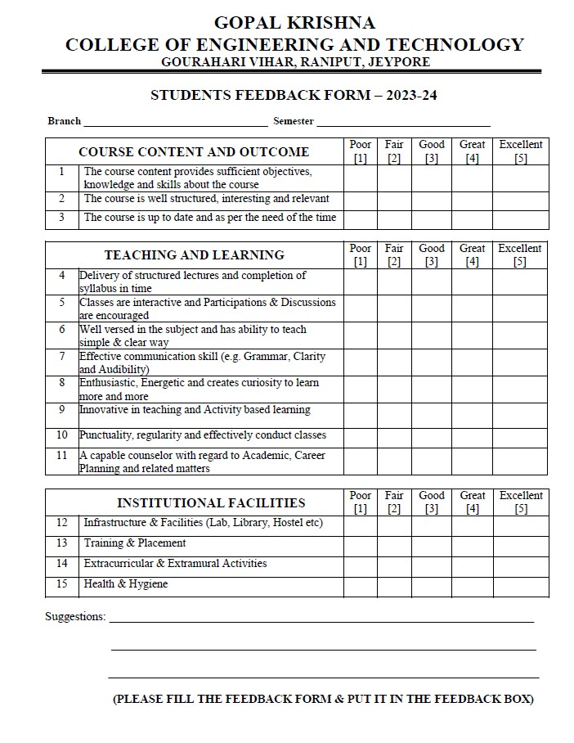

- Grievance Redressal mechanism for Faculty, staff and students
  - Grievances of Faculty and staff: These are redressed through normal channel of Development Officer----> HODs ----> Vice-Principal > Principal. The decision of
Principal is final.
  - Students : -
- Through Class Teacher / HOD then to Development Officer / Vice-Principal in matters other than Academics.
- Through respective Course Co-ordinators / Class Teachers ----> HODs >
Vice-Principal > Principal in Academic matters.

Establishment of Anti Ragging Committee
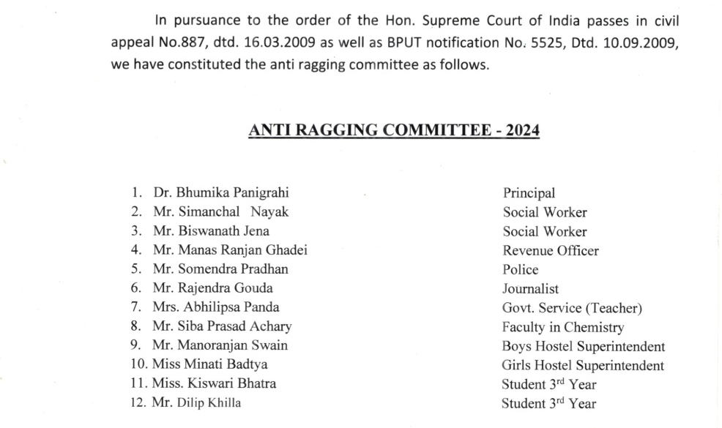

- Establishment of Online Grievance Redressal Mechanism
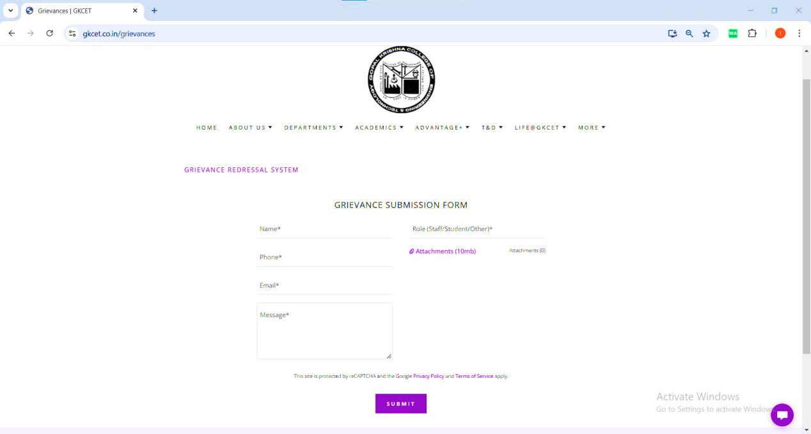

Establishment of Grievance Redressal Committee in the Institution and Appointment of OMBUDSMAN

  - Committee Type: Grievance Redressal
  - Appointment Order Reference Number; GKCET/2023/2718(08)
  - Date of Appointment-31.12.2023
  - Name of the Committee Member: Himansu Sekhar Nahak
  - Address; Jeypore
  - Mobile No.: 9778624624
  - E-Mail Id: gkcet.hsn@gmail.com
  - Designation: Administrative Officer
  - Department: Science & Humanities

Establishment of Internal Complaint Committee (ICC)

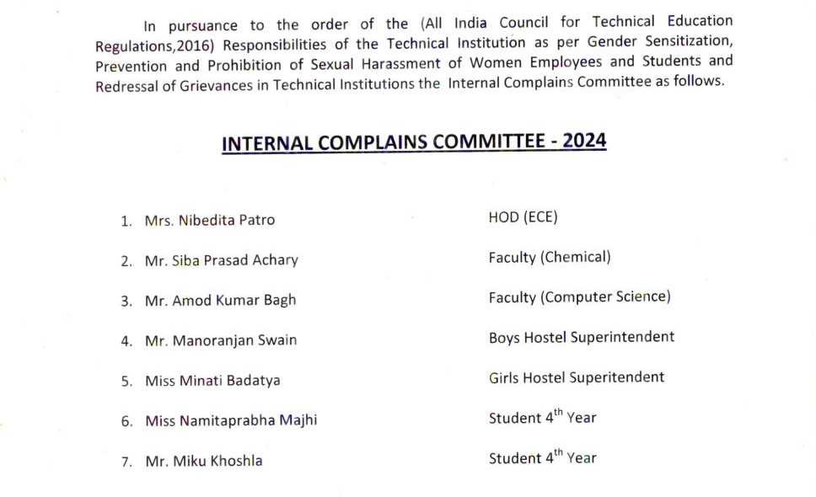
- Establishment of Committee for SC/ ST

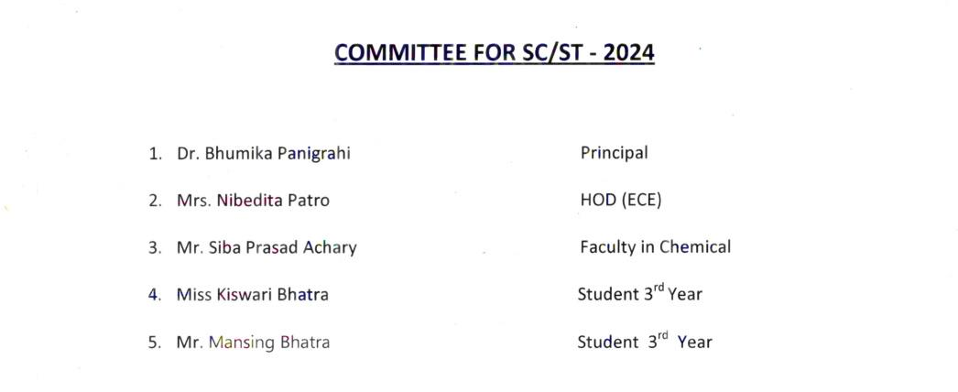

Internal Quality Assurance Cell (IQAC)

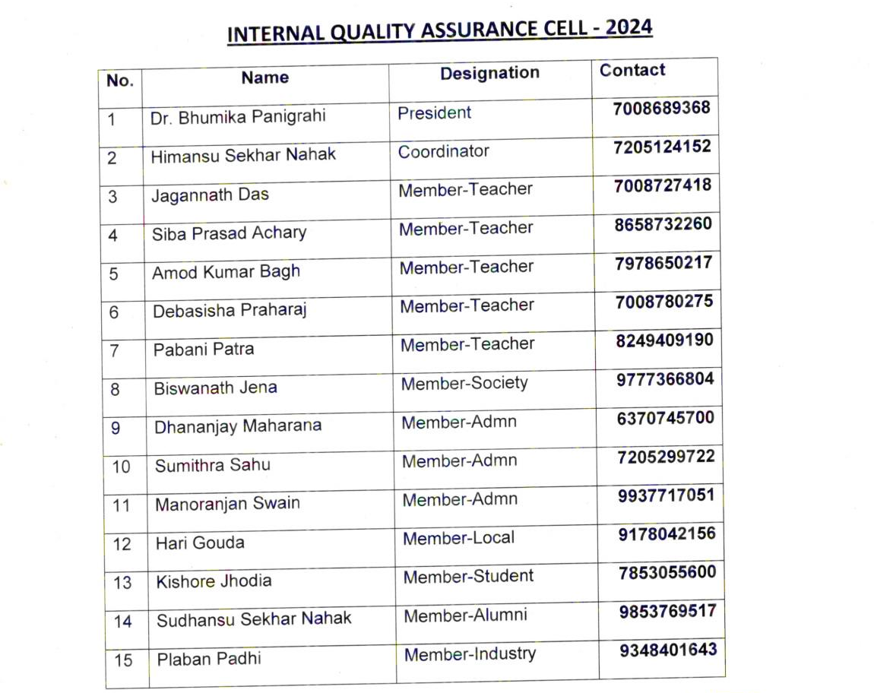

Programmes
  - Name of Programmes approved by AICTE : B.Tech
    - Total number of Courses : 7

  - For each Programme the following details are to be given:

    - Name: Civil Engineering
    - Number of seats: 60
    - Duration: 4
    - Cut off marks/rank of admission during the last three years : 45% for General Students and 40% for SC & ST Students
    - Fee: Rs.45,000/-
    - Placement Facilities: YES
    - Campus placement in last three years with minimum salary, maximum salary and average salary:
2023-24: Min Salary: 2LPA Maximum Salary: 3LPA & Average Salary: 3LPA
    - Name: Electrical Engineering
    - Number of seats: 60
    - Duration: 4
    - Cut off marks/rank of admission during the last three years : 45% for General Students and 40% for SC & ST Students
    - Fee: Rs.45,000/-
    - Placement Facilities: YES
    - Campus placement in last three years with minimum salary, maximum salary and average salary:
2023-24: Min Salary: 2LPA Maximum Salary: 3LPA & Average Salary: 3LPA
    - Name: Computer Science & Engineering
    - Number of seats: 60
    - Duration: 4
    - Cut off marks/rank of admission during the last three years : 45% for General Students and 40% for SC & ST Students
    - Fee: Rs.45,000/-
    - Placement Facilities: YES
    - Campus placement in last three years with minimum salary, maximum salary and average salary – NEW BRANCH in 2023
    - Name: Biotechnology
    - Number of seats: 30
    - Duration: 4
    - Cut off marks/rank of admission during the last three years : 45% for General Students and 40% for SC & ST Students
    - Fee: Rs.45,000/-
    - Placement Facilities: YES
Campus placement in last three years with minimum salary, maximum salary and average salary – NEW BRANCH in 2023
    - Name: Chemical Engineering
    - Number of seats: 30
    - Duration: 4
    - Cut off marks/rank of admission during the last three years : 45% for General Students and 40% for SC & ST Students
    - Fee: Rs.45,000/-
    - Placement Facilities: YES
Campus placement in last three years with minimum salary, maximum salary and average salary – NEW BRANCH in 2023
    - Name: Electronics & Telecommunications Engineering
    - Number of seats: 30
    - Duration: 4
    - Cut off marks/rank of admission during the last three years : 45% for General Students and 40% for SC & ST Students
    - Fee: Rs.45,000/-
    - Placement Facilities: YES
    - Campus placement in last three years with minimum salary, maximum salary and average salary:
2023-24: Min Salary: 2LPA Maximum Salary: 3LPA & Average Salary: 3LPA
    - Name: Mechanical Engineering
    - Number of seats: 60
    - Duration: 4
    - Cut off marks/rank of admission during the last three years : 45% for General Students and 40% for SC & ST Students
    - Fee: Rs.45,000/-
    - Placement Facilities: YES
    - Campus placement in last three years with minimum salary, maximum salary and average salary:
2023-24: Min Salary: 2LPA Maximum Salary: 3LPA & Average Salary: 3LPA

Faculty
  - Branch wise list Faculty members:

BRANCH | PERMANENT FACULTY | ADJUNCT FACULTY | PERMANENT FACULTY: STUDENT RATIO :
Civil Engineering | 9 | 0 | 20:1
Electronics & Telecommunication Engineering | 5 | 0 | 20:1
Mechanical Engineering | 9 | 0 | 20:1
Electrical Engineering | 9 | 0 | 20:1
Computer Science & Engineering | 3 | 0 | 20:1
Chemical Engineering | 3 | 0 | 20:1
Biotechnology | 3 | 0 | 20:1
Basic Science & Humanities | 7 | 0 | 20:1

Profile of Principal/ Faculty

No. | Name | Designation | Qualification | Appointment Type | Appointment Date
1 | Dr. Bhumika Panigrahi | Principal | Ph.d | Regular | 1-11-2002
2 | Smarita Lenka | Assistant Professor | M.Sc | Regular | 1-05-2023
3 | Dr. Susmita Mahapatra | Assistant Professor | Ph.d | Regular | 18-12-2024
4 | Subhasmita Panda | Assistant Professor | M.Sc | Regular | 2-04-2024
5 | P Ramakrishnan | Assistant Professor | PhD | Regular | 23-09-2024
6 | Bijaya Kumar Maharana | Assistant Professor | M.Sc | Regular | 10-06-2017
7 | Prince Das | Assistant Professor | M.Sc | Regular | 15-07-2016
8 | Siba Prasad Achary | Assistant Professor | M.Sc | Regular | 3-12-2010
9 | Maruwada Srinivasan | Assistant Professor | M.Tech | Regular | 29-07-2008
10 | Pabani Patra | Assistant Professor | M.Tech | Regular | 11-09-2017
11 | Umarani Pujari | Assistant Professor | B.Tech | Regular | 15-11-2022
12 | Valachiti Chaitanya | Assistant Professor | B.Tech | Regular | 13-02-2024
13 | Ambika Nahak | Assistant Professor | M.Tech | Regular | 1-10-2011
14 | Bhupendra Pratap Dongri | Assistant Professor | M.Tech | Regular | 20-09-2017
15 | Puja Maharana | Assistant Professor | M.Tech | Regular | 29-08-2018
16 | Swikruti Tripathy | Assistant Professor | M Sc | Regular | 05-12-2024
17 | Amod Kumar Bagh | Assistant Professor | M.Tech | Regular | 5-08-2013
18 | Rameswari Pattnaik | Assistant Professor | B.Tech | Regular | 22-08-2015
19 | Subrat Prasad Rath | Assistant Professor | M.Tech | Regular | 2-03-2012
20 | Jagannath Das | Assistant Professor | M.Tech | Regular | 14-08-2009
21 | Nibedita Patra | Assistant Professor | M.Tech | Regular | 16-10-2001
22 | Suvendu Swain | Assistant Professor | M.Tech | Regular | 22-08-2015
23 | Sudhansu Sekhar Nahak | Assistant Professor | MBA | Regular | 12-07-2013
24 | Hrudaya Kumar Panigrahi | Assistant Professor | M.Tech | Regular | 5-02-2017
25 | Debashisa Praharaj | Assistant Professor | M.Tech | Regular | 3-02-2015
26 | Soumya Ranjan Rout | Assistant Professor | B.Tech | Regular | 13-02-2024
27 | R Hareram Krushna Reddy | Assistant Professor | B.Tech | Regular | 13-02-2024
28 | Ghanashyam Sahu | Assistant Professor | B.Tech | Regular | 15-05-2023
29 | Kusuma Oyal | Assistant Professor | B.Tech | Regular | 11-09-2023
30 | Debasish Sahu | Assistant Professor | M.Tech | Regular | 02-09-2024
31 | Sambeed Sourav Mahakul | Assistant Professor | M.Tech | Regular | 16-08-2018
32 | Manoranjan Choudhury | Assistant Professor | M.Tech | Regular | 14-04-2012
33 | Rashmi Mishra Ranjan | Assistant Professor | M.Tech | Regular | 30-08-2013
34 | Tapan Kumar Nayak | Assistant Professor | M.Tech | Regular | 14-08-2005
35 | Chandranan Behera | Assistant Professor | B.Tech | Regular | 13-08-2014
36 | Shantanu Kumar Maity | Assistant Professor | M.Tech | Regular | 20-12-2023
37 | Pradeep Kumar Nahak | Assistant Professor | B.Tech | Regular | 6-09-2017
38 | Himansu Sekhar Sethi | Assistant Professor | M.Tech | Regular | 22-02-2019
39 | Deepak Kumar Dip | Assistant Professor | M.Tech | Regular | 02-09-2024
40 | Mohit Kumar Aruk | Assistant Professor | M.Phil | Regular | 16-08-2008
41 | Sumithra Sahu | Assistant Professor | MBA | Regular | 12-09-2022
42 | Sirisha Bisoi | Assistant Professor | MA | Regular | 1-09-2021
43 | Himansu Sekhar Nahak | Assistant Professor | M.Com | Regular | 1-07-2011
44 | Punam Dalai | Assistant Professor | M.Sc | Regular | 6-09-2019
45 | Dinesh Mahato | Assistant Professor | M.Sc | Regular | 9-11-2022
46 | Dhananjay Moharana | Assistant Professor | MA | Regular | 14-08-2015
47 | Anjali Pangi | Assistant Professor | MA | Regular | 01-11-2024
48 | Rakhi Baidya | Assistant Professor | MA | Regular | 2-01-2023

- Fee

- Details of fee, as approved by State Fee Committee, for the Institution: Rs.45,000/-(Tuition Fee)
- Time schedule for payment of fee for the entire programme:
2 to 3 Instalments
  - 1st Instalment (10 – 20%) at the time of Admission
  - 2nd Instalment (20 – 40%) before 1st Semester
  - 3rd Instalment (rest 35-40%) before 2nd Semester
- No. of Fee waivers granted with amount and name of students: 5% of Approved Intake i.e. Total No.=6 Amount: Rs. 45,000/- of each stuudent
Names: 1. Soumya Ranjan Biswal – Civil Engineering
- Harapriya Dhal - Civil Engineering
- Kamesh Barik – Mechanical Engineering
- Sibaprasad Behera - Mechanical Engineering
- Number of scholarship offered by the Institution, duration and amount: 1, Duration: 4 Years and Amount: Rs.31,500 – Rs.45,000/-
- Criteria for fee waivers/scholarship:
  - >= 70% in +2, 100% Tuition Fee Waiver
  - >= 60% in +2, 50% Tuition Fee Waiver
- Estimated cost of Boarding and Lodging in Hostels: Rs.20,000/-

Admission
  - Number of seats sanctioned with the year of approval: 330
  - Number of Students admitted under various categories each year in the last four years:
AICTE Approved Intake during last 4 years
Level | Courses | 1st Year of approval by  AICTE | 2021-22 |  | 2022-23 |  | 2023-24 |  | 2024-25 |  | Status of Accreditation (Validityperiod)
Level | Courses | 1st Year of approval by  AICTE | Approved Intake | Actual Admn. | Approved Intake | ActualAdmn. | Approved  Intake | Actual Admn. | Approved  Intake | ActualAdmn. | Status of Accreditation (Validityperiod)
UG -  B.  Tech | Civil | 1999 | 60` | 33+59 | 60` | 16+33 | 60 | 10+50 | 60 | 24+20 | No
UG -  B.  Tech | Electrical | 1999 | 30 | 06+29 | 30 | 02+21 | 60 | 01+20 | 60 | 06+15 | No
UG -  B.  Tech | ETC | 2003 | 30 | 01+02 | 30 | 01+01 | 30 | 02+04 | 30 | 03+03 | No
UG -  B.  Tech | Mechanical | 2013 | 30 | 02+54 | 30 | 09+26 | 60 | 05+24 | 60 | 01+21 | No
UG -  B.  Tech | Computer Science | 2023 | - | - | - | - | 60 | 09+00 | 60 | 14+18 | No
UG -  B.  Tech | Biotechnology | 2023 | - | - | - | - | 30 | 01+00 | 30 | 07+06 | No
UG -  B.  Tech | Chemical | 2023 | - | - | - | - | 30 | 02+00 | 30 | 01+30 | No

Admission Procedure
  - Mention the admission test being followed, name and address of the Test Agency and its URL (website)
    - Admission Test: JEEMAIN
    - Name and Address of the Test Agency: National Testing Agency
Block C-20 1A/8 ,Sector- 62
IITK Outreach Centre, Gautam Buddh Nagar Noida-201309, Uttar Pradesh (India)
    - URL (Website): https://nta.ac.in/
    - Admission Test: OJEE
    - Name and Address of the Test Agency: Odisha Joint Entrance Examination
Gandamunda, Bhubaneswar, Odisha
    - URL (Website): https://ojee.nic.in/

Criteria & Weightage of Admission

As per JEE MAIN or OJEE Rankings & Counseling Procedure

List of Applicants

Not Applicable

Results of Admission under Management Quota

Not Applicable

Information of Infrastructure and Other Resources Available
  - Number of Class Rooms: 12 and size of each: 66 (Sq.m)
  - Number of Tutorial rooms: 3 and size of each: 33 (Sq.m)
  - Number of Laboratories: 35 and size of each: 66 (Sq.m)
  - Number of CAD Centre: 1 with capacity of each: 132 (Sq.m)
  - Number of Computer Centres: 2 with capacity of each: 150 (Sq.m)
  - Central Examination Facility: YES
  - Barrier Free Built Environment for disabled and elderly persons: YES
  - Occupancy Certificate: YES
  - Fire and Safety Certificate: YES
  - Hostel Facilities: YES, Separate Hostel for BOYS & GIRLS
  - Library
    - Number of Library books:16244, Titles: 2150 Journals available: 48
    - List of online National: 30 International Journals subscribed: 30
    - DELNET Subscription Available
  - Ε Library: 15 Systems with internet connectivity available
  - NDL Membership Available
  - Laboratory and Workshop
    - List of Major Equipment/Facilities in each Laboratory/ Workshop: Refer website: https://gkcet.co.in →Department → Branch
    - List of Experimental Setup in each Laboratory/ Workshop: Refer website: https://GKCET.ac.in/
https://gkcet.co.in →Department → Branch
  - Computing Facilities
    - Internet Bandwidth: 70Mbps
    - Number and configuration of System: 100
    - Total number of system connected by LAN: 100

  - VARIOUS COMMITTEES & CELLS
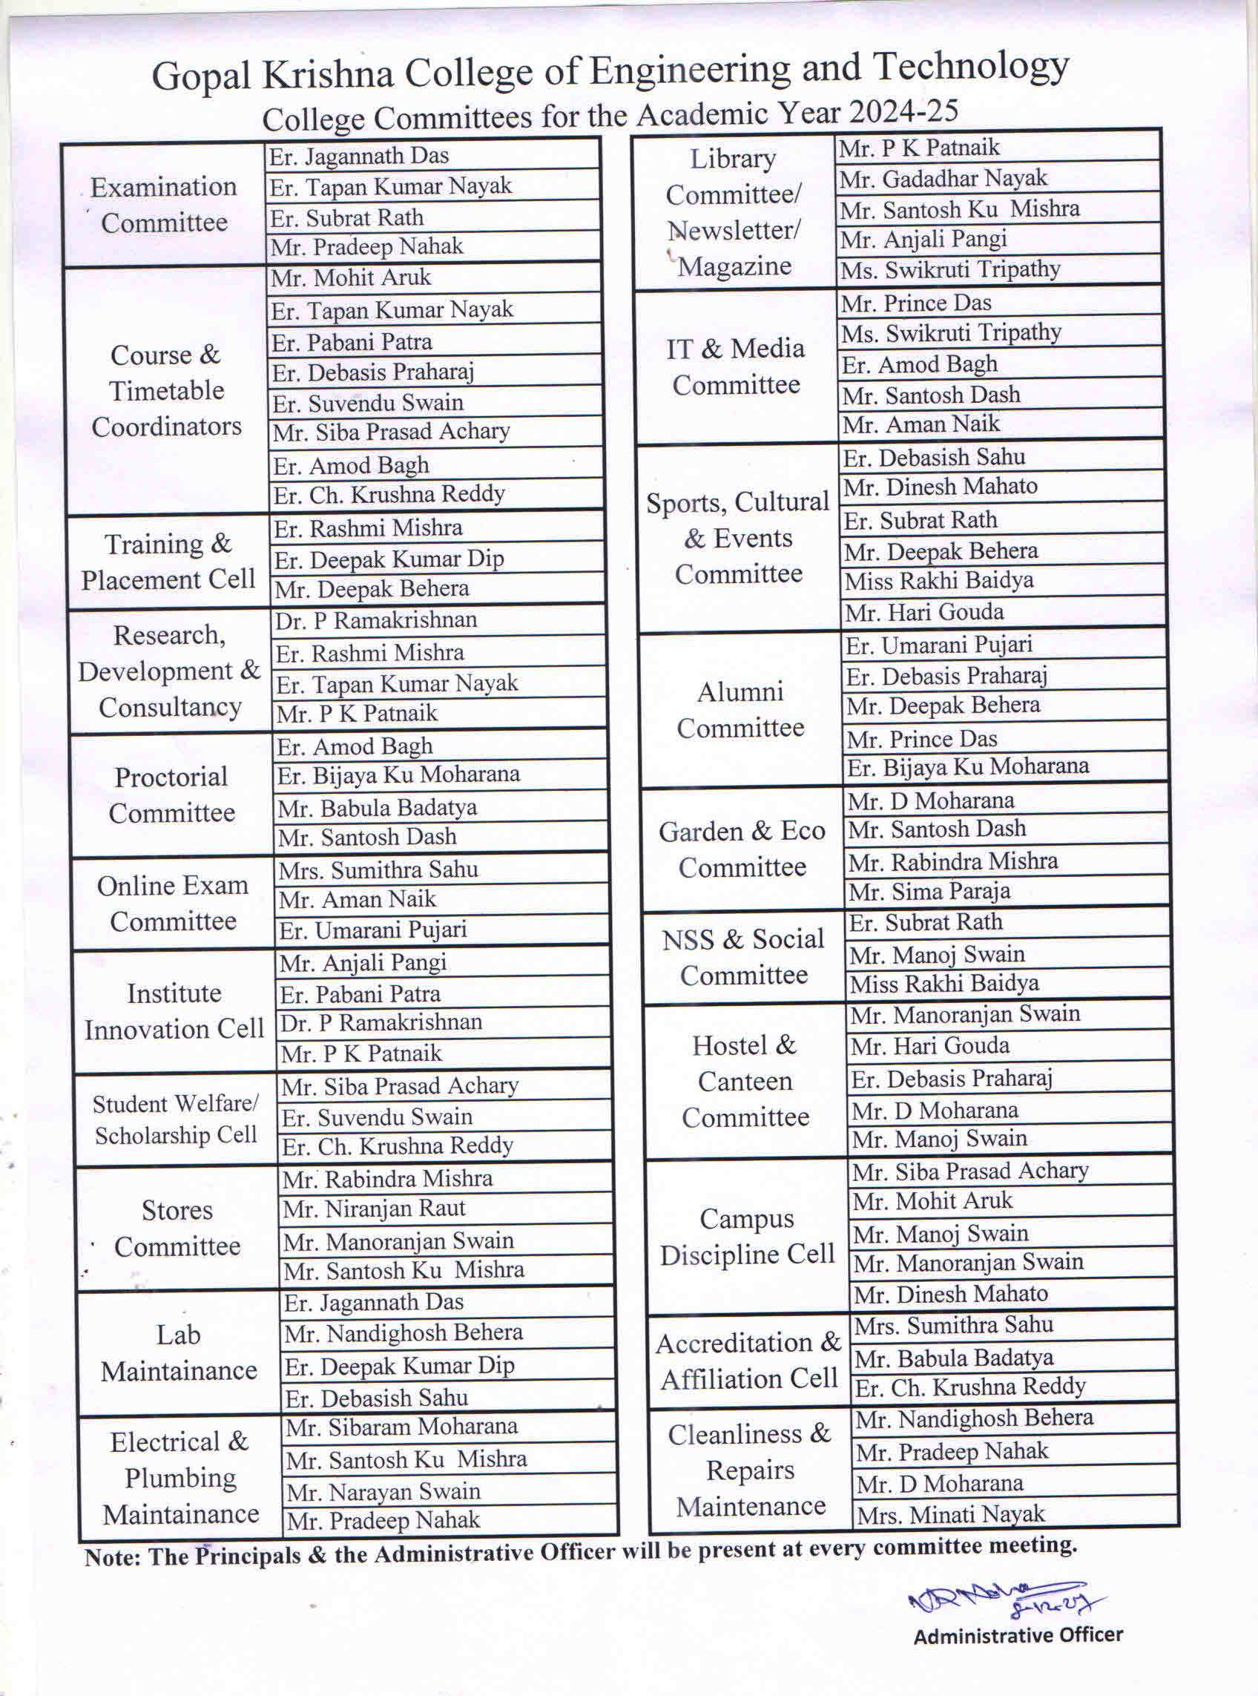

    - List of facilities available: Refer website: https://gkcet.co.in →Life@Campus → Facility
    - Games and Sports Facilities: Refer website: https://gkcet.co.in →Life@Campus → Sports & Cultural
    - Extra-Curricular Activities: Refer website: https://gkcet.co.in →Life@Campus
    - Soft Skill Development Facilities: Refer https://gkcet.co.in/training
  - Teaching Learning Process
    - Curricula and syllabus for each of the programmes as approved by the University: YES
    - Academic Calendar of the University: Please Refer Quick Links→ https://gkcet.co.in/time-table
    - Academic Time Table with the name of the Faculty members handling the Course: Please Refer Quick Links→https://gkcet.co.in/time-table
    - Teaching Load of each Faculty: Please Refer Quick Links→https://gkcet.co.in/time-table
    - Internal Continuous Evaluation System and place: YES
    - Student’s assessment of Faculty, System in place: YES

Enrollment of students in the last 4 years
AICTE Approved Intake during last 4 years
Level | Courses | 1st Year of approval by  AICTE | 2021-22 |  | 2022-23 |  | 2023-24 |  | 2024-25 |  | Status of Accreditation (Validityperiod)
Level | Courses | 1st Year of approval by  AICTE | Approved Intake | Actual Admn. | Approved Intake | ActualAdmn. | Approved  Intake | Actual Admn. | Approved  Intake | ActualAdmn. | Status of Accreditation (Validityperiod)
UG -  B.  Tech | Civil | 1999 | 60` | 33+59 | 60` | 16+33 | 60 | 10+50 | 60 | 24+20 | No
UG -  B.  Tech | Electrical | 1999 | 30 | 06+29 | 30 | 02+21 | 60 | 01+20 | 60 | 06+15 | No
UG -  B.  Tech | ETC | 2003 | 30 | 01+02 | 30 | 01+01 | 30 | 02+04 | 30 | 03+03 | No
UG -  B.  Tech | Mechanical | 2013 | 30 | 02+54 | 30 | 09+26 | 60 | 05+24 | 60 | 01+21 | No
UG -  B.  Tech | Computer Science | 2023 | - | - | - | - | 60 | 09+00 | 60 | 14+18 | No
UG -  B.  Tech | Biotechnology | 2023 | - | - | - | - | 30 | 01+00 | 30 | 07+06 | No
UG -  B.  Tech | Chemical | 2023 | - | - | - | - | 30 | 02+00 | 30 | 01+30 | No

- MoUs with Industries:

Please Refer Website Link: https://gkcet.co.in/mous

- LoA and subsequent EoA till the current Academic Year:
Please Refer Website Link: https://gkcet.co.in/accreditation%2Faffiliation

