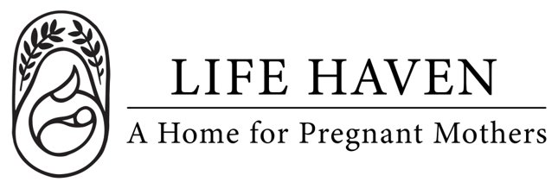
Job Title:
Publishing
Committee Member

Employment Type: Part-time Volunteer Location: Remote

About the Organization
Life Haven is a Christ-centered residential ministry providing safe housing, support, and guidance to women experiencing unplanned pregnancies and early motherhood. Our mission is to create a nurturing environment where residents can grow spiritually, emotionally, and practically.

Position Summary
We are seeking a volunteer member to join our Publishing Committee. This committee supports the organization’s communication, branding, and storytelling efforts through strategic guidance, content development, and promotional support. The ideal volunteer is a collaborative, mission-driven communicator with skills or interest in marketing, writing, design, or digital outreach.

Key Responsibilities
- Contribute to the planning and execution of marketing and communication initiatives to promote the organization’s programs, events, and campaigns.
- Assist in developing content for newsletters, website, and social media.
- Provide input on branding, publications, and other promotional materials.
- Support the development and distribution of print and digital marketing materials.
- Help identify media opportunities and community engagement strategies.
- Attend committee meetings and participate in team discussions and planning.
- Collaborate with staff and other volunteers to ensure consistent messaging and alignment with the organization’s mission.

Qualifications
- Strong interest in nonprofit marketing, communications, or public relations.
- Excellent communication, writing, or editing skills.
- Experience or familiarity with any of the following is a plus: graphic design, digital marketing, social media management, or publication layout.
- Ability to work collaboratively as part of a team of volunteers and staff.
- Commitment to the organization’s mission and values.
- Maintain confidentiality of sensitive organizational and client information.

Spiritual & Personal Attributes
- Committed follower of Jesus Christ with a desire to serve women and children in a ministry setting.
- Team player who is flexible, dependable, and proactive in problem-solving.

Work Environment & Schedule
- This is a remote position.
- 5-10 hours per month, flexible schedule.
- Attendance at weekly committee meetings required (1 hour per week). Can be scheduled around your availability.
- Collaborative and supportive work environment centered on faith and mission.

Compensation & Benefits
- The personal satisfaction of serving women and children in a life-changing, Christ-centered environment.
- This is a volunteer position, no financial compensation is provided.
- If you are interested in this position but you need financial compensation, reach out anyway! We want to work with the right people and we believe we God will provide what’s needed for the success of this mission.

