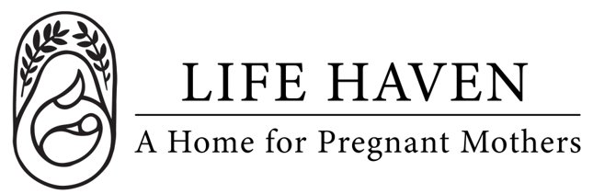
Job Title:
Operations Manager

Employment Type: Part-time Paid Location: Lynnwood, Arlington, Remote

About the Organization
Life Haven is a Christ-centered residential ministry providing safe housing, support, and guidance to women experiencing unplanned pregnancies and early motherhood. Our mission is to create a nurturing environment where residents can grow spiritually, emotionally, and practically.

Position Summary
We are seeking a paid Operations Manager to oversee the operations of the Life Haven house and internal departments. Your role will be to support the Residence manager and staff of the home and ensure that residents are happy and that regulatory compliance is maintained. You will also support the internal volunteer staff of Life Haven and provide a single point of communication between the managers of the organization and the Board of Directors.

Key Responsibilities
- Weekly meetings with Residence Manager and Case Manager, as well as other house staff
- Attend and participate in the intake and exit interviews of each resident
- Provide phone support for emergency situations within the home
- Support the Volunteer Coordinator and ensure that open positions within the organization are filled in a timely manner
- Support the Marketing and Advancement teams to ensure the coordinated success of the ministry
- Obtain background checks for volunteers who work in the home or yard
- Oversee the updating of job descriptions for Residence Manager, Case Manager, and Volunteers when necessary
- Review and update policies and procedural manuals biannually, and as needed
- Escalate issues to the Board of Directors for decision
- Ensure proper compliance and documentation of established policies and procedures
- Ensure the home maintains appropriate cleanliness and safety with regular visits.
- Schedule and assure compliance with house maintenance requirements (i.e. changing of furnace filter every 6 months and checking of fire alarms every month)

Qualifications
- Prior management or human resource experience, demonstrating an ability to delegate tasks and follow up for completion
- Dependable, stable, and capable of following through on commitments
- Always demonstrate respect for all residents, staff, and volunteers
- Complete a criminal background history, which includes a central registry for child abuse
- Administrative, organizational, and record-keeping skills including proficiency in Microsoft Office, Google Workspace, or similar software
- Excellent written and verbal communication skills
- Maintain confidentiality of sensitive organizational and client information.

Spiritual & Personal Attributes
- Committed follower of Jesus Christ with a desire to serve women and children in a ministry setting
- A regular attendee and in good standing with a local church whose doctrine and practices align with the Mission, Statement of Faith, and Values of Life Haven
- Exhibits a strong commitment to the pro-life position
- Team player who is flexible, dependable, and proactive in problem-solving

Work Environment & Schedule
- This position requires both remote work and in person visits to the home in Arlington (minimum once per week), and the office in Lynnwood (for monthly board meetings)
- 20 hours a week, flexible schedule.
- Collaborative and supportive work environment centered on faith and the mission

Compensation & Benefits
- The compensation range for this position is determined on experience
- Time off is negotiable and flexible with adequate prior communication to the Board of Directors

