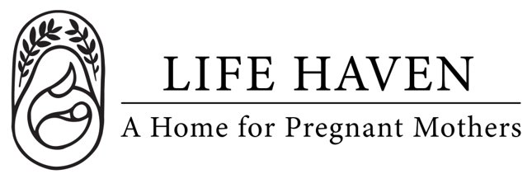
Job Title:
Resident Assistant (Overnight Staff)

Employment Type: Full-Time / Part-Time / Live-In / Overnight Shift Location: Arlington, WA

About the Organization
Life Haven is a Christ-centered residential ministry providing safe housing, support, and guidance to women experiencing unplanned pregnancies and early motherhood. Our mission is to create a nurturing environment where residents can grow spiritually, emotionally, and practically.

Position Summary
The Resident Assistant (RA), also known as an Overnight Staff Member, plays a key role in maintaining a safe, structured, and nurturing home environment. The RA supports residents by modeling healthy living, encouraging personal growth, and helping ensure that the daily operations of the home run smoothly.

This position requires maturity, empathy, and a heart for service — balancing compassion with consistent boundaries and accountability.

Key Responsibilities
- Provide supervision and support to residents during assigned shifts (day, evening, or overnight).
- Ensure a calm, safe, and orderly home environment that aligns with program rules and values.
- Build positive, mentoring relationships with residents through daily interactions and encouragement.
- Respond to resident needs, conflicts, or emergencies with professionalism and empathy.
- Conduct regular house checks to ensure cleanliness, safety, and adherence to routines.
- Support residents in developing life skills (e.g., cooking, cleaning, budgeting, parenting).
- Monitor curfews, visitor policies, and other program guidelines.
- Document daily activities, incidents, and progress notes in accordance with program procedures.
- Coordinate with case managers and other staff to communicate resident concerns or needs.
- Participate in staff meetings, trainings, and resident-related discussions as needed.
- For overnight shifts: remain awake and alert throughout the night, perform safety rounds, and provide assistance in emergencies.

Qualifications
- Prior experience in residential care, social services, ministry, or childcare preferred.
- Ability to set healthy boundaries and model respect, responsibility, and integrity.
- Strong communication, conflict resolution, and problem-solving skills.
- Ability to handle sensitive information with confidentiality and professionalism.
- Must pass background checks and meet all state/local licensing requirements.
- CPR/First Aid certification (or willingness to obtain).
- Valid driver’s license and reliable transportation (if transporting residents).

Preferred Attributes
- Warm, patient, and empathetic demeanor.
- Flexible and dependable — able to adapt to changing needs or schedules.
- Strong role model with a nurturing but firm approach.
- Comfortable working with diverse populations and backgrounds.

Schedule & Work Environment
- Shifts may include days, evenings, weekends, or overnights.
- Live-in or on-call options may be available depending on home structure.
- Work is performed in a residential setting with a mix of independent and team-based responsibilities.

Compensation & Benefits
- [Specify hourly rate, stipend, housing allowance, or benefits if applicable.]
- The personal satisfaction of serving women and children in a life-changing, Christ-centered environment.
- This is a volunteer position.
- If you are interested in this position but you need financial compensation, reach out anyway! We want to work with the right people and we believe we God will provide what’s needed for the success of this mission.

