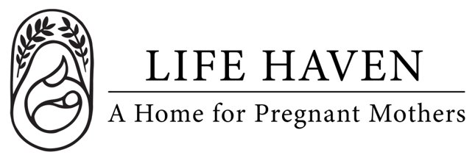
Job Title:
Office Assistant

Employment Type: Part-time Paid Location: Lynnwood

About the Organization
Life Haven is a Christ-centered residential ministry providing safe housing, support, and guidance to women experiencing unplanned pregnancies and early motherhood. Our mission is to create a nurturing environment where residents can grow spiritually, emotionally, and practically.

Position Summary
We are seeking a paid Office Assistant to help with clerical and organizational duties for Life Haven. This position includes working in the Life Haven office in Lynnwood organizing files, entering data for new contacts, making phone calls as needed, pulling reports from various software applications, and other clerical activities. We will teach you if you are willing to learn!

Key Responsibilities
- Perform general administrative duties (filing, data entry, scanning, copying)
- Prepare correspondence, reports, and basic documents
- Maintain office supplies and place orders as needed
- Support staff with clerical and operational needs
- Maintain organized physical and digital filing systems
- Handle incoming and outgoing mail and deliveries

Qualifications
- Strong organizational and time-management skills
- Proficiency in Microsoft Office (Word, Excel, Outlook) or similar software
- Basic computer and data entry skills
- Excellent written and verbal communication skills
- Ability to prioritize tasks effectively
- Attention to detail and accuracy
- Maintain confidentiality of sensitive organizational and client information.

Spiritual & Personal Attributes
- Committed follower of Jesus Christ with a desire to serve women and children in a ministry setting.
- Team player who is flexible, dependable, and proactive in problem-solving.

Work Environment & Schedule
- This is an in person position at the Lynnwood office.
- 3 or more hours a week, flexible schedule.
- Collaborative and supportive work environment centered on faith and mission.

Compensation & Benefits
- The personal satisfaction of serving women and children in a life-changing, Christ-centered environment.
- This is a volunteer position, no financial compensation is provided.
- If you are interested in this position but you need financial compensation, reach out anyway! We want to work with the right people!

