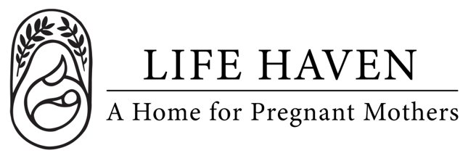
Job Title:
Client Services Coordinator

Employment Type: Part-Time Volunteer Location: Arlington, WA

About the Organization
Life Haven is a Christ-centered residential ministry providing safe housing, support, and guidance to women experiencing unplanned pregnancies and early motherhood. Our mission is to create a nurturing environment where residents can grow spiritually, emotionally, and practically.

Position Summary
The Client Services Coordinator ensures that all residents receive coordinated, high-quality care and support while living at the maternity home. This role involves managing resident schedules, overseeing program services, supporting staff and volunteers, and acting as a central point of contact for both residents and community partners.

The ideal candidate demonstrates organizational skill, compassion, and a heart for ministry, helping residents thrive in a Christ-centered environment.

Key Responsibilities
- Serve as the primary contact for residents regarding program schedules, services, and resources.
- Coordinate with Intake Coordinator, Case Manager, Resident Manager and other staff to ensure residents’ needs are met.
- Assist residents in connecting with healthcare, counseling, educational, and employment resources.
- Monitor resident progress and engagement in life skills classes, spiritual formation, and program activities.
- Maintain accurate records of services provided, appointments, and resident participation.
- Collaborate with volunteers, mentors, and external agencies to ensure effective service delivery.
- Support crisis management and conflict resolution, providing guidance and referrals as needed.
- Facilitate communication among staff, volunteers, and residents to ensure a seamless program experience.
- Participate in staff meetings, devotions, and prayer to maintain a unified ministry approach.
- Assist in evaluating and improving program services and procedures.

Qualifications
- Experience in case management, client services, or social service coordination.
- Strong organizational, communication, and interpersonal skills.
- Ability to handle sensitive situations with confidentiality, professionalism, and empathy.
- Knowledge of trauma-informed care, crisis intervention, and community resources.
- Proficiency with Microsoft Office, Google Workspace, and client management systems.
- Must pass background checks and comply with child and vulnerable adult protection policies.

Spiritual & Personal Attributes
- Committed follower of Jesus Christ with a desire to serve women and children in a ministry setting.
- Demonstrates compassion, patience, and strong relational skills.
- Encourages spiritual growth through prayer, mentoring, and Christ-centered guidance.
- Team player who supports collaboration, respect, and unity among staff and residents.
- Flexible, dependable, and proactive in problem-solving.

Work Environment & Schedule
- Primarily on-site at the maternity home, with occasional off-site meetings or community engagement.
- 5-10 hours per week.
- Collaborative and supportive work environment centered on faith and mission.

Compensation & Benefits
- The personal satisfaction of serving women and children in a life-changing, Christ-centered environment.
- This is a volunteer position, no financial compensation is provided.
- If you are interested in this position but you need financial compensation, reach out anyway! We want to work with the right people and we believe we God will provide what’s needed for the success of this mission.

