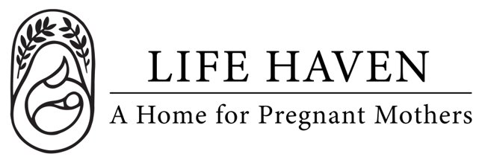
Job Title:
Volunteer Coordinator

Employment Type: Part-Time Volunteer Location: Remote

About the Organization
Life Haven is a Christ-centered residential ministry providing safe housing, support, and guidance to women experiencing unplanned pregnancies and early motherhood. Our mission is to create a nurturing environment where residents can grow spiritually, emotionally, and practically.

Position Summary
The Volunteer Coordinator is responsible for recruiting, training, and supporting volunteers to ensure that they are effectively integrated into the organization’s programs and events. This person serves as the primary point of contact for volunteers, maintaining strong relationships and ensuring that volunteer experiences are meaningful, rewarding, and aligned with the nonprofit’s mission.

Key Responsibilities
- Develop and implement a comprehensive volunteer management plan.
- Recruit, screen, and onboard new volunteers for various roles and programs.
- Coordinate volunteer schedules, assignments, and placements based on organizational needs.
- Maintain volunteer records and track hours, engagement, and feedback using volunteer management software or databases.
- Organize volunteer orientations, training sessions, and appreciation events.
- Serve as the main contact for volunteer communication, ensuring clear expectations and ongoing support.
- Collaborate with program staff to identify volunteer needs and develop role descriptions.
- Evaluate and enhance the volunteer program to improve retention, satisfaction, and impact.
- Promote volunteer opportunities through community outreach, social media, and partnerships with schools, churches, and civic groups.
- Ensure compliance with all organizational policies and safety procedures for volunteers.

Qualifications
- Experience in human resources, volunteer management, community engagement, or nonprofit program coordination.
- Strong interpersonal, communication, and leadership skills.
- Experience in hiring, recruitment, or public speaking.
- Background in training, mentorship, or team development.
- Ability to manage multiple projects, meet deadlines, and work collaboratively.
- Proficient or willingness to learn Microsoft Office, Google Workspace, and volunteer management tools (e.g., VolunteerHub, SignUpGenius).
- Passion for the mission and values of Life Haven.

Personal Attributes
- Warm, approachable, and inclusive leadership style.
- Strong organizational skills and attention to detail.
- Compassionate and mission-driven, with a genuine interest in empowering others to serve.

Compensation & Benefits
- The personal satisfaction of serving women and children in a life-changing, Christ-centered environment.
- This is a volunteer position, no financial compensation is provided.
- If you are interested in this position but you need financial compensation, reach out anyway! We want to work with the right people and we believe we God will provide what’s needed for the success of this mission.

