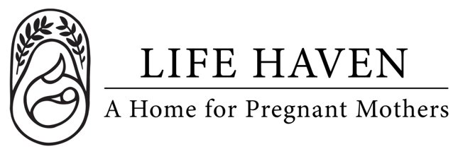
Job Title:
Case Manager

Employment Type: Part-Time Volunteer Location: Arlington, WA

About the Organization
Life Haven is a Christ-centered residential ministry providing safe housing, support, and guidance to women experiencing unplanned pregnancies and early motherhood. Our mission is to create a nurturing environment where residents can grow spiritually, emotionally, and practically.

Position Summary
The Case Manager serves as the primary advocate and support for each resident, guiding her through a Christ-centered program of healing, growth, and preparation for independent living. This role includes assessing needs, developing individualized service plans, coordinating resources, and walking alongside residents as they work toward spiritual, emotional, and practical stability.

The ideal candidate is compassionate, organized, and deeply committed to serving women through both professional excellence and ministry-minded care.

Key Responsibilities
- Conduct initial assessments and develop individualized case plans addressing each resident’s spiritual, emotional, educational, and life goals.
- Provide ongoing case management, goal-setting, and accountability sessions with residents.
- Connect residents with community resources such as healthcare, counseling, education, employment, and childcare.
- Coordinate with staff and volunteers to support residents’ progress in all aspects of the program.
- Maintain detailed case notes, progress reports, and documentation in accordance with confidentiality and program standards.
- Facilitate or arrange life-skills classes, parenting education, and spiritual enrichment activities.
- Participate in team meetings, prayer, and devotions to support a unified ministry approach.
- Communicate regularly with the Program Director about resident progress, needs, and challenges.
- Assist in crisis intervention and conflict resolution with professionalism and grace.
- Encourage spiritual growth through prayer, mentorship, and connection to local faith communities.
- Advocate for residents while promoting responsibility, personal accountability, and integrity.

Qualifications
- Experience in case management, social services, or residential ministry.
- Knowledge of trauma-informed care, pregnancy support, and family services.
- Excellent communication, organizational, and problem-solving skills.
- Ability to handle sensitive situations with empathy, discernment, and confidentiality.
- Proficient in Microsoft Office, Google Workspace, and case management or documentation systems.
- Must pass background checks and adhere to child and vulnerable adult protection policies.

Spiritual & Personal Attributes
- Committed follower of Jesus Christ with a desire to serve the ministry.
- Respectful and professional in interacting with residents, staff, volunteers, and visitors.
- Demonstrates reliability, integrity, and a servant’s heart.
- Willingness to contribute to the welcoming, faith-centered atmosphere of the home.

Work Environment & Schedule
- Primarily on-site at the maternity home; occasional off-site meetings or appointments.
- Flexible schedule; some evenings or weekends may be required.
- Collaborative environment centered on faith, teamwork, and mission.

Compensation & Benefits
- The personal satisfaction of serving women and children in a life-changing, Christ-centered environment.
- This is a volunteer position, no financial compensation is provided.
- If you are interested in this position but you need financial compensation, reach out anyway! We want to work with the right people and we believe we God will provide what’s needed for the success of this mission.

