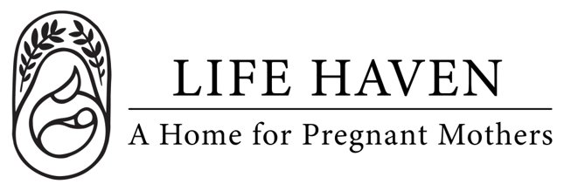
Position Title:
Advisory Committee Member / Professional Counsel

Employment Type: Part-time Volunteer Location: Remote

About the Organization
Life Haven is a Christ-centered residential ministry providing safe housing, support, and guidance to women experiencing unplanned pregnancies and early motherhood. Our mission is to create a nurturing environment where residents can grow spiritually, emotionally, and practically.

Position Summary
Advisory Committee Members provide guidance, expertise, and professional insight to support the organization’s mission, growth, and operational effectiveness. While they do not have direct management responsibilities, their counsel informs strategic decisions, program development, and best practices.

Committee members may represent areas of professional expertise such as healthcare, social services, law, finance, fundraising, counseling, or education. Members also serve as ambassadors for the organization in the community.

Key Responsibilities
- Provide professional expertise and guidance on policies, programs, and organizational development.
- Review and advise on strategic initiatives, program design, and operational challenges.
- Support best practices in areas such as maternal health, social work, legal compliance, finance, fundraising, or nonprofit governance.
- Attend advisory committee meetings (frequency typically quarterly or biannually) and participate in discussions.
- Provide feedback on program outcomes, evaluation processes, and impact assessment.
- Maintain confidentiality of sensitive organizational and client information.

Qualifications
- Professional experience or expertise in areas relevant to the maternity home’s mission (e.g., social work, healthcare, law, finance, counseling, nonprofit management, fundraising, or education).
- Commitment to the mission and values of the organization, including faith-aligned principles if applicable.
- Strong judgment, integrity, and the ability to provide constructive, strategic advice.
- Ability to attend meetings regularly and actively participate in discussions.
- Understanding of nonprofit operations, governance, or program development preferred but not required.

Spiritual & Personal Attributes
- Committed follower of Jesus Christ, with a desire to serve and support the ministry.
- Demonstrates servant leadership, humility, and integrity.
- Encourages the organization’s mission with prayer, guidance, and mentorship.
- Able to balance professional expertise with grace, discernment, and collaboration.

Time Commitment
- Typically 2–4 meetings per year (quarterly or biannually), with occasional committee work via email or calls.
- Participation in special events, fundraising efforts, or strategic planning sessions may be requested.
- Remote participation possible.

Compensation & Benefits
- The personal satisfaction of serving women and children in a life-changing, Christ-centered environment.
- This is a volunteer position, no financial compensation is provided.
- If you are interested in this position but you need financial compensation, reach out anyway! We want to work with the right people and we believe we God will provide what’s needed for the success of this mission.

