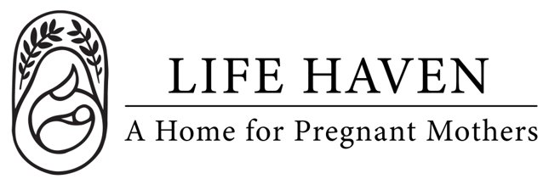
Job Title:
Social Media Manager

Employment Type: Part-time Volunteer Location: Remote

About the Organization
Life Haven is a Christ-centered residential ministry providing safe housing, support, and guidance to women experiencing unplanned pregnancies and early motherhood. Our mission is to create a nurturing environment where residents can grow spiritually, emotionally, and practically.

Position Summary
The Social Media Manager will play a key role in shaping the organization’s digital voice and presence. This individual will lead the development and execution of social media strategies that increase awareness, engagement, and support for our mission. The ideal candidate is both creative and analytical, passionate about social impact, and skilled at turning complex issues into compelling stories that resonate with audiences.

Key Responsibilities
- Develop and implement a comprehensive social media strategy aligned with the organization’s mission and communication goals.
- Manage and grow the organization’s presence across platforms including Instagram and Facebook.
- Create and curate engaging, mission-driven content — including graphics, videos, stories, and written posts — that highlight our impact.
- Plan and maintain a content calendar to ensure consistent posting and message alignment across channels.
- Engage with followers, respond to comments and messages, and foster an inclusive and supportive online community.
- Track and report on engagement metrics and campaign performance, using data to refine strategies.
- Collaborate with program staff to share impact stories and event updates.
- Support fundraising and advocacy campaigns through targeted social media initiatives.
- Stay current on social media trends, tools, and nonprofit digital communication best practices.

Qualifications & Preferred Skills
- Experience managing social media for a nonprofit or mission-driven organization preferred, but not required.
- Excellent storytelling, writing, and visual communication skills.
- Understanding of platform algorithms, analytics, and scheduling tools.
- Maintain confidentiality of sensitive organizational and client information.
- Experience with basic design and video tools (e.g., Canva, CapCut).
- Familiarity with digital fundraising or advocacy campaigns.

Spiritual & Personal Attributes
- Committed follower of Jesus Christ with a desire to serve women and children in a ministry setting.
- Demonstrates reliability, integrity, and a servant’s heart.
- Team player who is flexible, dependable, and proactive in problem-solving.

Work Environment & Schedule
- This is a remote position, with attendance of weekly Communication Committee meetings preferred but not required.
- 5-10 hours per month, flexible schedule.
- Collaborative and supportive work environment centered on faith and mission.

Compensation & Benefits
- The personal satisfaction of serving women and children in a life-changing, Christ-centered environment.
- This is a volunteer position, no financial compensation is provided.
- If you are interested in this position but you need financial compensation, reach out anyway! We want to work with the right people and we believe we God will provide what’s needed for the success of this mission.

