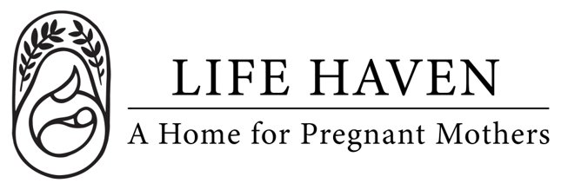
Job Title:
Prayer Network
Coordinator

Employment Type: Part-time Volunteer Location: Local Parish or Regional Area

About the Organization
Life Haven is a Christ-centered residential ministry providing safe housing, support, and guidance to women experiencing unplanned pregnancies and early motherhood. Our mission is to create a nurturing environment where residents can grow spiritually, emotionally, and practically.

Role Summary
The Parish Outreach Representative serves as a vital link between Life Haven and their parish community. This volunteer helps strengthen the connection between the organization and local faith communities by sharing information, promoting volunteer opportunities, and encouraging parish involvement in the nonprofit’s programs, events, and initiatives.

This is a wonderful opportunity for individuals who feel called to serve, connect with others, and be an ambassador for a mission-driven cause within their parish.

Key Responsibilities
- Serve as the primary liaison between Life Haven and the parish community.
- Share updates, announcements, and volunteer opportunities through parish bulletins, newsletters, and community boards.
- Represent the nonprofit at parish events.
- Encourage parishioners to participate in nonprofit programs, service projects, and fundraising efforts.
- Communicate parish feedback, interests, and needs to Life Haven’s Outreach team.
- Attend brief orientation/training sessions and occasional check-in meetings with the Outreach team (virtual or in-person).
- Promote collaboration between parish ministries and the nonprofit when appropriate.

Qualifications
- Active member of a Christian Church parish, Orthodox, Catholic, or Protestant.
- Strong interpersonal and communication skills.
- Reliable, organized, and comfortable speaking with parishioners or sharing information publicly.
- Passionate about community service and the mission of Life Haven.

Work Environment & Schedule
- Approximately 2–4 hours per month, flexible to your parish needs.
- Remote connection with Life Haven, meetings times are flexible and as needed.
- Work within your local parish, with the blessing of your parish pastor or priest.

Compensation & Benefits
- This is a volunteer position, no financial compensation is provided.
- Play an active role in extending the mission of Life Haven within your parish community.
- Strengthen parish engagement and promote acts of service and compassion.
- Gain experience in community outreach, faith-based engagement, and nonprofit communications.
- The personal satisfaction of serving women and children in a life-changing, Christ-centered environment.

