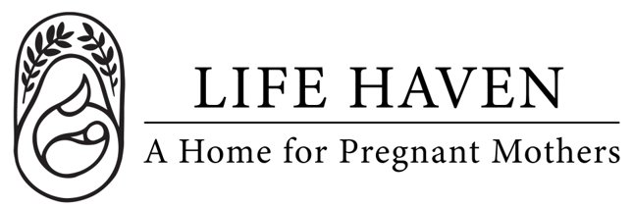
Job Title:
Intake Coordinator

Employment Type: Part-Time Volunteer Location: Remote

About Life Haven
Life Haven is a Christ-centered residential ministry providing safe housing, support, and guidance to women experiencing unplanned pregnancies and early motherhood. Our mission is to create a nurturing environment where residents can grow spiritually, emotionally, and practically.

Position Summary
The Intake Coordinator serves as the first point of contact for women seeking help and plays a crucial role in welcoming them with the love of Christ. This person listens with compassion, provides accurate information about the program, and helps each woman discern whether Life Haven is the right place for her journey.

The Intake Coordinator manages the intake and admissions process with professionalism, empathy, and spiritual sensitivity — ensuring that every applicant feels seen, heard, and valued.

Key Responsibilities
- Receive and respond promptly to phone calls, emails, and referrals from women, churches, and partner organizations seeking help.
- Provide caring, faith-centered support to each caller, offering prayer, encouragement, and practical next steps.
- Conduct thorough intake interviews to assess needs, eligibility, and readiness for the program.
- Collaborate with the Program Director and Case Manager to determine admissions decisions.
- Coordinate move-in logistics and ensure a smooth, welcoming transition for new residents.
- Maintain accurate intake records, documentation, and data in compliance with confidentiality and ethical standards.
- Track inquiries, referrals, and outcomes to evaluate program reach and effectiveness.
Qualifications
- Experience in intake, case management, counseling, or client services preferred.
- Strong interpersonal and communication skills, with the ability to listen compassionately and respond with discernment.
- Understanding of trauma-informed care, crisis intervention, and boundaries within ministry contexts.
- Ability to uphold confidentiality and exercise sound judgment.
- Proficiency with Microsoft Office, Google Workspace, or case management systems.
- Must pass background checks and comply with child and vulnerable adult protection policies.

Spiritual & Personal Attributes
- A committed follower of Jesus Christ with a heart for ministry and service.
- Demonstrates humility, grace, and patience when supporting women in crisis.
- Demonstrates reliability, integrity, and a servant’s heart.
- Team-oriented, flexible, and dependable.

Work Environment & Schedule
- Remote work, availability to respond promptly to calls as they come in.
- Primarily weekday hours, with flexibility for evening or weekend intake calls as needed.

Compensation & Benefits
- The personal satisfaction of serving women and children in a life-changing, Christ-centered environment.
- This is a volunteer position, no financial compensation is provided.
- If you are interested in this position but you need financial compensation, reach out anyway! We want to work with the right people and we believe we God will provide what’s needed for the success of this mission.

