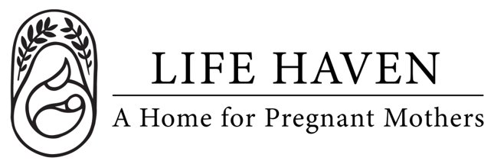
Job Title:
Prayer Network
Coordinator

Employment Type: Part-time Volunteer Location: Local Parish or Regional Area

About the Organization
Life Haven is a Christ-centered residential ministry providing safe housing, support, and guidance to women experiencing unplanned pregnancies and early motherhood. Our mission is to create a nurturing environment where residents can grow spiritually, emotionally, and practically.

Role Summary
The Prayer Network Coordinator coordinates and communicates the prayer needs both within the Life Haven organization and the Pro-Life community at large.

This is a wonderful opportunity for individuals who feel called to serve, connect with others, and believe in the power of prayer.

Key Responsibilities
- Regularly check in with the Residence Manager for prayer needs within the Life Haven Home.
- Regularly check in with the Operations Manager for prayer needs within the Life Haven Organization.
- Keep tabs on local Pro-Life groups and events such as 40 Days for Life and include them in the prayer list.

Qualifications
- Active member of a Christian Church parish, Orthodox, Catholic, or Protestant.
- Strong interpersonal and communication skills.
- Reliable, organized, and comfortable speaking with parishioners or sharing information publicly.
- Passionate about community service and the mission of Life Haven.

Work Environment & Schedule
- Approximately 2–4 hours per month, flexible to your needs.
- Remote connection with Life Haven, meetings times are flexible and as needed.

Compensation & Benefits
- This is a volunteer position, no financial compensation is provided.
- Gain experience in community outreach, faith-based engagement, and nonprofit communications.
- The personal satisfaction of serving women and children in a life-changing, Christ-centered environment.

