# CAMDEN DIOCESE CATHOLIC RENEWAL

## EVENT REGISTRATION FORM

### OCTOBER 5TH - 7TH 2018

**Behold, I make all things new.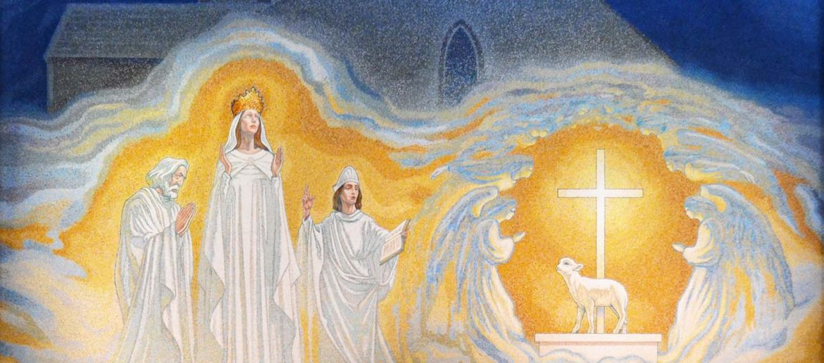The Holy Spirit & Mary ~ Inseparable**

**Rev. 21:5**

Join Us at the Wildwood Conference Center

Name:_________________________________________________________

Address:_____________________________________________________

**CITY_______________________________ STATE_______ ZIP___________**

**PHONE_______________________ EMAIL:___________________________**

CATHOLIC RENEWAL WEEKEND EVENT FEE:

1 Adult - $40.00 (In Advance) $50.00 (At the Door)

1st Youth $25.00 each additional Youth $20.00

**Deadline for Mail In Event Forms is Monday Sept 17, 2018**

Make Checks Payable to CDCC

Mail Checks and Event Forms to:

40 Old New York Road – Galloway, New Jersey 08201

Online Register Visit the Website: www.CamdenDioceseCatholicRenewal.org

**Call 609-652-7729 with any questions!**

**Or Email: support@CamdenDioceseCatholicRenewal.com**

*PLEASE USE ONE FORM PER PERSON*

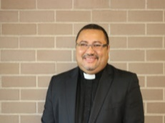 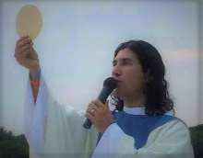 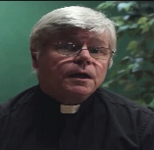 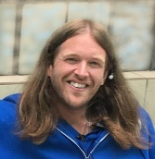   

**MC is Father Rene Canales**

Father Rene is the Moderator of the Camden Diocese Catholic Renewal. He is also a Diocesan Priest who serves at the Pastor of Hispanic Ministries at Our Lady of Hope Parish in Blackwood, NJ. Father Rene has a dynamic personality and has been leading the Camden Diocese Charismatic Renewal– now known as the Camden Diocese Catholic Renewal over the past several years. We are excited to have such a spirit-filled and joyful M.C.

**Our Guest Speakers:**

**Father Ariel Hernandez**:

Father Ariel is a priest for the Camden Diocese in New Jersey and was born and raised in Argentina. Father Ariel is now the pastor of Our Lady of the Blessed Sacrament Parish in the Newfield area. His parish is blessed to have four churches and two shrines, including the outdoor Padre Pio Shrine in Landisville. He served as Associate Vicar of the Spanish Apostolate in the Camden Diocese. Father Ariel is very active in the healing ministry and celebrates a monthly Healing Mass at Our Lady of the Blessed Sacrament Parish. He is devoted to Our Blessed Mother under many titles. Father Ariel received a special gift from the Blessed Virgin under the title of Our Lady of Schoenstatt and he is the custodian of a miraculous image of her from Argentina. Father has been an MC and a guest speaker at several past Camden Diocese Charismatic Conferences and he has led retreats and Charismatic Masses at many parishes in the tristate area and also abroad. We are very happy to have him return this year as a speaker!

**Father James Blount**:

Father Jim is a priest of the Society of Our Lady of the Trinity – Georgia Mission. A very gifted Spiritual Director and Confessor, Fr. Jim is a bold charismatic preacher endowed and empowered with the gifts of the Holy Spirit. He speaks of living a life in relationship with each of the Persons of the Holy Trinity, The Father, The Son, and the Holy Spirit. His teachings depict his deep love for the Eucharist and his intimate relationship, love and devotion to Jesus and Mary draws many souls to also fall in love with them. Father is a powerful instrument of the Holy Spirit as evidenced by so many stories of miracles, healings and con-versions. His talks help to increase awareness of the intense Spiritual Battle in our present world where evil has waged war against the Sacred thus aiming toward the destruction of holy family life. His humble boldness and untiring drive to minister to the lost and ill are particularly noteworthy. Dedicated to his healing and deliverance ministry, Father travels preaching and proclaiming the Gospel whenever and wherever he can, in the United States and abroad. It is a joy to have him return to the conference this year!

**Music by Tommy Doyle:**

Tommy has written and recorded many original songs. He has a joy and presence that shines through his music. He is able to play and sing a wide variety of Praise and Worship music, and has been active in the Charismatic Community for many years. He is also one of our steering committee members!

**Youth Tracks:**

**Senior Youth Track will be held on Saturday, Oct. 6th (Ages are 14-18yrs.)**

Our Senior High Youth Leader is Rebekah Hardy, and the program will be implemented by Forgotten Truth.

**Rebekah Hardy**

Rebekahis a Religion teacher at St. Rose of Lima Elementary school where she teaches 6th-8th grade. Rebekah holds a degree in Theology and Religious education from Mount St. Mary’s University in Emmitsburg MD. Through her blog “Classy Catholic” Rebekah evangelizes to today’s youth by addressing topics of faith and relationships. To contact Rebekah for speaking opportunities, please email bekahhardy7@gmail.com. Rebekah’s blog may be found at catholiclifesite.wordpress.com.

**Forgotten Truth**

will be conducting the High School Track at the conference this year. Lead by Jeffrey Shields, Forgotten Truth is a South Jersey band and ministry, whose mission is to share through their music; the hope, truth, and struggles. Jeffrey is the Director of Youth Ministry at St Rose of Lima Parish in Haddon Heights NJ, and has a bachelor’s degree in Philosophy and Theology from Holy Apostles College and Seminary in Cromwell Connecticut.

Like and hear Forgotten Truth @ www.facebook.com/forgottentruth or Instagram @4gottentruth

**Our Junior Youth Track will be held on Friday Night and Saturday. (Ages are 11-14 yrs.)**

**Mark and Kim Pesotski** will be facilitating the Junior High Youth Track. Kim is the youth director for Mary Mount Carmel Parish in Hammonton, NJ and has been leading the youth group there for the past 3 yrs. Kim and Mark are enthusiastic leaders who are devoted to family life and sound Catholic teaching.