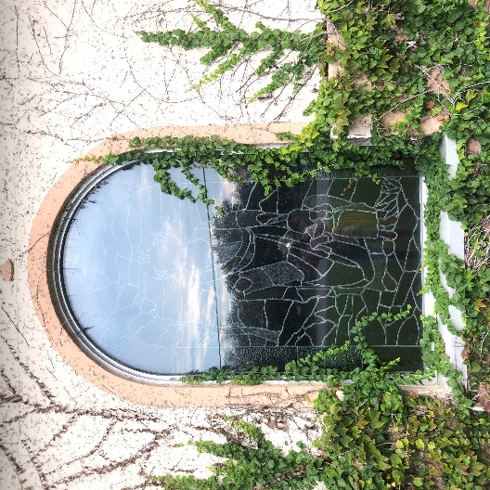
The Kingdom of God and Small Things.
Homily by Father Antonio June 13,2021

In today’s Gospel, Jesus talks about the Kingdom of God.
Let us remember: Jesus came to set up the Kingdom of God, and he wants this kingdom to spread
around the world. He awaits our participation and collaboration so that this Kingdom reaches all
hearts, all homes, all towns and countries.
Our Lord explains to all of us that the Kingdom of God is like a small mustard seed in the beginning,
but it grows, little by little, and becomes the largest of plants with large branches, so that the birds of
the sky can dwell in its shade.
The smallest seed turns into a big plant. The action of water, sun, air and soil nutrients makes this
work. These elements represent the power of God, His grace, His love and wisdom. The first
reading manifests the same idea, concept or reality.
He counts on us to build it. We are simple creatures, very limited, but God makes wonderful things
with poor instruments. His kingdom on earth and in Heaven is a beautiful reality.
How many saints live in heaven?
How many good people live among us?
How many people worship the Lord every day, every week, every Sunday, like us?
How many people make works of charity everywhere, every day, with generosity and sincere love?
How many people work every day for love of God?
Only God knows the answer. The Kingdom of God is alive and is growing constantly.
This is why we pray Psalm 92 - Thank you Lord.
In the second reading, St. Paul encourages us to be courageous, to walk by faith, to please God. We
can build the Kingdom of God if we are courageous, confident in the Lord, trying to please God. He
asks us for fidelity in small things and He will do the rest. He asks us to sow the seed and He will do
the rest.
If we pray the Rosary
If we pray a creed daily
If we come to Mass with devotion
If we make one act of charity daily
If we are kind especially with our family
If we respond politely to those who annoy us
If we work with enthusiasm until the end for love of God and not for money only

If we carry the daily cross with a cheerful spirit
If we make the sign of the cross every morning, before we start our work.
If we make fraternal corrections with humility or listen to fraternal corrections with a humble and
grateful heart
If we help others for love of God and in God for them
If we obey our Pope, our Bishop, our Priest, our parents, our superiors with good spirit and generosity
If we fight against temptation with joy and generosity, knowing that I am not alone, that the Lord is
with me.
If we try to lead or draw our friends to God, to the Church, to Jesus
If we pray daily for the conversion of sinners
If we offer a small daily sacrifice for the Church, for the Pope, etc. etc.
Then God will do wonderful things in each mind and heart, the Kingdom of God will continue to grow.
Matthew 25:21 “Well done, good and faithful servant, you have been faithful over a little, I will set you
over much; enter into the joy of your master.”
St. Therese of Lisieux was a great saint; she is the Patron of Missions. She was great because she
loved small things. She is the saint of little things. She was kind and loving in her daily interactions
with her sisters. She fulfilled her daily tasks with a cheerful spirit. She is great because she loved
very much, greatly.
Our Mother Mary was a normal woman. She only knew to say “Yes” to God.
Joseph her husband was a normal man. He obeyed God with hope.
With them we learn the value of small things. With them it is easier to collaborate with God in the
building of The Kingdom.
Guardian Angels, spiritual creatures, help us to be faithful in small things.
God is doing the rest.

