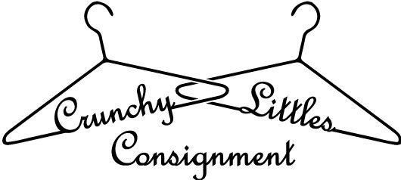

Car Seat Agreement

In order to sell a children’s car seat, please read and sign the following:
Consignor (print name and consignor #) ____________________________, agrees that this car seat being sold is to the best of my knowledge, free of safety recalls, is less than 5 years old and has never been in an automobile accident. Consignor further agrees that they are the original owner of the car seat so I can attest to this agreement and the statements made herein.
Consignor further agrees that they have reviewed the Federal and State
Guidelines and to their knowledge this product meets those guidelines and is safe for resale and usage.
Car Seat Information:
(please fill out one agreement for each car seat sold)
Date Manufactured:______________________
Brand: _________________________________
Model # ________________________________
Serial #__________________________________
I, the consignor, attest that all above information is true to the best of my knowledge. Further, I release Crunchy Littles Consignment, LLC and its owners from any and all liability with regard to the car seat detailed within this agreement.
Consignor Signature: ____________________________________
Date: _________________
Consignor Name: (print) _________________________________
Consignor #: ___________

