Sanger Saddle Club

P.O Box 863

Sanger, TX 76266

**2023 OFFICIAL MANUAL**

**Bylaws**

**Committees**

**Playday Rules**

|  |
| --- |
|  |

**TABLE OF CONTENTS**

PAGE 1: ARTICLE I – Title, Objective, Place of Business

PAGE 2: ARTICLE 1 - Title, Objective, Place of Business

PAGE 2: ARTICLE II FORMATION BYLAWS AND ARTICLE III MEMBERS

PAGE 3: ARTICLE III MEMBERS AND ARTICLE IV OFFICERS

PAGE 4: OFFICERS (CONTINUED)

PAGE 5: OFFICERS (CONTINUED) AND ARTICLE IV COMMITTEES

PAGE 6: ARTICLE IV COMMITTEES (CONTINUED) ARTICLE V SOCIAL MEDIA

PAGE 7: PLAYDAY RULES ,EVENTS, and VOLUNTEERS

PAGE 8: PLAYDAY RULES AND EVENT (CONTINUED) and RIDERLESS EVENTS

PAGE 9: PLAYDAY GAMES AND DESCRIPTIONS

PAGE 10: FLAGS

PAGE 11: FLYING W

PAGE 12: GOLFETTE

PAGE 13: POLES

PAGE 14: PYLONS

PAGE 15: SPUR

PAGE 16: BIG T OR TEXAS T

PAGE 17: STRAIGHT BARRELS

PAGE 18: HITCH N GO

**SANGER SADDLE CLUB 2022 BYLAWS**

**ARTICLE I – Title, Objective, Place of Business**

**Section 1 Title**

This Association shall be known as SANGER SADDLE CLUB

and shall be operated and conducted as a not-for-profit organization.

**Section 2 Objective**

The purposes of this organization shall be to encourage the motto of "Horsemanship, Sportsmanship and Citizenship" and to keep alive "The Spirit of the Old West.” It shall promote the acquaintance and

friendship among members and the club through the sponsoring of activities related to mounted and riderless sports.

**Section 3 Place of Business**

The principal place of business shall be designated as the Club Headquarters. Its members and

officers may be residents of any State or Territory. The business may be transacted anywhere convenient to such members or officers. ~

**ARTICLE II – Formation**

On January 19, 2022, the Sanger Saddle Club was officially formed. The Founders of the Club are Ethel Strother, Bliss Coulter, and Philip and Rebel Voss. Until the members appoint a former board, Ethel Strother will serve as interim President, Bliss Coulter will serve as interim Vice President, and Philip Voss will serve as the Director of Committees. There will be an appointment of the Secretary, Treasurer, and 2 board members at the first official board meeting. The President will refrain from voting unless there is a tie. The President, Ethel Strother, and Vice President, Bliss Coulter, will be responsible for all of the financial responsibilities of Sanger Saddle Club and any bank accounts established on behalf of the Sanger Saddle Club.

**BYLAWS**

The Bylaws of the Sanger Saddle Club are set forth as a guide for the use of the betterment of the Club and its members, committees, chairperson, and visitor. These Bylaws will be followed, and changes may only be made when proposed changes are being placed on the agenda during a scheduled meeting with a majority vote of its members. An emergency meeting may be called under certain circumstances.

**ARTICLE III - Members**

**Section 1 Membership**

A. Membership A member, as referred to in these By-Laws, shall be any person or family that has paid their club and or club dues and is in good standing,

B. Sponsorship A member or family may sponsor a child and include the child under their membership.

A child or sponsored child may only be added to a one-member family, and a family may only have 1 sponsored child.

**Section 2 Rules**

Members of the Club shall be admitted, retained, and expelled in accordance with such rules and regulations as the Delegates may, from time to time, adopt. **There will be no public display of alcohol at any Sanger Saddle Cub Event.**

**Section 3 Rights**

All Members, while in good standing, shall have equal rights, interests, and responsibilities with respect to the club and its property.

**Section 4 Dues**

The annual dues shall be $25.00 per family. Individual membership is $15.00 They are due January 1st. After Membership dues are due at the time of the first scheduled payday. (A family will include parents, domestic partners according to Texas Law or legal guardians, and unmarried children living as a household or sponsored child. When a child marries or reaches the age of 21 years unless, in the military or full-time student, a new immediate family is formed. If they are in the military or full-time students, an individual membership starts at age 25.) Children under the age of 18 shall be considered a family with membership under the parent or guardians’ name.

**Section 5. Discipline of Members**

Members of the Club shall be admitted, retained, and expelled in accordance with such rules and regulations as the Board may, from time to time, adopt. In the event a person has

been refused membership in the Sanger Saddle Club for any reason, it will require a two-thirds (2/3) majority vote of the Board at the next regularly scheduled delegates meeting to be accepted as a member at any time thereafter. In the event that a fight and/or severe misconduct occurs at any Sanger Saddle Club event, the President, or the President's designate, will call a meeting with the Executive Vice President and the appropriate committee chairman, or the designates, at the function where the infraction occurred. If one of these individuals or the immediate family is directly involved in the incident, the next Vice President will take their place on the committee. All three persons will have one (1) vote each determine if a fight or severe misconduct occurred. If the vote is carried out, the President will notify all members of the Executive Board and instruct the National Secretary to mail the first warning letter to all persons involved in the incident. The first letter will be notification of probation for one (1) year unless the committee deems the offense severe enough to warrant full suspension as designated in procedures of second misconduct or third misconduct. If any or all of these persons are involved in a second misconduct incident at a National Association function, the above procedures will be followed, and the second letter will be a notification of suspension of participation from all Sanger Saddle Club’s events or functions for a period of one (1) year. If any or all of these persons are involved in a third misconduct incident at a Sanger Saddle Club event or function, the above procedures will be followed, and the third letter will be a notification of permanent suspension from the Sanger Saddle Club. These suspensions will occur from the date of the infraction, and the President must perform these duties within ten (10) days of the infraction(s). The committee chairman will attend the three-people meeting. All appeals must be made within thirty (30) days of notification and be made by written letter to the President. The President will address the matter at a regularly scheduled meeting or a special called meeting within thirty (30) days of receipt of the letter, if requested, of the Executive Board. The parties involved may present why they should not have received the letter. When the discussion is completed, the parties will be asked to leave, and a vote will be taken. This vote will be final and supersede all previous actions taken by the three-man committee. These procedures are intended to manage incidents being considered extreme. They will be taken in addition to any actions taken by the appropriate committee at the time of the occurrence of the incident.

Section 3. Meeting of the Members

**ARTICLE IV – Officers**

**Section 1 Officers**

A. The officers shall be President, Vice President, Secretary/Treasurer, and two officers.

B. The President of the club shall be elected for a period of two (2) years and must meet the minimum experience requirements specified below.

C. The Vice President, Secretary/Treasurer, and officers will be nominated by active members and elected for a term of one year, whose terms shall be staggered to prevent having a large majority of new officers in any given year. The

D. The new officers of the Club will assume responsibilities of their offices immediately upon being sworn in.

E. No two members of the same family may serve as officers at the same time. (A family will include parents or legal guardians and unmarried children living as a household. When a child marries or reaches the age of 21 years unless, in the military or full-time student, a new immediate family is formed. If they are in the military or full-time students, an individual membership starts at age 25.)

Also, no two members of the same family can be in the checking account at the same time.

G. If an elected officer resigns from office, the Club refers to the Parliamentary Rules under the Roberts Rules of order for direction.

**Section 2 President**

The Founder of the club will serve as the President for a term of one year. At the end of 2023, an election will occur if that person chooses to run for a second year. After the second year, the following board rules will apply.:

**A.** This person must have been a member of the Club for a minimum of two years, after the initial first year of the clubs’ existence, and served in one of the following capacities or a combination thereof: Two years as a board member of an

**B.** The President shall be the Chief Executive Officer of the Club, shall preside at all meetings of the Board, and shall be an Ex-Officio member, with voting rights, of all committees. He/she shall be responsible for the enforcement of the By-Laws and rules of the Club and has the authority to suspend or expel a member, club, or district for violation of these rules.

**C.** In the event of a vacancy in the office of the President, the Vice President shall fill the office.

**D.** The President shall not hold the same office for over two consecutive years.

**E.** The President and Vice President will

**Section 3 Vice President**

The Co-Founder of the club will serve as the Vice-President for a term of one year. At the end of 2023 an election will occur if that person chooses to run for a second year. After the second year, the following board rules will apply.:

**A.** This person must have been a member of the Club for a minimum of one year and served in that capacity in good standing.

**B.** In the absence of the President, the Vice President shall perform the duties of the President. He/she shall perform such other duties as may be prescribed by the President. He/she shall be an Ex-Officio member of all committees with voting rights.

**C.** In the event of a vacancy in the office of the Vice President, the officers will nominate one of the board members to fill the office by a majority vote.

**D.** The Vice President shall not hold this office for over two consecutive years.

**Section 4 Secretary**

**A.** The Secretary (or acting Secretary) will be responsible for taking the minutes of each scheduled board meeting. A copy of the previous board meeting will be reviewed and approved during each board meeting.

**B.** The secretary will be responsible for keeping up with the member roster and checking for accuracy.

**C.** Assisting with playday registration and accuracy of registration and exhibitions.

**Section 5 Treasurer**

**A.** The Treasurer (or acting Treasurer) will handle all money at playdays and assure accuracy with the Secretary that all entry fees and registration add up.

B. Two people, Treasurer and one other, will be required to count the money and prepare for deposit of any and all money collected for the day and present it to the President or Vice President for deposit in the financial institution until otherwise noted in the Bylaws.

**Meetings**

The regular meetings of the members shall be held once a month or by-monthly at such time and place as may be fixed by resolution of the Board for the purpose of transacting business brought before the meeting. Notice of the regular meetings shall be given by mail, email, social media, text, or phone.

Members in good standing retain voting rights.

**ARTICLE V - Committees**

**The Chairperson of each committee shall be appointed by the President and be a member in good**

**standing. The chairperson’s term ends when they are appointed during the year. This “term” shall constitute a year of service. Committee Chairs may appoint as many members to their committees as they see fit.**

**A. Points Committee**

Responsible for keeping up with the points of all contestants and their placings for the year-end awards. They will be tallied and verified for accuracy after each event and posted on the website and the Club’s Facebook page.

Any discrepancies and or protests shall be brought up with the committee chairperson and resolved

**B. Awards Committee**

Responsible for recommending and presenting to the officers all awards, including the number of places for yearend awards. This committee will develop the budget of award for ordering awards and ensure the best pricing. The Awards budget will be presented to the board for approval.

**C. Arena/Rules Committee**

**1**. Duties are to recommend all repairs and improvements needed to the Officers.

**2**. Assure that there is the required number of judges in the area during events.

**C**. Prepare a schedule for tractor drivers if not provided by North Texas Trinity Cowboy Church

This committee is charged with the responsibility of recommending the rules for the Playday activities of the Club. Assures that event timers are set up and working properly and taken down and stored at the end of each event and that the PA System is set up and working properly and taken down and stored at the end of each event. All rules recommended by this committee shall be presented to the Executive

Board for final approval and clarification.

**D. Parade Committee**

This committee is responsible for arranging and organizing parade attendance and scheduling the club for parade events.

**E. Marketing/Social Media/Flyers Committee**

This committee is charged with the responsibility of promoting the Club.

**1.** To organize and publicize the use of the facility and to generate memberships.

**2.** To see that all Memorial and/or Donations or Sponsorships are acknowledged, reported to the family, and recognized at all events.

**F. Youth/14Hands Committee**

**1.** This person shall oversee the youth group and assist the youth group with organized activities for the youth at all Playdays, special events, and or functions.

**2.** This person will attend their meetings and oversee them with decision-making and planning.

**3.** This person will be responsible for assisting the youth group with riderless events and lead liners.

**G. Registration Committee**

The registration committee will be responsible for making sure that all forms are previously printed prior to each event or playday. That there is cash on hand for making change. They will ensure that there is enough coverage to register participants in a timely manner and that they are previously trained in the registration process. Example: filling out forms appropriately, Coggins and waivers are filled out. Methods of payments are checked in the appropriate boxes and trained in using the credit card transactions, and one person is assigned to that with the login.

**ARTICLE VI. Social Media Policy**

The main advantage of having a Social Media policy (2014) is to protect the Sanger Saddle Club, officers, chairpersons, Districts, clubs, and members, otherwise known as the association and entities if a person(s) acts unprofessionally on a Social Media site. Dislike of others and gossiping is part of human nature. The policy below is to allow everyone the advantage to make sure what is written, published, or shared does not in any way undermine the association or its

entities reputation.

**1.** Disclosing any information that may harm you, the association, or its entities.

**2.** Certain activities on the part of the association and entities may not be public knowledge due to confidentiality or pre-planning purposes. Posting of hearsay on a social media website about the association or its entities can be harmful or impair the work of the association.

**3.** Harassing, demeaning, or creating a hostile environment within the association and its entities in a social media forum can be disruptive, malicious, and harmful.

**4.** Disrupting the smooth and orderly flow of the association either directly or indirectly by disclosing confidential or proprietary information on social media.

**5.** Harming the goodwill and reputation of the association or its entities within a social media forum.

**6.** Poor social media tends to put in place the doubt of reliability, trustworthiness, or sound judgment of the person(s) who is the subject of the information; or member(s).

**7.** Do not ignore copyright laws. Cite any reference sources accurately. Remember, the prohibition against plagiarism applies online.

**8.** Do not use any Sanger Saddle Club logos or trademarks without permission from the Executive board. The absence of explicit reference to a particular site or association does not limit the extent of the application of this policy.

**9.** In the area of social media (print, broadcast, digital, and online), members may use such media in any way they choose as long as such use does not produce the adverse consequences noted within this article’s section. For this reason, the Sanger Saddle Club has adopted a policy for members to apply in their use of social media both as a member and or an officer.

**10.** A most prudent course of social media activity should always be taken regarding the club and its entities. Any member(s), clubs, or districts deemed responsible for such issues will be subject to counseling and or action were taken according to the Sanger Saddle Club By-laws.

**PLAYDAY GAMES AND RULES**

**The section of Playday Games is to acquaint the membership with the games that have been approved to be run on all Playdays and the rules governing them. The playday activities of the Sanger Saddle Club are a family affair and will require a group effort to ensure events and playdays run smoothly.**

**VOLUNTEERS**

**Participants are required to volunteer at all playdays to be eligible for points and or awards. This requires manual labor in the registration booth, concession stand (if applicable), the announcer’s vantage point where the records are kept, setting up and judging events, and working the gates, and any other volunteer opportunities listed on the Volunteer Sign Up Sheets when registering for games. Parents are required to volunteer in place of their children if they are too young to volunteer. Games will not begin until volunteers/judges are in place. Games require at least two judges that are familiar with the patterns and rules of each game. It is the responsibility of the volunteer to become familiar with the patterns and rules prior to judging the game.**

**Records are of great importance. The Club playday records are kept in the office by the system accumulating individual points. This enables all contestants to compare times with each other regardless of the location of the competition or arena size. Each game has its own formula of adjusting the dimensions according to the size of the arena.**

**RULE 1 Description of games.**

Refer to the specific game following the rules.

**RULE 2** **Arena Specifications**

**A.** For arena specifications, see the arena diagram preceding games.

**B.** Adjustments for sub-standard arenas - refer to Specific Games.

**C.** Starting line will be unmarked.

**D.** Any person assisting a playday rider into the arena shall be on foot and may not cross timers.

**E.** There will be an arena drag for every ten riders listed on the time sheets, with alteration at the discretion of the Playday Chair, according to arena conditions.

**RULE 3 Equipment**

**A.** Refer to a specific game.

**B.** Equipment shall be handed to the rider after he enters the arena.

**C.** Recommended that each district use equipment of the same color as listed in rule 8 B under Playday Games.

**RULE 4 Game Rules**

**A.** Age Division: Contestants in the games shall be divided into Classes: Riderless, Leadline (LL) Classic(CL 58+), Super Senior(SS 45-47), Super PeeWee (SPW 6 and under), PeeWee (PW 7-10), Junior(JR 11-15), Intermediate(INT 16-25), Senior(SR 26-44) (refer to Age Division, Article VII Section8-H)

**B.** Calls to Ride: Contestants shall be present at the time of the call for any event. Three calls will be made; if the contestant is not ready to ride on the third call, he will be disqualified. A rider can move up or down within his age group until the end of the age group. If the rider is the last rider, the rider has 5 minutes; in the event of a conflict, the rules chairman has the authority to override the 5 minutes to give the rider more time. After that, either ride or be disqualified. Riders can only move up or down with good cause to be determined by the gate judge. If the timer malfunctions and the rider is at the end of the class, that rider may have 5 minutes to re-ride. If the rider is peewee or younger, the parent is to make a decision.

**C**. Anyone child that participates in Super PeeWee (SPW 6 and under) may not participate in the Lead line classes.

**D**. Scoring of Points: Points to determine individual winners will be as follows: 10 points for 1st down to 1 point for 10th. (If only 6 places are given, 1st place would be 6 points, down to 6th place 1 point. The number of points may not exceed the number of contestants in the class or event. 1st through 10th Place should be awarded.

**E.** Closed Arena: All games will be run in a closed arena. The gate must be closed before the rider starts his pattern or before starting forward motion, with a disqualification on the rider if the gate is not closed. The gate should be closed until the rider brings his horse under control after the pattern. No equipment will be handed to the contestant until he enters the arena. The use of "L" gates (the opening in the arena fence is the “gate”) will be considered a closed arena. Once a rider has completed the event and has his horse under control, another rider may enter the arena.

“Closed arena” does not apply to an arena with a separate entrance and exit gate.

**F.** Horse Rule: A horse may not be ridden but one time in each class or event with the exception of a horse used by an immediate family (Immediate family will include parents or legal guardians and children, whether married or unmarried, and grandchildren. This also includes sons-in-law or daughters-in-law). Violation will result in the disqualification of ineligible riders.

**G.** A rider may only ride one horse in each prospective class.   
**H.** Tie: Single Event: When running off a tie for a single event, contestants must run within two seconds or less of their original time to win. This rule applies when the runoff time is slower than the original time. If, after two unsuccessful efforts, this has not been accomplished, the flip of the coin may be used. Each contestant must use the same horse as in the original contest unless the horse cannot be ridden, then the horse rule applies. If a rider’s horse is injured and they do not have a second horse, then a coin toss will decide the winner.

Tie Overall Highpoint: When running off a tie for Overall High Point, you must ride the original horse that was competed on unless the horse is injured; then, the horse rule applies.

**I.** A family can represent only one district at playday finals.

**J.** Designated people in the arena: No one except those designated by the arena director will be allowed in the arena.

**K.** Time starts and stops when the horse's nose reaches the timer line.

**L.** Striking a horse: A horse may not be struck with playday equipment at any time.

**M**. No physical assistance shall be given past the starting line in any class. Only one assistant per rider may be in the arena during that contestant’s ride. Any rider with mental or physical disabilities and/or special needs may be allowed as many assistants as needed past the starting line.

**RULE 5 Special Circumstances**

Under special circumstances such as fundraising events, sorting, or other events where the age division breakdown or the point system requires modifications. It shall be under the board’s discretion to modify how the awards are to be given based on the number of events/games or amount of awards given. The rules applying to that specific circumstance shall be posted.

**RIDERLESS EVENTS**

Riderless events will be held at the beginning of each playday. This class is set up for those that do not own or have access to a horse to ride. Events and classes will be arranged so that age-appropriate contestants compete against each other. Riderless events will be announced on each playday flyer prior to the playdays.

**CURRENT PLAYDAY GAMES**

**BARREL RACE**

This is a timed event. The rider will cross the timer line, make a 360-degree turn around the first barrel, go across the arena, make a 360-degree turn around the second barrel, then make a 360-degree turn around the third barrel, and return between the first and second barrels, crossing timer line. This is known as a clover leaf barrel pattern. A rider may run either a right or left pattern.

EQUIPMENT REQUIRED

1. Timer line (designates the beginning and end of each race marked by chalk or lime).

2. Three (3) 55-gallon standard oil drums with the dimensions being 23 inches from outside to outside on the ends and 34-1/2 inches long from the outside lip on top to the outside lip on the bottom, placed in a triangle formation ninety (90) feet apart for a cloverleaf pattern. The first and second barrels are sixty (60) feet from the timer line. Measurements should be taken from the center of barrels. Barrels must be a minimum of fifteen (15) feet from any arena fence.

3. Barrels must have barrel protectors.

PENALTIES

A five (5) second penalty will be added to the rider's time for knocking over a barrel.

DISQUALIFICATIONS

1. Breaking the pattern.

2. Failure to complete the race.

OFFICIALS

There must be at least 2 judges in the arena standing at all times during the event to observe the pattern and set up any barrels in their proper place when knocked over.

PATTERN ADJUSTMENTS

Adjustment for non-standard arenas. See the arena size diagram preceding games.

An arena that is too large creates no problem because the standard pattern can always be used. The arena that is too narrow can be adjusted by placing number one (1) and number two (2) barrels at the fifteen (15) foot minimum distance from the fence, then measuring the distance between the one and two barrels and subtracting from the total standard pattern of 270 feet. The number three (3) barrel should be placed half of this distance from the number two (2) barrel. The triangle totaled 270 feet.

Example: 100-foot arena -30 feet ( 15 feet on each side) = 70 feet.

270 feet - 70 feet =200 feet.

200 feet divided by 2 = 100 feet.

The third barrel is 100 feet from the first and second barrels.

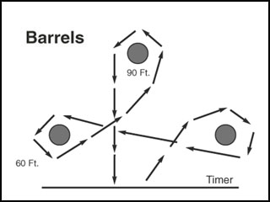

**FLAGS**

**Riders may start on either the right or left side**

**Description of Race**

The rider races across the start and finish line to the first barrel and picks up the flag. The rider continues to the second barrel, where the flag is placed on top of or in the second bucket as the rider goes around the outside of the barrel. The rider may circle either or both barrels during the run (2010). The rider continues across the start and finish lines. It is not necessary that the rider stick the flag in the sand, but the flag must remain in or on the bucket. The rider may ride either a right or a left pattern.

**Equipment**

Two (2) fifty-five (55) gallon barrels were placed one hundred eighty (180) feet from the start and finish line. The fifty-five (55) gallon barrels are placed twenty (20) feet from the fence line. The fifty-five (55) gallon barrels must be a minimum of forty (40) feet from the end of the arena. Two (2) two-and-one-half (2 1/2) gallon plastic buckets without obstructions, such as bails or ears, each completely filled level with (2008) arena dirt, to the top of the bucket, and one (1) put

on top of each of the fifty-five (55) gallon barrel at the back edge, which is the edge furthest away from the start and finish line. One (1) six (6) inch by eight (8) inch rectangular flag. The flag sticks are fourteen (14) inches long and one-half (1/2) inch in diameter with a three (3) inch marker on the flag stick to indicate how deep to put the flag down in the dirt. The flag stick must be beveled (2010). The flag is placed in the center of the first bucket, which is determined by the pattern direction run by the National Association of Riding Clubs & Sheriff’s Posses the contestant. There should be sufficient quantities of flags to keep the game moving.

**Judges**

Two (2) judges, one (1) at each barrel. In addition to judging, they are responsible for placing the flag in the proper bucket, in the proper position.

**Penalties**

There will be a five (5) second penalty added to the rider's time for knocking over the first bucket or barrel.

**Disqualification**

Dropping the flag on the ground or barrel. Failure to deposit the flag on top of the second bucket.

Knocking over (2022) the second bucket or barrel.

**FLYING W**

This is a timed event. The Flying "w" race is run with the same poles as used in the Quarter

Horse Poles. See the diagram below for measurements. The rider may run either a right or left

pattern. The rider races to the first pole, turn it, weaving each pole, turns the last pole, and

returns crossing the finish line.

**EQUIPMENT**

**1**. Timer line (designates the beginning and end of each race marked by chalk or lime).

**2**. The base will be a minimum of 14" to a maximum of 17" in diameter

**3**. The poles will be a minimum of 6 feet and a maximum of 7 feet in height.

**4**. PVC cap on the top of each pole

**5**. Bases to weigh a maximum of 12 Ibs.

**6**. Five poles made of PVC pipe, a minimum of 1" to a maximum of I 1/2" in diameter.

**PENALTIES**

A five-second penalty for each pole knocked over.

**DISQUALIFICATIONS**

1. Failure to complete the pattern

2. Breaking the pattern

Judges

There need to be at least 2 judges in the arena standing at all times to observe patterns and set up any poles in their proper place when knocked over.

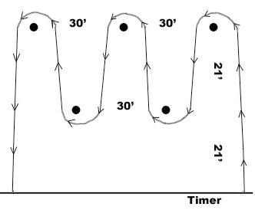

**GOLFETTE Description**

The rider races to the barrel, picks up the ball while turning or circling the barrel, returns to the barrel nearest the finish line, and deposits the ball in this barrel while passing by or circling it before crossing the finish line. The rider may run either a right or left pattern.

**Equipment**

180 ft from the start and finish line to the center of the back barrel. A 2.5-gallon bucket filled with sand & placed at the back of the barrel 20 ft from the start & finish line to the center of the front barrel 28

One (1) fifty-five (55) gallon barrel placed 180 feet from the start and finish line.

One (1) two-and-one-half (2-1/2) gallon metal or plastic bucket without obstructions, such as bails or ears, completely filled level with arena dirt, to the top of the bucket and placed on top of the fifty-five (55) gallon barrel at the back edge, which is the edge furthest away from the start and finish line. One white golf ball placed on the sand in the center of the bucket for each contestant. One 30-gallon barrel placed 20 feet from the start and finish line. This barrel is placed in line with and between the other barrel and the start and finish line. This barrel has an open top with the bottom cut out.

**Judges**

Two (2) judges, one (1) at each barrel. In addition to judging, they are responsible for placing the golf ball on the bucket and removing the golf ball from the goal barrel after each ride.

**Penalties**

A five (5) second penalty will be added to the rider's time for knocking over the fifty-five (55) gallon barrel or the golfette bucket.

**Disqualification**

Failure to pick up the golf ball.

Dropping the golf ball.

The golf ball touching the fifty-five (55) gallon barrel or the ground due to the horse or the

rider.

Failure to deposit the golf ball in the goal barrel.

Failure of the golf ball to remain in the goal barrel.

Knocking over the goal barrel.

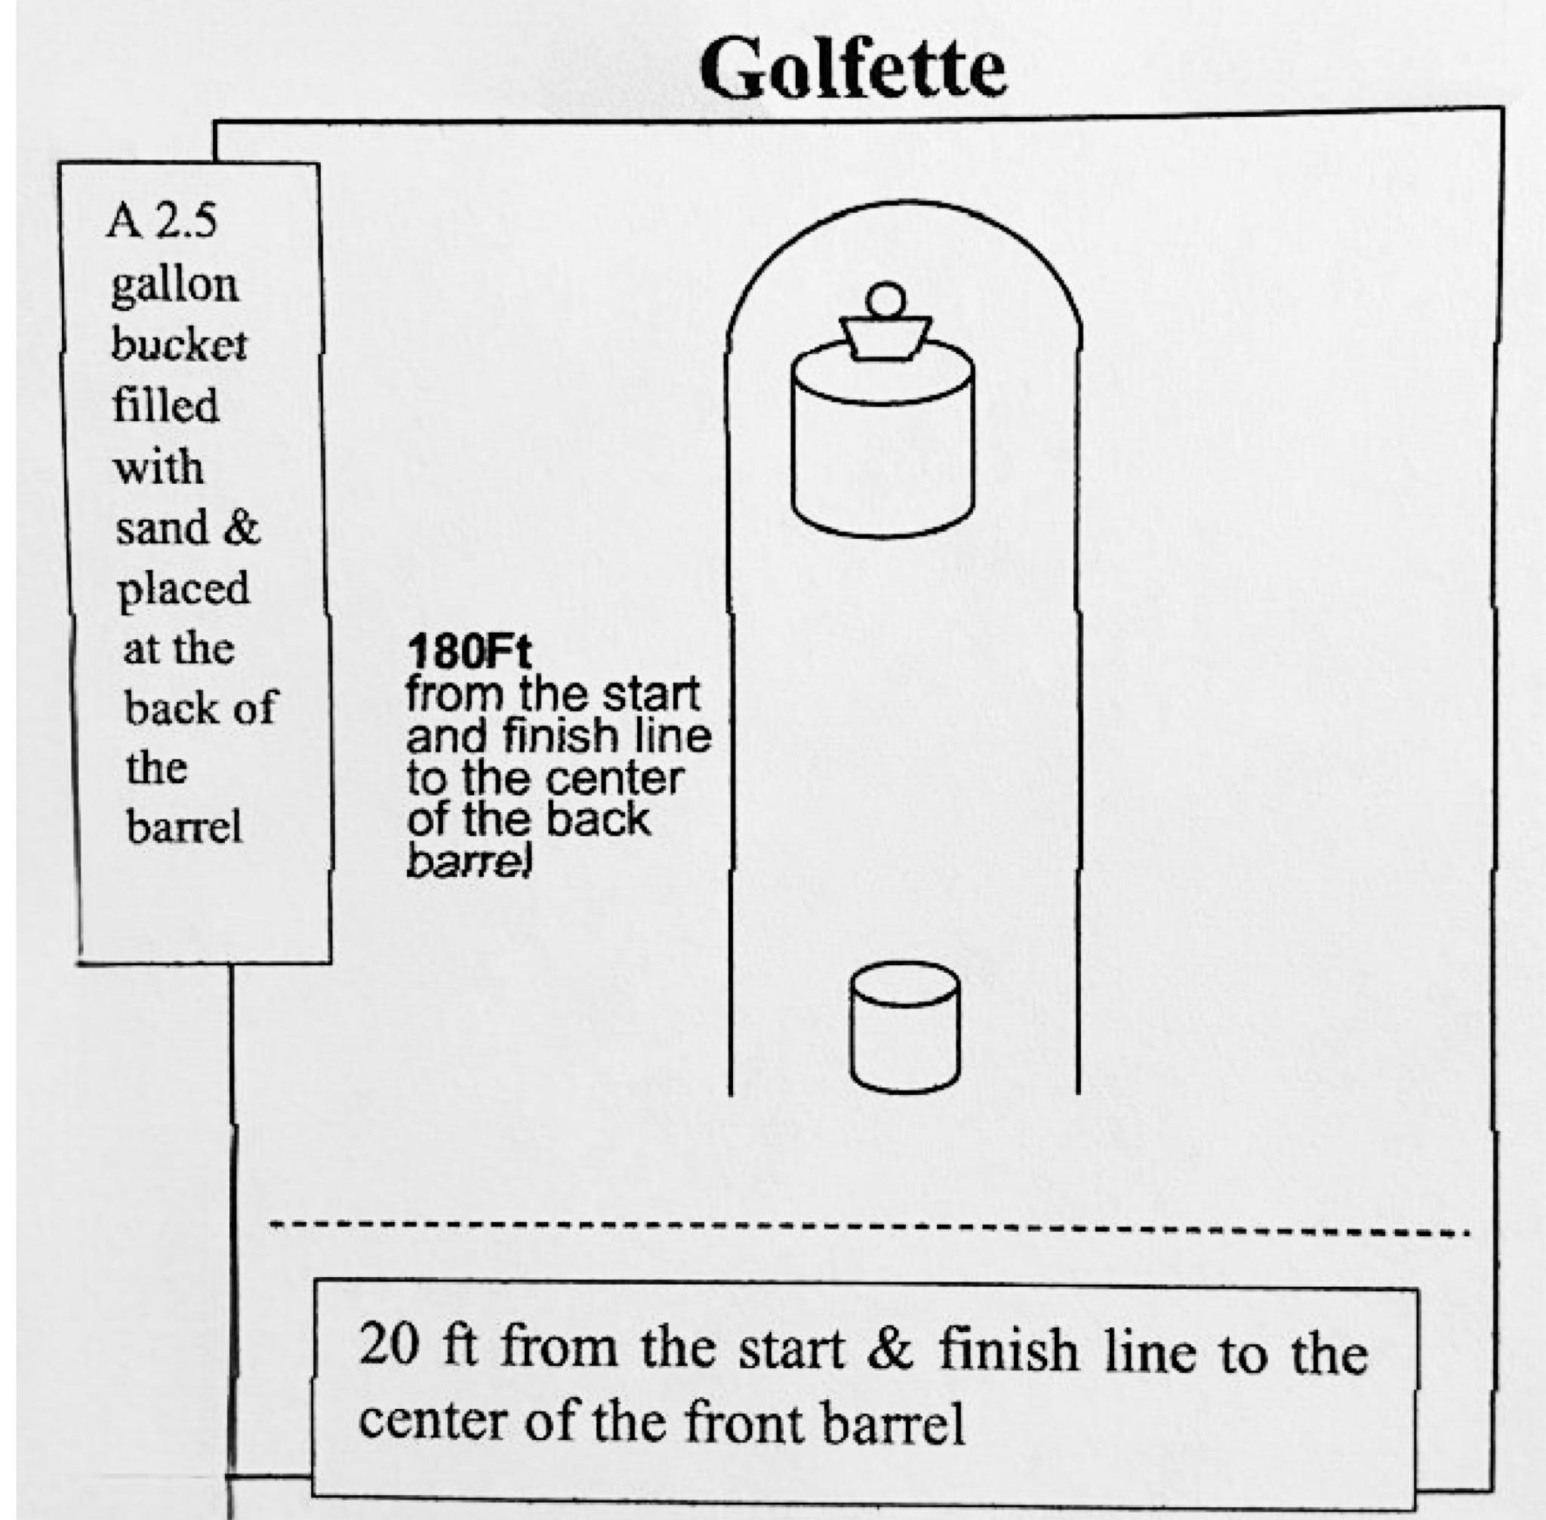

**POLES**

Description of Race

A horse may start either to the right or left of the first pole and then run the remainder of the pattern accordingly.

**Equipment**

Six (6) poles, which can be manufactured quarter horse poles, seven (7) feet in height. The bases should be a maximum of seventeen (17) (2015) inches in diameter, with a rubber hose covering the edge if metal discs are used. The maximum weight shall be twelve (12) pounds. The poles are to be spaced twenty-one (21) feet apart, the first pole being twenty-one (21) feet from the start and finish line. The pole pattern will not be set up any closer to the fence than 30 feet. 21 feet measurements are made from the center of the base of the pole.

**Judges**

One (1) judge at the start and finish line and as many judges as necessary to observe the pattern and to set up any poles knocked down. One (1) judge should be positioned to sight when repositioning poles.

**Penalties**

A five (5) second penalty will be added to the rider's time for knocking over a pole.

**Disqualification**

Breaking the pattern, such as failure to weave all the poles or properly correct the pattern.

**PYLONS**

Description of Race

The horse and rider must go between all pylons turning either to the right or left and going around the center pylon pole. The center pylon pole may be steadied. Then the rider must run the remainder of the pattern accordingly.

**Equipment**

Seven (7) highway-type pylons (Saf-T-Cones), 18 to 28 inches in height, placed 20 feet apart. The first two pylons are twenty (20) feet from the start and finish line and five (5) feet apart as measured from the inside base of the pylons (see diagram above). The last two (2) pylons are five (5) feet from the center pylon as measured from the inside base of the pylons. The center pylon has a maximum base size of seventeen (17) inches, contains a seven (7) foot pole, and weighs a maximum of twelve (12) pounds. Measurements are to be made from the inside base of the pylons and from the pole base (2017)

**Judges**

Two (2) judges to observe the pattern at the back of the pattern (2022) and set up the pylons in

their proper place if they are knocked over.

**Penalties**

A two (2) second penalty for knocking over a pylon or the center pylon pole.

**Disqualification:** Breaking the pattern

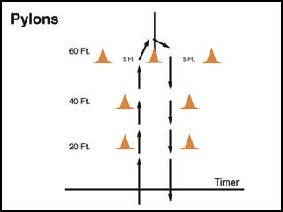

**SPUR**

**Description of Race**

The horse and rider must go through the first set of pylons and make a three hundred sixty (360) degree turn around the pole, returning through the second set of pylons. A right or left-hand pattern may be run.

**Equipment**

Five (5) highway-type pylons are eighteen (18) to twenty-eight (28) inches in height. The center pylon should have a maximum base size of seventeen (17) inches, contain a seven (7) foot pole, and weigh a maximum of twelve (12) pounds. The center pylon is placed one hundred twenty (120) feet from the start and finish line and is centered in the arena. Two (2) gates are formed, one on each side of the arena, with two (2) pylons used to form each gate. The pylons forming the gates are to be set ten (10) feet apart, ten (10) feet from the start and finish line, and thirty (30) feet from the centerline of the arena to leave sixty (60) feet between the set of pylons. All measurements are to be made from the inside base of the pylons.

**Judges**

Two (2) judges to observe the pattern and reset the pylons in the proper place if they are

knocked over.

**Penalties:** None

**Disqualification:**

Breaking the pattern

Knocking over any equipment

**TEXAS or BIG T**

**Riders may start on either the right or left side**

**Description of Race**

This is a timed event. A horse may start either to the right or left of the first pole and then run the remainder of the pattern accordingly.

**Equipment**

3 standard size poles

2-55-gallon barrels

Protective Barrel Pads

**Judges:**

Two (2) judges to observe the pattern and reset the equipment in the proper place if they are knocked over.

**Penalties**

A (5) second penalty will be added to the rider’s time for each pole and / or barrel knocked over.

**Disqualifications**

Breaking the pattern

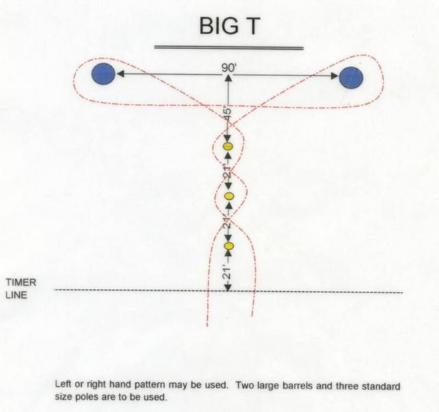

**STRAIGHT AWAY BARRELS**

**Riders may start on either the right or left side**

**Description of Race:**

This is a timed event. A rider crosses the timer line weaving either right or left of the first barrel, continuing weaving in and out to the third barrel, 360 degrees turning around the third barrel, then weaves back thru the barrels to cross the timer line. 33

**Equipment**

Timer line (designates the beginning and end of each race marked by chalk or lime). Three (3) 55-gallon standard oil drums with the dimensions being 23 inches from outside to outside on the ends and 34-1/2 inches long from the outside lip on top to the outside lip on the bottom, placed (50) feet apart and third barrel 150 feet from timer line. Barrels must have barrel protectors.

**Judges**

Two (2) judges to observe the pattern and set up the barrels, and place them in their proper place if they are knocked over.

**Penalties**

A five (5) second penalty for knocking over the barrel.

**Disqualifications**

Breaking the pattern, or Failure to complete the race.

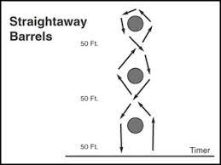

**HITCH N GO**

**Description of Race**

The rider crosses the timer line going between the first two (2) poles. Proceed to the next set of poles, either to the right or left pole. Going to the inside of the chosen pole, make a 360-degree turn around the pole. Proceed across the arena to the opposite pole and make the same (right/left) 360-degree turn, finishing on the inside of the pole. Finish the pattern by going back through the first two (2) poles to the finish line.

**Equipment**

Four (4) standard poles

34

The first two (2) poles are ten (10) feet from the starting line ten (10) feet apart, measured from the center of the poles and the center of the arena. The second two poles are fifty-five (55) feet from the starting line and sixty (60) feet apart, measured from the center of the poles and the center of the arena.

**Judges**

As many judges as necessary to observe the rider’s pattern and to set up the equipment in the proper place if they are knocked over.

**Penalties**

There will be a five (5) second penalty for knocking over a pole.

**Disqualifications**

Failure to run a correct/complete pattern will be a disqualification.

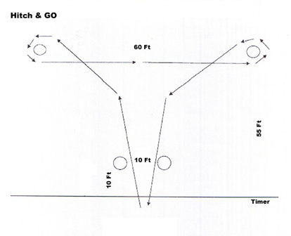

**LARYETTE**

**Description of Race**

The rider crosses the timer line either to the right or left set of poles. The rider goes outside the first pole, inside the second, and outside the third. Going around the barrel, the rider proceeds to the second set of poles, going outside the first, inside the second, and outside the third, and crosses the finish line.

**Equipment**

Six (6) standard poles

One (1) fifty-five (55) gallon barrel with barrel pad

Poles are thirty (30) feet between each going down the arena.

Poles are sixty (60) feet apart across the arena.

Barrel is centered in the pattern and thirty (30) feet from the last poles 35

**Judges**

As many judges as necessary to observe the rider’s pattern and to set the equipment in the proper place if they are knocked over.

**Penalties**

There will be a five (5) second penalty for knocking each pole or the barrel.

**Disqualification**

Failure to run a correct/complete pattern will result in disqualification.

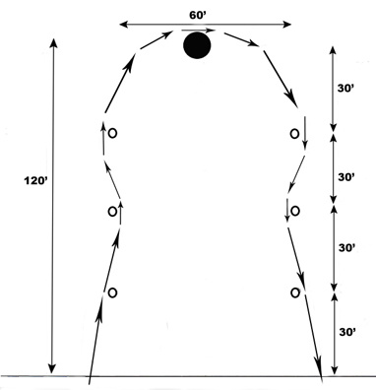

**TEAM EVENTS**

**CROSS FLAGS**

**Description of Race**

Each team is composed of two (2) riders on horseback. One (1) rider begins the race carrying a flag (of the same description as the flag race). The race begins when the first rider crosses the start/finish line from a point between both pylon and the outer fence. After depositing the flag in the bucket, which is placed atop and in the center of the barrel, the rider continues past the barrel to a point between the second set of pylons and the outer fence, the pylon being on the same side of the arena as the rider started from. The second rider is waiting at the back of the arena behind the line of the second set of pylons and the outer fence. The second rider must wait until the first rider deposits the flag in the bucket before crossing the line. The second rider must then retrieve the flag from the bucket and proceed across the start/finish line to stop the timer. The second rider may not enter or exit the pattern between the same pylon and fence as the first rider. The use of a back gate is suggested for the second rider to use to enter the arena. Circling the barrel is permitted.

**Equipment**

Two (2) pylons were placed twenty-five (25) feet off of the fence on the start/finish line. Two (2) more pylons placed (25) twenty-five feet off of the fence on a line no more than one hundred eighty (180) feet from the start/finish line and not less than forty (40) feet from the back of the arena. A fifty-five (55) gallon barrel is then placed in the center of this area to be an equal distance from the start/finish line and the back line and an equal distance from the side fences.

**Judges**

Two judges, one at the gate and one in the arena. The gate judge is responsible for ensuring that the first rider enters the pattern with the flag and that the second rider crosses the line with the flag. The second judge is responsible for ensuring that the second rider does not cross the back line before the first rider has deposited the flag in the bucket and ensuring that neither rider breaks the pattern.

**Penalties:** None

**Disqualification**

Breaking the pattern. Knocking over the barrel or bucket. Failing to deposit the flag in the bucket. The second rider crosses the back line before the first rider has deposited the flag in the bucket.

ailing to finish the pattern with the flag.

**RELAY**

**Description of Race**

Each team is composed of two (2) riders on horseback. One (1) rider carrying the baton starts the run from the start and finish line. The baton is exchanged at the end of the arena. The first rider hands off to the second rider, who is stationed behind the drums. Both riders must go around the second drum. The second rider races on across the start and finish line and must be ahead of the first rider. The rider receiving the baton must be behind the drum when the race starts and remain there until the hand-off is made.

**Equipment**

Two (2) weighed plastic drums were placed one hundred eighty (180) feet from the start and finish line, and each set in twenty-five (25) feet from the fence line. The two (2) drums must be a minimum of forty (40) feet from the end of the arena. One baton of semi-rigid material is eighteen (18) inches in length. A white (2010) judging line across the arena is one hundred eighty (180) feet from the start and finish line on the edge of the drum nearest to the start and finish line. The use of a helmet is encouraged.

**Judges**

One Judge at the start and finish line and one judge at the back of the drums to watch the exchange of the baton and the rider's pattern.

**Penalties**

A five (5) second penalty will be added to the rider's time for knocking over or steadying the drums.

White (2010) judging lines from the edge of the drum nearest to the start and finish line to the fence

25 Ft

Minimum clearance from the center of each drum to the side fence 180 Ft from the start and finish line to the center of each drum 40Ft Minimum clearance from the center of the drums to the back fence

39

**Disqualification**

Dropping the baton. Exchanging the baton outside the hand-off area. A rider other than the second rider crosses the finish line first. The relay baton must be exchanged behind the judging chalk line (at the drums). The baton cannot come out of the hand-off area until the hand-off is made. Failure of either rider to follow the pattern. Throwing the baton. The rider who receives the baton not being behind the drum when the race starts. The baton is not being exchanged behind the white (2010) judging chalk line (at the drums).

**RIBBONS**

**Description of Race**

Two (2) team members, mounted on separate horses, and each holding opposite ends of the ribbon by one hand, race to and around the barrel and return to the finish line. The time starts when the first horse crosses the start line and stops when the first horse crosses the finish line. The riders may run either a right or a left pattern. Both riders must cross the start and finish lines holding onto opposite ends of the ribbon.

**Equipment**

Ribbon, which will be a strip of crepe paper the nearest to two (2) inches wide that is available, and 4 (four) feet long. One (1) weighted plastic barrel placed one hundred eighty (180) feet 40Ft Minimum

Clearance from the center of the barrel to the back fence 180Ft from the start and finish line to the center of the barrel 41 from the start and finish line or a minimum of forty (40) feet from the end of the arena, on a line down the center of the arena. The use of a helmet is encouraged. Judges

Two judges at the start/finish line and one judge at the back of the barrel, and as many judges to

properly observe the pattern and issue ribbons to the contestants.

**Penalties**

A five (5) second penalty will be added to a rider's time for knocking over or steadying the drum.

**Disqualification**

Breaking the pattern. Dropping or breaking the crepe paper.

Attaching the horses in any manner except by riders holding the ends of the crepe paper. No

deliberate touching of any kind is allowed. Deliberately twisting, shortening, or manipulating the

ribbon to strengthen the crepe paper.

