First Aid & CPR
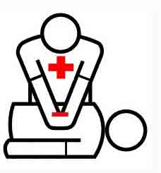
As a Resource Parent, you are required to maintain a valid “CPR, AED, and Basic First Aid for adults, children, and infants” certification. This is one of those important skills we hope we never need to use, but we all need to know, just in case!
Krista will reimburse you for the cost of the class after a foster child has been placed in your home for 30 days. Certifications are valid for two years. Krista will reimburse your certification renewal if you have had a foster child placed in your home at any time that year.
When you complete the class, please provide a copy of your card to your Krista social worker or office staff.
Here are a few local options for taking this class:
Kiser CPR & First Aid
4.0
4425 Tralee Ln
(530) 921-1455
https://www.kisercpr.com/
CPR/AED/First Aid class $60 (4 hours)
Varying days/times

Carol Howard CPR & First Aid (A Plus Safety LLC.)
5.0 ·
2765 Bechelli Ln
(530) 222-8485
http://www.aplussafetyllc.com/first-aid
CPR/Basic First Aid class $30 (3.5 hours)
Varying days/times

Fred Wycoff
347-6991
CPR/First Aid class
Call for days/times/costs
Please call or check the websites for the most up-to-date information on class schedules and costs.

