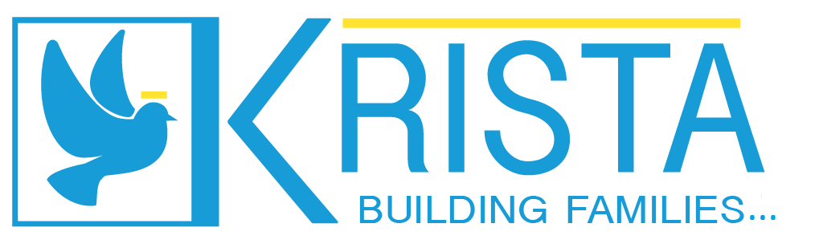

krista Foster Homes
Policies and Procedures

Risk Management Plan 2021

Risk Management 2020 Analysis

In 2020, KHF most prominent risk has continued to be the lack of new parents coming into the agency. Last year’s Risk Management analysis described the many issues affecting new parents coming into the foster parenting sector.
CCL has been a support to KFH. There was 1 complaint against KFH in 2020.
KFH continues to do internal facility inspections on our office located at 1135 Pine Street, Redding CA, 96001. Our building manager has been responsive and helpful. The building owners added an encloser to the front entrance offering more shade, improved weather protection, and reduced homeless persons “camping” at our front door during the night hours.
Staff mistakes or omissions were not an issue in 2020 as in 2019. Trainings in 2020 were almost completely on-line due to COVID-19.
KFH company vehicle and staff use of personal vehicles has been accident free. Insurance cards and emergency kits have been maintained.
KFH has had no known theft / fraud issues. The annual audit has no new ideas to improve our agency. Krista board members are monitoring our progress.

Krista Foster Homes

Risk Management Plan 2020
Areas of possible loss exposure:
- Number of RFA Homes available
Analysis of possible loss exposure:

How to rectify exposure:
A proposed plan to develop and implement specific recruitment strategies was given to our Strategic Planning team; goals and plans were devised. Increase Social media presence, contact local news/radio stations for advertising opportunities, keep the financial bonus for finding new foster parents, and reach out to churches were suggested.
Implementation of actions to reduce risk:
Continue recruitment efforts by attending and supporting local community events. Increase efficiency of SAFE certification process to open homes faster. Continue sending bed availability to Shasta and relevant California counties to increase the number of possible client placements, remind staff and resource parents to mention foster care, check in with churches and radio stations.
Monitoring of Actions to Reduce Risk:
Administrator and designee will monitor recruitment efforts, speed of RFA process, and the continuing efforts to communicate with placement workers regarding available bed space. Target date for reassessment is KFH Annual Conference in February 2021.

- CCL Complaints
Analysis of possible loss exposure:

How to rectify exposure:
Train staff annually on the policy and procedures of KFH regarding CCL complaints, discuss complaints (if any) that arise throughout the year, and comply with all current regulations. If CCL complaints do arise throughout the year, KFH staff will cooperate with CCL Contact and follow CCL guidance to resolve the matter.

Implementation of actions to reduce risk:
Finish policy manual for staff with regulations put in layman term, regulations in all Social Worker offices. Follow regulations and do not cut corners.

Monitoring of Actions to Reduce Risk:
The administrator or supervising social worker will monitor new and current staff participation in familiarizing selves with regulations and participate in questions, dialogue, clarifying expectations. Communication with CCL may be appropriate.

- Facility Safety
Analysis of possible loss exposure:

How to rectify exposure:
KFH administrator will bring in a third party, external inspector to assess the property for safety and provide recommendations if needed. KFH administration or designee will also conduct an internal safety check bi-annually. Both safety checks will be used to identify and correct risks or potential risks.
Implementation of actions to reduce risk:
Follow safety regulations, conduct emergency safety drills, and ensure proper insurance.
Monitoring of Actions to Reduce Risk:
The administrator or designee will conduct bi-annual internal evaluations of the facility. The administrator will review the third party’s external inspection report and apply any recommended changes to adhere to state regulations. The internal safety inspection reports can be found in the ‘Emergency Drill Binder’.

- Staff mistakes or omissions
Analysis of possible loss exposure:

How to rectify exposure:
Proper training, follow-up, preparation.
Implementation of actions to reduce risk:
Continuous training for all staff, accountability for mistakes with dialog and supervision.
Monitoring of Actions to Reduce Risk:
The administrator or designee will monitor staff training and document compliance.
Staff who make errors/mistakes will meet with the supervising social worker or administrator, engage in appropriate interventions including possible disciplinary action(s).

- KFH vehicle accident
Analysis of possible loss exposure:

How to rectify exposure:
Train staff, proper driver’s license/insurance, and company insurance covering any KFH staff using a vehicle (personal or company) to conduct the organization’s business. Office administrator and relevant staff will ensure that all vehicles used have a copy of the “Transportation – Road Emergency Policy” and a safety kit in the vehicle.
Implementation of actions to reduce risk:
Ensure staff has license, training, insured on KFH insurance policy, and has private insurance on any personal vehicles used. Annual review of “Staff Transportation Agreement” including signatures from both staff and administrator, then filed in their personnel file.
Monitoring of Actions to Reduce Risk:
The office administrator will monitor staff files for current compliance regarding up to date training, driver’s license, and personal insurance, as well as ensure employees who are transporting clients are included on KFH company insurance and pass the insurance company’s DMV check.

- New LOC Rate Structure
Analysis of possible loss exposure:

How to rectify exposure:
Advocate for increased LOC rate.
Implementation of actions to reduce risk:
Staff identifies under rated clients and requests assessment. Continue with Needs and Services Plans to address LOC rate structure. Adopt the Quarterly Needs and Services Plans implemented by Shasta County for Shasta County Clients.
Monitoring of Actions to Reduce Risk:
The administrator and/or social work supervisor ensures that social work staff are evaluating possible clients for assessment and ensure request for assessments are done.

- Fraud/ Theft
Analysis of possible loss exposure:

How to rectify exposure:
Follow Policy & Procedures to the letter.
Implementation of actions to reduce risk:
Comply and complete checks and balances, monitoring by board, and audit compliance.
Monitoring of Actions to Reduce Risk:
Administrator and office manager collaborate to ensure internal controls and policies and procedures are followed. Board member(s) check over reports for accuracy. Audits are completed annually and can be found in the box labeled ‘Audits’ in the office records room.

Administrator’s Signature: __________________________________ Date: _________________

