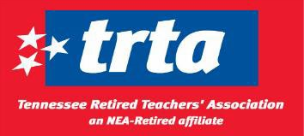
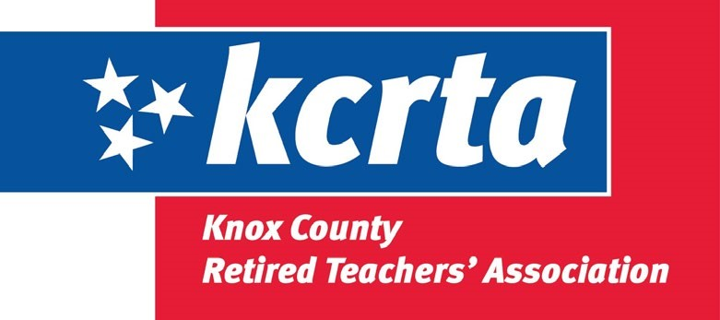
Knox County Retired Teachers’ Association
711 N Hall of Fame Drive
Knoxville, TN 37917
July 1, 2026 - June 30, 2027 MEMBERSHIP YEAR
Since 1957, KCRTA /TRTA has been working to improve the lives of retired educators and educational support personnel. KCRTA /TRTA is the only organization working to improve retiree benefits.
- KCRTA /TRTA advocates and lobbies for retiree pension (TCRS), COLA and health insurance.
- KCRTA provides an opportunity for fellowship, community service, and timely information on issues involving retirement.
- KCRTA /TRTA membership entitles you to discounts for Hearing tests and Hearing aids through HEAR in America.
- KCRTA /TRTA membership includes the ACCESS DISCOUNT PROGRAM through TEA.
- NEA-R membership enables you to maintain your NEA insurance, credit cards, travel, car rental, cell phone discounts, and all other NEA member benefits.
Unified 2026-2027 Dues:
NEA-Retired Lifetime  NEA-Retired Annual  TRTA Annual  KCRTA Annual | $300 one-time payment (check payable to NEA-Retired)  $35 ($2.92 per month if using automatic withdrawal)  $25 ($2.08 per month if using automatic withdrawal)  $10 ($0.83 per month if using automatic withdrawal)
*ESP-Educational Support Personnel Dues:
(Members who worked as teaching assistants, secretaries, custodians, etc.)
NEA-Retired ESP* Lifetime NEA-Retired $180 one-time payment (check payable to NEA-Retired)
ESP* Annual $21 per year

If paying by check, complete Section 1 and 2. If using automatic withdrawal, complete Section 1 and 3. Mail this form and your check(s), if needed, to
KCRTA, 711 N Hall of Fame Drive, Knoxville, TN 37917
1. KCRTA Enrollment Form  Name:  First  MI  Last  Address:  Street  City State Postal Code  Phone # ( ) __________- _________  Home Email _________________________  Member Signature ____________________________________  Birth Date  (mm/dd/yyyy)  Date: | 2. Unified membership is required if you retired after August 1992. You must belong to NEA-Retired, TRTA and the local Association to be a unified member.  Member #  NEA-Retired Annual Membership $ 35  TRTA Annual Membership $ 25  KCRTA Annual Membership $ 10  Total Dues paid $ 70  Check # if paying by Check  Association Officer | 3. Optional Automatic Dues  Withholding from your TCRS  Pension Check  I hereby authorize TCRS to deduct the following dues from my TCRS pension check. I agree that the dues shall be deducted until such time as I notify TRTA and TCRS in writing that I no longer wish to have such dues deducted.  Authorization signature  SS# if pension deduction  -  -  Da  te:  NEA-R Annual Dues $ 2.92  TRTA Annual Dues $ 2.08  Local Dues $ 0.83  Total $ 5.82 per month

