**The Believer as Priest!**

1Peter 2:5 “Ye also, as lively stones, are built up a spiritual house, a holy priesthood, to offer up spiritual sacrifices, acceptable to God by Jesus Christ.

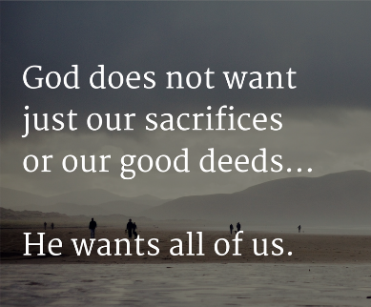**Offering God my Sacrifices.**

# So what do you know about the Offerings of the Priesthood of Believers?

* Like the Old Testament Believer offered God their lives first than offered God offerings!
* The New Testament Believer as The Believer Priest offers God our life first and then offerings.

**Our Sacrifice is Fivefold**

1. **Offering ourselves as a Living Body For Jesus–**

* *Your Body [Heart] is the highest offering to give!*
* **Rom 12:1 “I beseech you therefore, brethren, by the mercies of God, that ye present your bodies a living sacrifice, holy, acceptable unto God, which is your reasonable service.**
* Q. What does God want?
* Q. How do I offer it to God?
* **Phil. 2:17 “Yea, and if I be offered upon the sacrifice and service of your faith, I joy, and rejoice with you all.**
* Q. How are to offer our bodies?
* Q. What type of attitude should I have?
* **2 Tim 4:6 “ For I am now ready to be offered, and the time of my departure is at hand.**
* Q. When times are tough what does God want from us?
* James 1:27 “Pure religion and undefiled before God and the Father is this, To visit the fatherless and widows in their affliction, and to keep himself unspotted from the world.
* Q. Who should I visit?
* Q. What kind of Religion is this?
* **1John 3:16 “ Hereby perceive we the love of God, because he laid down his life for us: and we ought to lay down our lives for the brethren.**
* **Q. How did God show His love to us?**
* **Q. How do we show our love for the people?**

1. **Offering our praises to God Continually.**

* Hebrews 13:15 “ By Him [God] therefore let us offer the sacrifice of praise to God continually, that is, the fruit of our lips giving thanks to his name.
* Q. What Does God want us to do continually?
* Q. Why are we able to do this?
* Psalms 116:17”I will offer to thee the sacrifice of thanksgiving, and will call upon the name of the LORD.
* Q. What did King David like to do?
* Psa 107:21 “Oh that men would praise the LORD for his goodness, and for his wonderful works to the children of men!
* Q. What does God want us to do?

1. **Offering our Substance to God’s Work**

* Rom 12:13 “ Distributing to the necessity of saints; given to hospitality
* Q. What is God asking us to do?
* Gal 6:10 “ As we have therefore opportunity, let us do good unto all men, especially unto them who are of the household of faith.
* Q. What opportunities should we be looking for?
* Act 2:44-45 And all that believed were together, and had all things common; And sold their possessions and goods, and parted them to all men, as every man had need.
* Q. Does God bless us so we can bless others?

1. **Offering our Service To do good always!**

* **James 4:17 “Therefore to him that knoweth to do good, and doeth it not, to him it is sin.**
* Q. How does God see us not doing good?
* Hebrews 13:2 “Be not forgetful to entertain strangers: for thereby some have entertained angels unawares.
* Q. How do treat strangers?

1. **Offering Interceding**

* Colossians 4:12 “Epaphras, who is one of you, a servant of Christ, saluteth you, always labouring fervently for you in prayers, that ye may stand perfect and complete in all the will of God.
* Q How should we see our prayers for God’s servants?

***Conclude:***

1. **Does God have your heart?**