Helmers Street Baptist Church
We are a Bible-Believing and Evangelistic Church:
Office # 713-692-3281 | Pastor’s Cell # 832-964-4199
Thank You for Joining Us Today!
Sunday. November 13, 2022
Opening Prayer Preparation for worship
HYMN “He Lives” #132
HYMN “Sweet By and By” #504
Greeting, Announcements & Worship with tithes and offerings
Special Music Liz Morquecho
HYMN “When I See the Blood” #232
Message Pastor Jacob Mendoza
Invitation “Softly and Tenderly” 246
Sunday Afternoon Service @ 2:30pm
HYMN “Tis So Sweet to Trust in Jesus” #257
HYMN “Blessed Assurance” #255
Special Music To be announced.
Afternoon Message - Lesson #1 “Salvation” Pastor Jacob Mendoza
Postlude “Room at the cross for you” 243

This Week at Helmers
Sunday, 11.6.22
- 10:00 am Sunday Bible School – All Ages
- 11:00 am Morning Worship
- 2:00 pm Afternoon Service – Different Message.
Wednesday, 11.9.22
- 6:00 pm Dinner in the fellowship Bldg.
- 6:30 pm Prayer Time and Bible Study
Saturday, 11.12.22
- 10:00 am Evangelism and Church Cleaning – Be a Volunteer!

Zoom info is the same each week:

I.D.# 895 2007 5380, then type, Password# 7721
Facebook – Search for Helmers Street Baptist Church –
Like and share our page.
Coming Events – “Plan to Participate”

November 8 – Election Day – Voter’s Guide-Pro. 9:10, 14:34,
November 20 – Thanksgiving Celebration Lunch
December 10 – A gift box to the Women’s Shelter
December 18 – Christmas Cantata & Lunch Celebration

Date: November 12, 2022
Time: 2:30pm
Location: Helmers Street Baptist Church
Charismas Choir Practice

Date: November 11, 2022
Grades: 3rd- 12th
Cost: Free
Study Passage: Psalms 119:1-24
Time: 7pm-8:30pm
Location: Emmanuel Baptist Church

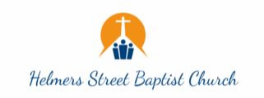
Special Emphasis Saturdays
1st Saturday of Each Month @ 10:00am-11am
- Let’s go “Soul Winning” - Obeying God’s Great Command.
2nd Saturday of Each Month @ 10:00am-11am
- Angel’s Closet Ministry - Free Cloths & Food for neighborhood.
3rd Saturday of Each Month @ 9:30am-11:30am
- Let’s go “Soul Winning” - Obeying God’s Great Command.
4th Saturday of Each Month @ 10:00am-Noon
- Workday at the Church.
Memorizing the book of the Bible:
- Genesis  - Exodus  - Leviticus  - Numbers  - Deuteronomy  - Joshua  - Judges  - Ruth  - 1 Samuel  - 2 Samuel | - 1 Kings  - 2 Kings  - 1 Chronicles  - 2 Chronicles  - Ezra  - Nehemiah  - Esther  - Job  - Psalms  - Proverbs | - Ecclesiastes  - Song of Solomon  - Isaiah  - Jeremiah  - Lamentations  - Ezekiel  - Daniel  - Hosea  - Joel
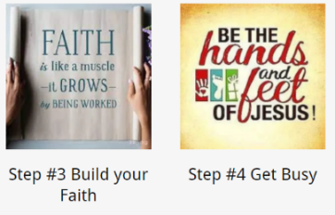
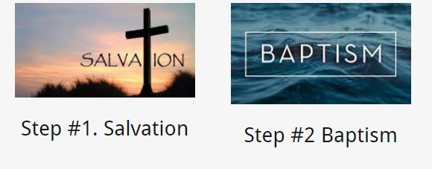

- Are you saved?
- Are you baptized?
- Are you growing in faith by listening to God’s Word?
- Are you getting busy for Jesus and doing His will?
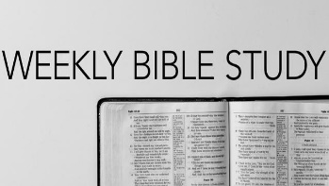
Every Wednesday @ Helmers
Time: 6:30- 7:30pm
Supper @ 6pm –
Everyone invited

Happy Birthdays in November:
| 20th Martin | Lopez 23rd |Vanessa |28th Bob Kennard
Happy Anniversary
* None *
“Glorifying Jesus in 2022”
MyHelmersStreet.org
November 13, 2022

7721 Helmers Street, Houston, Texas 77022
“Building Christ-Like Believers to reach the World for Jesus.”

John 3:30
“He must increase, but I must decrease”

