**Helmers Street Baptist Church**

**We are a Bible-Believing and Evangelistic Church:**

**Office # 713-692-3281 | Pastor’s Cell # 832-964-4199**

**Thank You for Joining Us Today!**

**Sunday. November 20, 2022**

**Opening Prayer Preparation for worship**

**HYMN “Come, Christians, Join to Sing” #55**

**HYMN “How Great Thou Art!” #37**

**Greeting, Announcements & Worship with tithes and offerings**

**Special Music Liz Morquecho**

**HYMN “Come, Thou Long-Expected Jesus” #84**

**Message Pastor Jacob Mendoza**

**Invitation “Softly and Tenderly” 246**

**Sunday Afternoon Service @ 2:30pm**

**HYMN “Tis So Sweet to Trust in Jesus” #257**

**HYMN “Blessed Assurance” #255**

**Special Music To be announced.**

**Afternoon Message - Lesson #1 “Salvation” Pastor Jacob Mendoza**

**Postlude “Room at the cross for you” 243**

**This Week at Helmers**

**Sunday, 11.20.22**

* 10:00 am Sunday Bible School – All Ages
* 11:00 am Morning Worship
* 2:00 pm Afternoon Service – Different Message.

**Wednesday, 11.23.22**

* 6:00 pm Dinner in the fellowship Bldg.
* 6:30 pm Prayer Time and Bible Study



#### Zoom info is the same each week:

#### I.D.# 895 2007 5380, then type, Password# 7721



Facebook – Search for Helmers Street Baptist Church –

Like and share our page.

Coming Events – “Plan to Participate”

November 20 – Thanksgiving Celebration Lunch

November 24 – Happy Thanksgiving!

November 26 – Spend time with family – no Church Activities

December 9 – White Elephant 6-8pm & work on gift boxes

December 10 – Gift boxes to the Women’s Shelter

December 18 – Christmas Cantata & Lunch Celebration

December 25 – Merry Christmas! & Sing Carols at noon

December 31 – New Year Eve Service – 6-8pm

February 12-17 – Bible Conference at Helmer’s Baptist

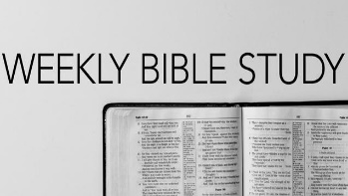

Every Wednesday ; Fellowship Bldg.

Time: 6:30- 7:30pm

Dinner @ 6pm –

Bring a friend – Open to Everyone

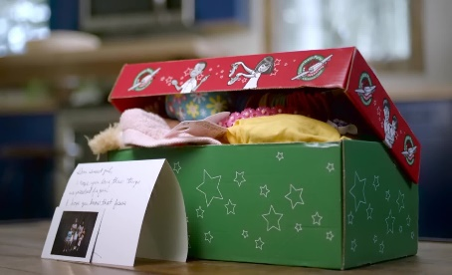December 10 – Gift boxes to the Women’s Shelter

Time: 1pm

Location: Star of Hope –

1811 Ruiz St. Hou., Tx 77002



Date: December 18, 2022

Time: 11:00Am Service

Location: Helmers Street Baptist Church

**Special Emphasis Saturdays**

**1st Saturday of Each Month @ 10:00am-11am**

* **Let’s go “Soul Winning” - Obeying God’s Great Command.**

**2nd Saturday of Each Month @ 10:00am-11am**

* **Angel’s Closet Ministry - Free Cloths & Food for neighborhood.**

**3rd Saturday of Each Month @ 9:30am-11:30am**

* **Let’s go “Soul Winning” - Obeying God’s Great Command.**

**4th Saturday of Each Month @ 10:00am-Noon**

* **Workday at the Church.**

|  |  |  |
| --- | --- | --- |
|  |  |  |

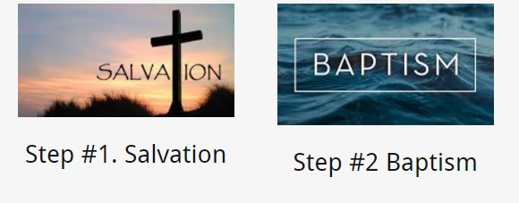***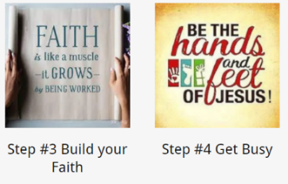*Memorizing the book of the Bible:**

|  |  |  |  |
| --- | --- | --- | --- |
| 1. **Genesis** 2. **Exodus** 3. **Leviticus** 4. **Numbers** 5. **Deuteronomy** 6. **Joshua** 7. **Judges** 8. **Ruth** 9. **1 Samuel** 10. **2 Samuel** 11. **1 Kings** 12. **2 Kings** | 1. **1 Chronicles** 2. **2 Chronicles** 3. **Ezra** 4. **Nehemiah** 5. **Esther** 6. **Job** 7. **Psalms** 8. **Proverbs** 9. **Ecclesiastes** 10. **Song of Solomon** 11. **Isaiah** | 1. **Jeremiah** 2. **Lamentations** 3. **Ezekiel** 4. **Daniel** 5. **Hosea** 6. **Joel** 7. **Amos** 8. **Obadiah** 9. **Jonah** 10. **Micah** 11. **Nahum** 12. **Habakkuk** | 1. **Zephaniah** 2. **Haggai** 3. **Zechariah** 4. **Malachi** |

1. **Are you saved?**
2. **Are you baptized?**
3. **Are you growing in faith by listening to God’s Word?**
4. **Are you getting busy for Jesus and doing His will?**

**Happy Birthdays in November:**

19th Polo M.| 20th Martin L/ | 23rd Vanessa G. |28th Bob K

**“*Glorifying Jesus in 2022”***

***MyHelmersStreet.org***

***November 20, 2022***

***7721 Helmers Street, Houston, Texas 77022***

**“Building Christ-Like Believers to reach the World for Jesus.”**



**Matthew 13:8**

[But other fell into good ground, and brought forth fruit, some an hundredfold, some sixtyfold, some thirtyfold.](https://www.kingjamesbibleonline.org/Matthew-13-8/)