**Helmers Street Baptist Church**

**7721 Helmers St. Houston Tx 77022**

“We are a Bible Believing & Evangelistic Church”

Office # 713-692-3281 | Pastor’s Cell # 832-964-4199

www.MyHelmersStreet.org

**8/4/2024**

**Welcome!**

**We are so glad you’re here!**

**Our church exists to help others know Jesus**

**and develop a more intimate walk with Him.**

**Today’s Order of Service .**

Opening Prayer........................................................ Preparation for Worship

HYMN……………………………………………….”**Surely Goodness and Mercy”** #292

HYMN………………………………………………………………..”**Lead Me to Calvary”** #123

Greeting and Announcements

Worship with tithes and offerings.

HYMN………………………………………………”**There is Power in the Blood”** #198

Special ………………”**To Everything there is a season”** - Hamilton Family

Message …………………………………………………………………… Pastor Jacob Mendoza

Invitation…………………………………………. **“Have Thine Own Way, Lord”** #388

**A Word from Pastor**

Having A Relationship with God is what the Chirstian life is all about. Walking in the right fellowship through His Word is our goal. Trust in His Grace that is sufficient for all our needs to live godly in this present world.

Make time to be in God’s Word each day. Pastor Jacob & family.

**We are a church on purpose!**

Step 1 – “Know Christ and committed to membership”

Step 2 – “Growing in Christ and committed to maturity” Step 3 – “Serving Christ and committed to ministry”

Step 4 – “Sharing Christ and committed to missions

|  |  |
| --- | --- |
| **Upcoming Events: Plan to Participate**  **Men’s Fellowship -**  August 10 @ 11am-1pm  **The Lord Supper**  August 25  **Friday Night Prayer**  August 30 @ 7pm-8pm  September 27 | **August is**  **Prayer Month**  This month we will be focusing on giving our prayers to God for what we need in our lives and church. |

**WEEKLY SERVICES & MEETINGS .**

|  |  |
| --- | --- |
| **SUNDAYS**  10AM Sunday School  11AM Morning Worship  **SATURDAYS**  10AM -Noon – Telling others about the Gospel of Jesus.   * Mattthew 28:19-20 | **WEDNESDAYS**  6:30PM Bible Study   * “Study to show thyself approve unto God…   ” 2 Tim. 2:15 |

|  |  |
| --- | --- |
| **Weekly Events at Helmers**  **Sunday,**   * 10:00 am Sunday School * 11:00 am Morning Worship   **Wednesday,**   * 6:30 pm Prayer Time and Bible Study   **Saturday,**   * 10:00am - Reaching the Community   **Home-Builders Class-**   * **Join us every Sunday Morning at 10:00am** * **New Class: Begins Aug 4th** * **Building a life and home with Jesus.**   ” |  |

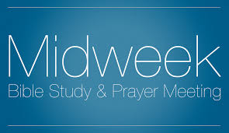**Every Wednesday Bible Study -**

Who: All Adults & All kids come grow in Christ!

When: We Start @ 6:30pm – Ends @ 7:30pm

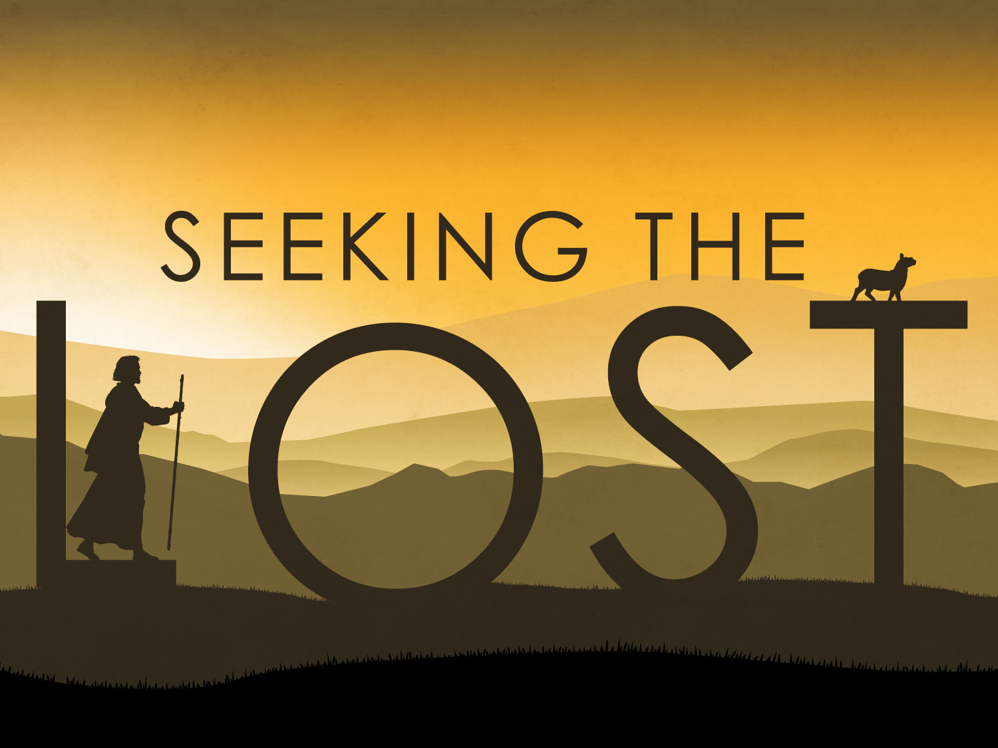 **Every Saturday – 10:00am - Noon**

Calling Soul winner – Let’s Reach the lost for Jesus. - Help Spread the Hope of Jesus.



**This Week Nursery Team:**

**Sunday 10am – Beth M.**

**Sunday 11am – Idalia M & Eva C.**



**This week Cleaning Team:**

**Yard Cleaning – Pastor Jacob**

**Church Cleaning – Pastor Jacob**

**A Special Note for our Guests: .**

*We are so thrilled to have you join us for our services today! We believe there is nothing quite so great as being a member of a Bible-believing, Bible-preaching church family. If there's anything we can do to be of service to you, don't hesitate to reach out.*

**What We Believe: find a complete list of our beliefs on our website:** [**www.MyHelmersStreet.org**](http://www.MyHelmersStreet.org)

***Prayer Challenge:***

***"We have to pray with our eyes on God, not on the difficulties." Oswald Chambers***



**August 4, 2024**



**1Corinthains 10:31  ‘Whether therefore ye eat, or drink, or whatsoever ye do, do all to the glory of God.****”**

**Watch us live on YouTube or ZOOM**

**Watch past messages on YouTube anytime.**