2020 Fall Sensation Softball Tournament

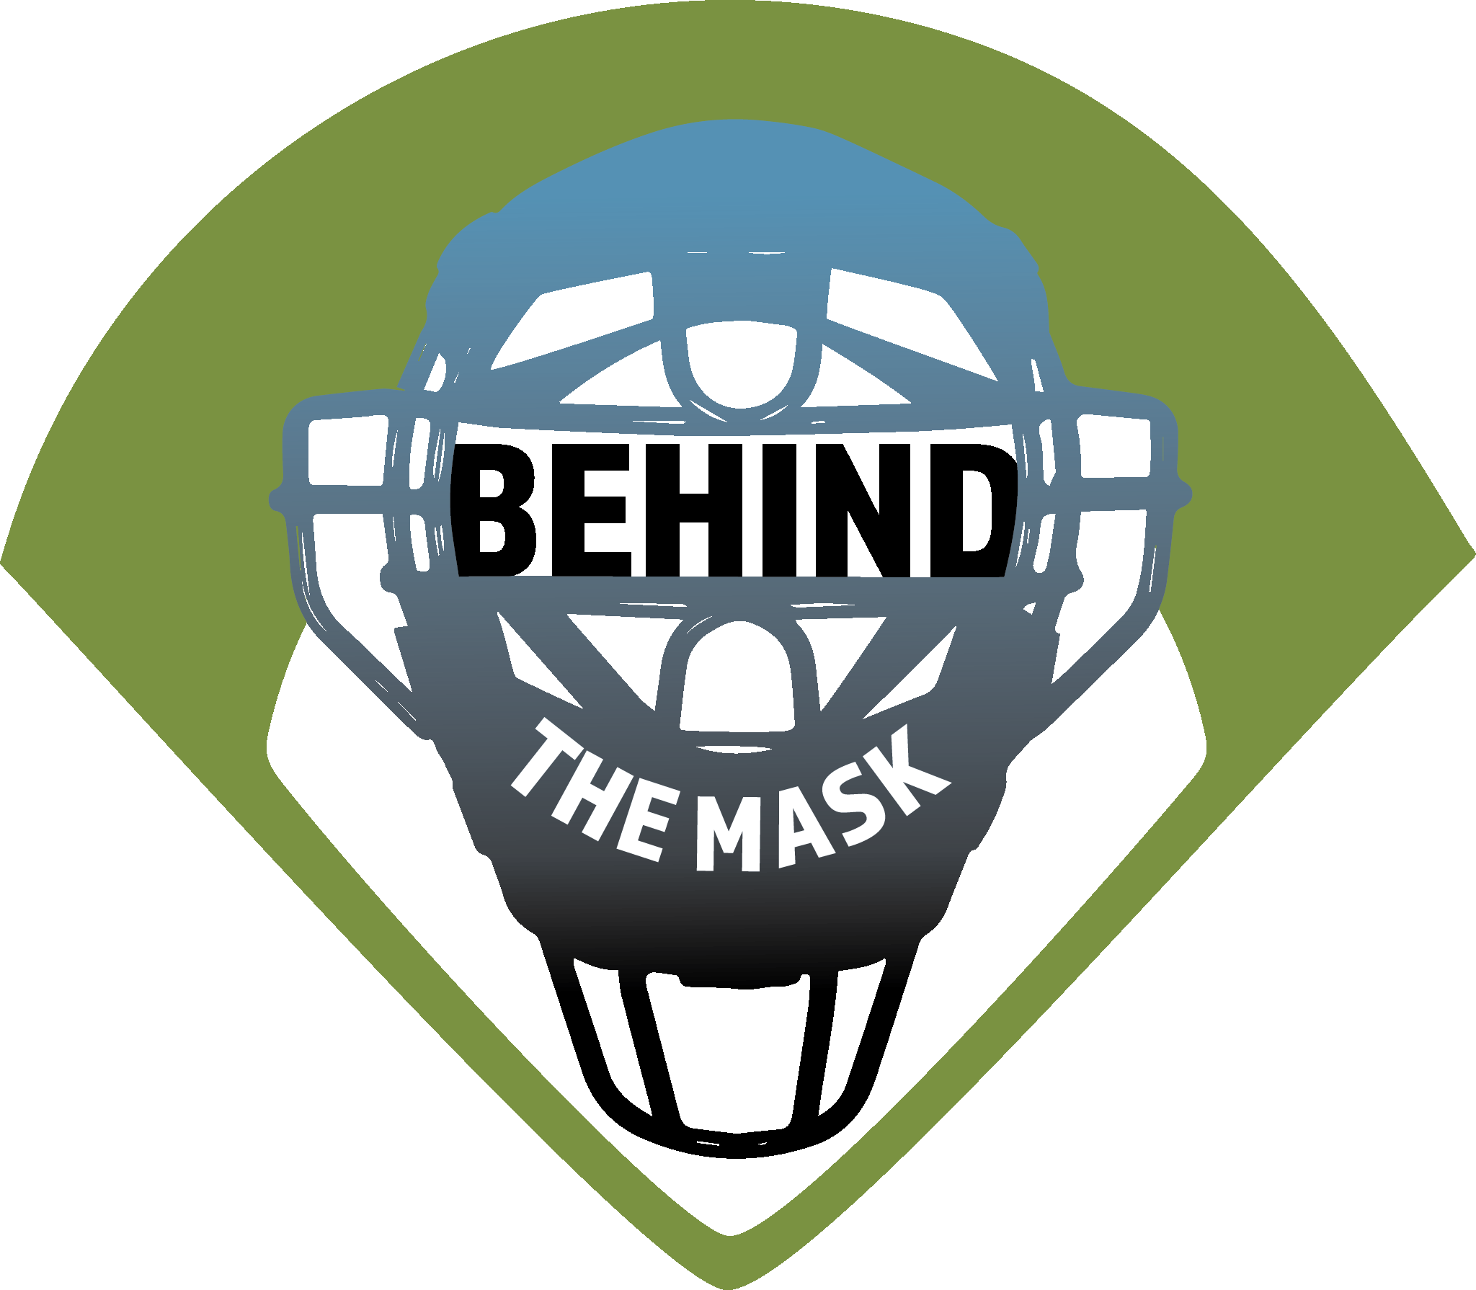
October 3rd & 4th at Caswell Park North Mankato
Class A & AAA play on October 3rd
Class AA & AAAA play on October 4th

- 3 game guaranteed
- Entry Fee – 275.00 no gate fee and no awards
- All game will use 2 umpires
- Brackets will be formed by your High School classification, you can play up a class if you wish but cannot play down
- Each class will have an 8 team bracket.
- High School coaches will not be allowed to coach their team according to MSHL guidelines
- Checks made payable to Behind The Mask, this organization is funding the development of the next generation of umpires.
- Mail checks to: Joel Schmidt 307 Smith Court Mapleton, MN 56065

Team name:_____________________________________________________________
Coaches Name:___________________________ Phone ________________________
Coaches Email ____________________________________________________________
Classification A AA AAA AAAA
For more information call Brian DeVos @ 507-291-1314
Email – info@umpiresbehindthemask.com
Behind The Mask website https://umpiresbehindthemask.com/

