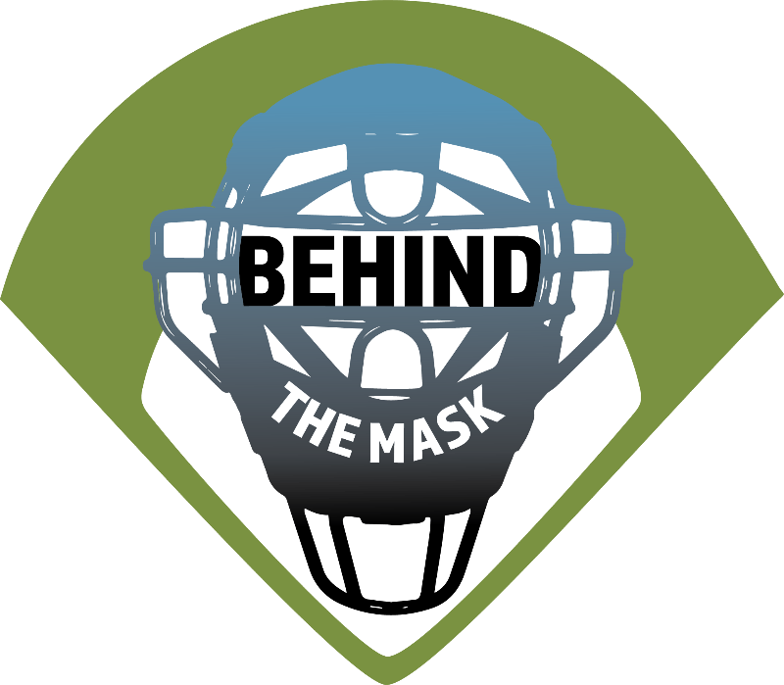
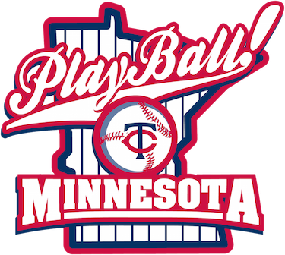

MISSION:
  - To train, equip, mentor and retain new softball and baseball umpires thru a mentor training program

Plan:
  - Complete Classroom training
  - Gym training
  - Tournament training with Mentor
  - League games with Mentor
  - USA Softball registration meeting
  - USA Softball registration fees paid
  - Equipment provided: Mask, shirt, cap, ball bag, plate brush, indicator
  - You buy: Heather grey pants and Black shoes

Contact:
  - Behind The Mask
  - C/O Brian DeVos
  - 904 9th St SE
  - Waseca MN 56093
  - Call: Brian (507) 291-1314
  - OR
  - Joel: (507) 317 -4474
  - Email:
  - info@umpiresbehindthemask.com
  - Website:
  - https://umpiresbehindthemask.com
  - Facebook:
  - @UmpiresBehindTheMas

