CHISLEHURST
HALF MARATHON
www.chislehursthalf.com

RACE INFORMATION PACK
Sunday 15 May 2022
Registration from: 8.00 am
Race starts: 9.30 am
Run under UK Athletics rules
UKA race licence: 2022–42813

Race HQ: Glebe Football Club, Foxbury Avenue off Perry Street, Chislehurst, Kent, BR7 6SD (Please allow plenty of time to travel and do not over-rely on the post-code and satellite-navigation to accurately locate the venue.)
A non-profit event in aid of The Maypole Project

www.themaypoleproject.co.uk
Dear Runner,  Welcome to the fifth running of the Chislehurst Half Marathon.  We hope that you enjoy your visit to this leafy and green part of the London Borough of Bromley with a 13.1 mile undulating multi-terrain run along the trails of Foxbury Manor woods and scenic Scadbury Park (the latter twice – once in each direction) and some shorter sections of pavement.  Please read the following information about the race to make your day a safe and pleasant experience.  Any last minute updates can be found on our website www.chislehursthalf.com or via our Facebook page.  Thank you to all our participants, our sponsors and our volunteers who have kindly given up their time to help out at the event.  Programme for the day  08:00-09:15 Collect numbers/drop baggage  09:15 Warm-up by a life:lab gym personal trainer  09:20 Runners to enter the start pens in their anticipated time category  09:25 Race instructions to runners  09:30 Race start  10:50 First runner expected to finish  c. 12.00 - Trophy Presentation by Sally Flatteau Taylor, Founder and Chief Executive of The Maypole Project | On arrival  Race registration  On arrival at Race HQ, please head to registration inside the sports pavilion where you should approach the desk which handles the first letter of your surname and we will then provide you with your numbered race-bib.  Entry on the day  There will be entries available on the day from 8 am at Race HQ.  Race-bib  Please write your emergency contact and any medical conditions on the back of your race-bib.  Your race-bib has a timing chip attached and must be fixed to the FRONT of your running vest above waist level - safety pins will be available. It must not be folded, cut, altered or mutilated in any way.  Wearing a number that is not registered in your name will result in disqualification.  No baggage drop  Baggage should be stored inside your vehicle and valuables kept out of sight. We shall have a mat near the start/finish however which will be unsupervised and where a bag with spare clothing can be left but please do not leave money or valuables.

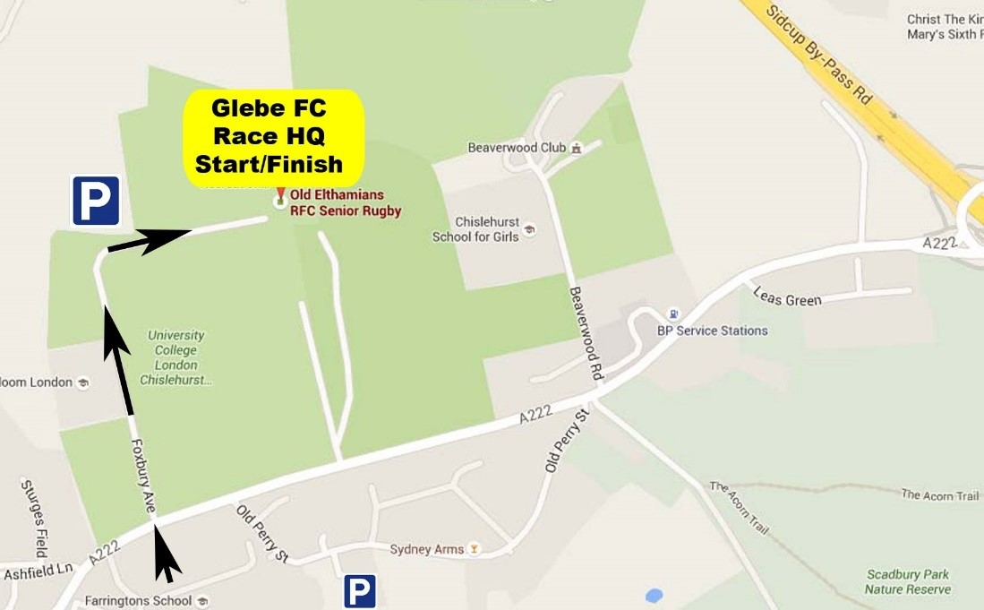
How to get to Race HQ

Postcode  BR7 6SD (Sat-Nav users please don’t over rely on this as this postcode covers a wide area.)  By car from the M25 - leave the M25 at junction 3 and take the A20 towards London, leaving at the Frognal Roundabout slip road after about 5 miles on to the westbound A222 (Perry Street) and go half a mile, past sports ground on your right, until you reach Foxbury Avenue on the right. Race HQ is at the end of Foxbury Avenue.  By car from London on the A20 - take the slip road before Frognal Roundabout and take the third exit westbound along the A222 (Perry Street) and go half a mile until you reach Foxbury Avenue on the right. Race HQ is at the end of Foxbury Avenue.  By train: from Chislehurst Train Station. Details of train times can be located on www. nationalrail.co.uk or National Rail Enquiries. Some engineering works may be undertaken over the weekend in the Chislehurst area so it is worth checking the South Eastern Railway website at www.southeasternrailway.co.uk/your-journey/engineering-work/ | Chislehurst Station is about 30 minutes walk away from the Race HQ at Glebe FC in Foxbury Avenue.  When leaving the train platforms, exit to the right on to Station Approach and then turn left onto Summer Hill (A222) and proceed up the hill and continue straight for half a mile past the Chislehurst Memorial Crossroads and continue along the A222 into Bromley Lane until you reach Foxbury Avenue on the left.  Bus routes: Buses on routes 160 and 269 serve Perry Street and buses 61, 161 and 273 serve nearby Royal Parade by the Chislehurst Memorial crossroads.  Parking  There is parking available for early arrivals at Race HQ.  For later arrivals we suggest that you use Old Perry Street which is the road opposite and to the left of Foxbury Avenue, or Beaverwood Road which is the next road on the left down Perry Street after you turn left upon leaving Foxbury Avenue/ Please be considerate towards local residents and other runners.  Please also take care when leaving Race HQ as there may still be runners on Foxbury Avenue up to 1pm

For a map of the course, go to:-https://connect.garmin.com/modern/activity/8697138638?fbclid=IwAR1SGi2FagDGlkhKGJBmvH2t1kNrcmm9EN-TpgKHCNr2qkQilegbuWhY3HA?fullscreen=true
Or look on the Facebook page where you can follow the route from start to finish by pressing on the black button.

Marshals will be in place along the route and will remain in position until directed to stand down by the ‘sweep’ marshal who will be at the rear of the field.
Please always obey the instructions of the marshals and the police. They have been instructed to minimise the risk to runners as well as other road users.
There will be no road closures.

This race is 50% off-road along footpaths, some of which are narrow in places. Please be aware of low branches, uplifted ground, roots and muddy and slippery surfaces which may be present dependant on recent weather. Please also respect other participants and members of the public. No cycles, pushchairs or wheelchairs are allowed to participate on the course. Officials will remain at the finish until the ‘sweep’ marshal has crossed the finish line.  Toilets and changing facilities  There are male and female toilets available inside and at the rear of the pavilion. There are no changing facilities. It is suggested where possible that you should plan to arrive in your running gear.  The start  The Chislehurst Half Marathon will start promptly at 09.30am at the flagpole in front of the pavilion. All runners should assemble in the pens by 09.25am. We kindly ask that slower runners to start at the back so as not to impede faster runners and avoid any unnecessary accidents. To make this easier we will have start pens based on predicted finish times, so please be realistic about your time. Please obey the marshals’ instructions and listen to announcements. Should you require any further help please do not hesitate to ask a race marshal. | The finish  Once you cross the finish line please walk slowly through the funnel to collect your medal. Sports Massage will be available - adjacent to the finish area - for a suggested donation of £10 to The Maypole Project.  Timing system  Your race-bib has an RFID tag (“chip”) attached to it. This chip is used to record your start and finish time. A race-clock will be positioned at the finish line with the gun time to give you an indication of your time. Your gun to chip time as well as your chip to chip time will be published. The chip to chip time is an accurate measure of your time between crossing the start and finish lines.  Medical support  Qualified first-aiders from St John Ambulance will be located at various points around the course and will be on hand at the finish line to ensure your well-being. If you have any first-aid requirements, please make yourself known to a first-aider or to a marshal who will assist you to the nearest first-aider.  Headphones  Due to the nature of the race, the use of any equipment that impairs participants’ ability to hear ambient sound during the event is not permitted. The use of bone conduction headsets is acceptable. Participants will be running on, near and across roads that are not wholly closed to traffic and should be responsive to what is happening around them, including: warnings, instructions, other runners, traffic, emergency vehicles, etc..  Transfers  Transfers are allowed until midnight on Thursday 12th May. Please e-mail the full name, sex and date of birth of the transferor as well as the transferee. Transfers WILL NOT be allowed on the day of the race.  Cancellation  The organisers of the Chislehurst Half Marathon reserve the right to cancel the race if severe weather or any other circumstances make conditions too dangerous for runners. In this situation, NO REFUNDS will be given, but a free entry to a future event will be available.

Hydration
Please follow a sensible hydration strategy and avoid ‘over-drinking’ which can cause serious medical problems, even fatalities. There is water available approximately every 5km (3 miles) on the route and also at the finish. The race route passes through Scadbury nature reserve which needs to be respected. When finished with cups please could you drop them and any other litter into the bins provided or pass them to a marshal.
Our volunteer marshals must clear the course of all litter and your cooperation will help and be greatly appreciated.
Refreshments may also be purchased at the finish. Tea, coffee and hot snacks will be available, as well as a licenced bar which will be open from 11 am.

Results and awards

Trophies  Trophies will be presented at noon in front of the Pavilion by Sally Flatteau Taylor, Founder and Chief Executive of The Maypole Project.  Male general classification trophies will be awarded for 1st, 2nd and 3rd places, as well as trophies for M40, M50, M60 and M70.  Female general classification trophies will be awarded for 1st, 2nd and 3rd places as well as trophies for F35, F45, F55 and F65.  The first 3 males/females over the finish line win 1st, 2nd and 3rd overall classification trophies regardless of their own age category.  If an age related runner (over 40 for males and 35 for females) finishes in the first three in the general classification, the age category trophy is then attributed to the next finisher in their age category.  Please note: gun times are used for awarding general classification- and chip times for age category- trophies and only one individual trophy is awarded to any one entrant. | 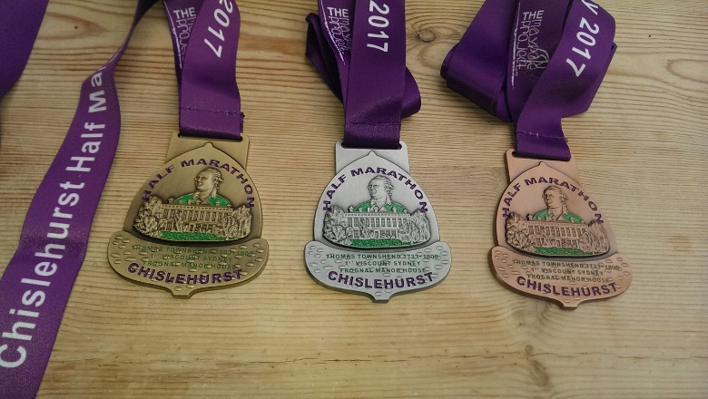  Medals  Medals will be presented to each finisher shortly after crossing the line. The first 5 male and first 5 female finishers’ medals will be gold coloured, the next 20 male and 20 female finishers’ medals will be silver coloured and all others will be bronze.  Results  Results will be available online at https://www.racetimeresult.co.uk/. For further details, please see the results page on our website www.chislehursthalf.com.

The Maypole Project

The Chislehurst Half will donate the surplus from the race to The Maypole Project, an Orpington based charity which helps children with complex medical needs and their whole families.  The Maypole Project provides a lifeline of support to children with complex and life threatening illnesses, across South East London.  The Maypole Project’s support work relies on fundraising. The unique emotional support that The Maypole Project offers is ongoing, flexible, responsive, professional and confidential. | Each family is supported by a key worker who is specifically trained and supervised to offer emotional support, which ranges from befriending to counselling or therapy.  This can be provided to whole families, one to one, couples, groups, and also extends into provision of information, advice and advocacy. Please visit The Maypole Project’s website at www.themaypoleproject.co.uk for further information about the work of the charity.

Finally, thanks to gymnasium life:lab based at Race HQ to the rear far side of the Glebe FC clubhouse for providing the pre-race warm-up routine and for the use of their w.c.’s on race day. Some details about what life:lab can offer to those seeking to improve their physical fitness can be found below:-

Life:lab was created because we genuinely believe that people are getting short-changed by their gym experience. We wanted to create a training experience that brought fitness to life, a place that was member focused and service driven. Above all else, we want life:lab to be a place where people come to get the results that they want, whilst actually enjoying their workouts.
We believe that we have created the optimum gym in Chislehurst. Utilising cutting edge technology to monitor and manage your health, along with the support offered by our excellent Personal Trainers, all in a fun, yet focused training environment, allowing you to fulfil your potential.

