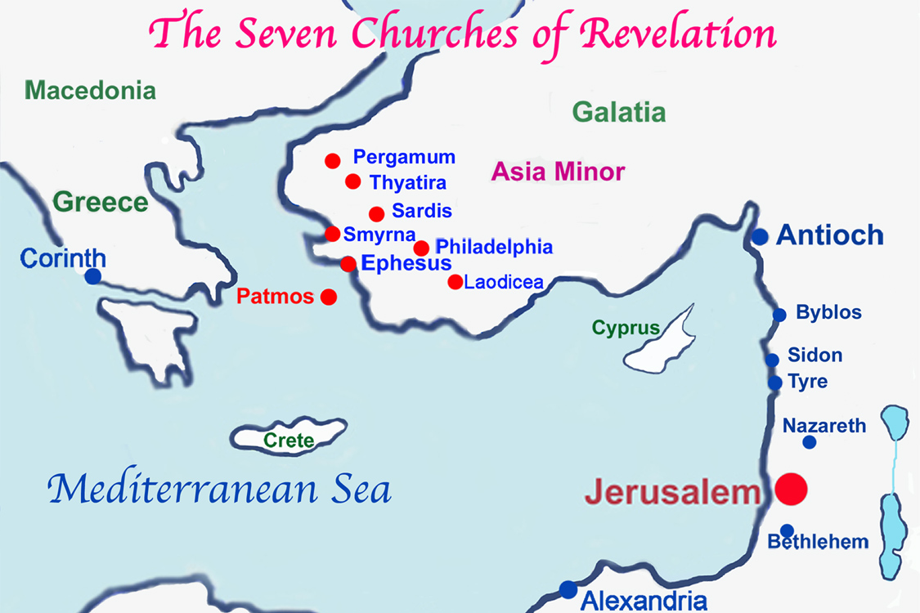

**Ephesus - Boundary Keeping** ,big important port city ½ million 1st century , Paul founded Pricilla and Aquilla much spirituality bad Greek and roman gods, Artemis, Dianna zeal for purity lost love. Doctrine over spirit. (LGBT no compassion)

**Smyrna – Consumerism -** **overcame** - prosperous port city church a business, small suffering church Earthquakes, mega church today counter built many times in past, commitment vs individualism , Alliance to Roma, Rome and Jews challenge, only church that still exists, Polycarp’s church, Still Thriving Izmir. Resilient, give a lot require little

**Pergamum – Accommodation** High fortress, history of ruling area, first city in Asia position to support Roman emperor worship. Egypt, Cannan, Assyria, Babylon, Persia, Rome all conquered( Don’t follow bible)

**Thyatira - Privatized faith**. Flat Plain no fortress, Guilds powerful money or Christians, Jezebel spirit dividing body and soul threat from within church, Gnosticism, Greek pluralism Least politically and economically of the churches, Apollo ,church /world separate

**Sardis - Apathy.** Fortified City no threat or challenge, stagnant un changing**,** Hole in the wall, sleeping, pride ,Past Glory, living off that non offensive faith, White stone ticket in. Older city than Thyatria, Pergamamum and Ephesus.

**Philadelphia - Fear -overcame** fear with love**,** earthquakes fear to return home many obstacles became opportunities. Hellenism leader of area Open door area, Hostile Jews, Scattered, shut out of synagogues protection. Door to Hermus valley hard road

**Laodicea – Self-sufficiency** lukewarm prosperous, Material Prosperous self-sufficiency don’t need god.no spiritual power in church, banking, CLOTHING MEDICAL SCHOOL City of open Best Dressed Spiritual pride 6 miles from water too far from Jesus HRSHEST LETTER. Open door to Hermus valley, easy road