**Getting Started with Homeschool Cheat Sheet: 10 Steps to get you going!**

Congratulations on deciding to home school your children! I know it could be scary. I know you may have tons of questions. Your decision to homeschool may have taken a lot of thought and faith. I believe it is the best decision for you and your family. It is why you made it right?!? Homeschool opens so many opportunities that traditional homeschool does not. This is a simple getting started guide. For more in dept training and support, go to www.homeschool-helps.com and order your copy of “*Homeschool Helps: A helpful guide to getting started with homeschooling your children!”*

**Step 1** – Find out your state requirements for homeschooling. https://hslda.org will allow you to select your state and get the requirements. Some states require a lot, and some states have little to no requirements. www.homeschool.com has tons of information. There are some laws that go across all states such as…

* Fact: Homeschooling is legal in all 50 states.
* Fact: Each state has different state homeschooling regulations.
* You must follow your state’s homeschooling regulations or face prosecution.
* If you are road schoolers, you need to follow the state homeschooling laws from the state in which you have your driver’s license/vehicle registrations. Take proof that you have followed those laws along with you when traveling to other states.
* Grandparents, parents, or family members that have been appointed by the legal guardian may homeschool the child once the legalities of homeschooling in that state have been set up.
* Keep a transcript or detailed record of your student’s accomplishments when they begin high school. Keeping up with this is vital for your teen’s future. Follow the suggested course guidelines for your state and meet or exceed their requirements.

(taken from homeschool.org)

**Step 2** – Teach subjects that are mandatory and subjects your child enjoys. The main subjects that must be taught are;

* Language Arts.
* Mathematics.
* Biological and Physical Science.
* Social Science (Social Studies)
* Fine Arts.
* Physical Development and Health.

You can add additional courses according to your child’s needs and desires. You have the freedom to plan and execute the best plan for your child. Find out what they like and how they like to learn.

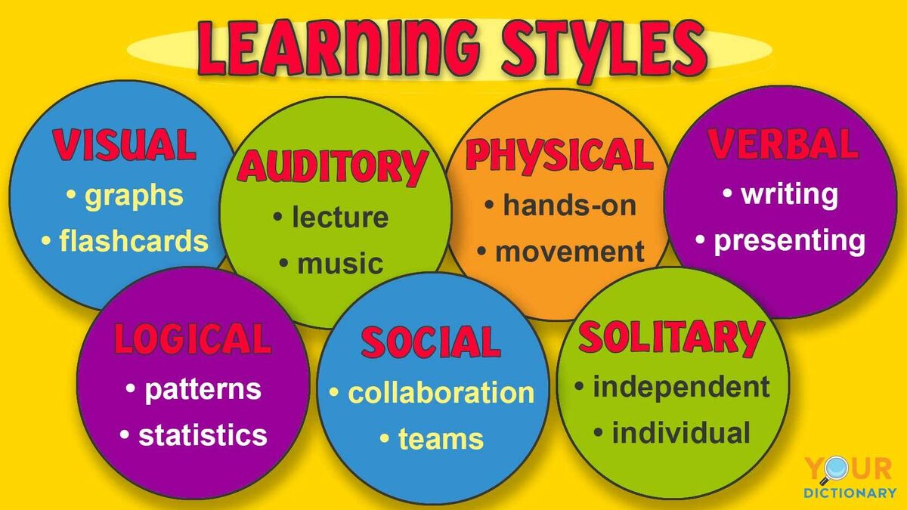**Step 3** – Find your child’s learning style. Create your teaching plan according to your child’s learning style. Here is a quick view of different learning styles. Image taken from yourdictionary.com. You find their style by test and trial. Give lessons in the beginning on each and see what is easiest for them. They may have multiple styles. That is okay!

**Step 4** – You Choose the curriculum.

Some states require you to teach certain things, but there are many, many curriculum options. You may find it easier to mix and match. You can even buy books from Amazon. There are even online options where you can enroll your child and someone else does the teaching for you.

**Step 5** – Get started!

Just start! It is just that simple. I thought I needed a certification, but nope, you do not! I thought I was in over my head. I wasn’t. It was me over thinking. Do not overthink. Learn! Grow as you go. Make mistakes if needed but learn from them. Get started!

**Step 6** – Join a community/co-op.

There are so many home school students, groups, organizations, options, etc. Your child does not have to miss a thing! I highly recommend checking out homeschool groups in your area. You can find support groups and co ops via social media, google, or your local library. Go to the meetings and find what suits you and your child. There are so many options! Including physical activities, skating, bowling, arts, etc.

**Step 7** – Keep records of grades.

Create a transcript. Keep up with classes they have taken and the grades they earned. Yes! They need to earn the grade. Do not be so hard, but please make sure they learn.

**Step 8** - There is no one “correct” way! Your way is correct!

You do not have to teach like the next person. Your child may not learn like the next person. That is okay! Yes, advice from others is okay. But do not feel like you have to do it just like the next person. You may have some techniques that others need!

**Step 9** – Explore!

Go out! Your classroom is wherever you are. The world is your classroom. Go out of town. Go on trips near and far. Sometimes, sleep in. Do what works for you. Find a way to make as many things as possible teaching lessons.

**Step 10** – HAVE FUN!

Homeschool is supposed to be fun. It is non-traditional. You can have trip days. House cleaning can be a school day. Grocery shopping is a life lesson and math lesson. Be creative!

We pray this quick start was beneficial for you. We have a more detailed book being released September 2023. You can obtain from our website. If you need more assistance, looking for a virtual/hybrid co-op for you and your family, please connect with us at homeschoolhelps2@gmail.com or homeschool-helps.com. We look forward to connecting with you! Thank You!